Rudolf Steiner’s “Mexican Mysteries” Reviewed

Chapter III of American Chapters

Stephen Clarke
Dec. 5, 2004

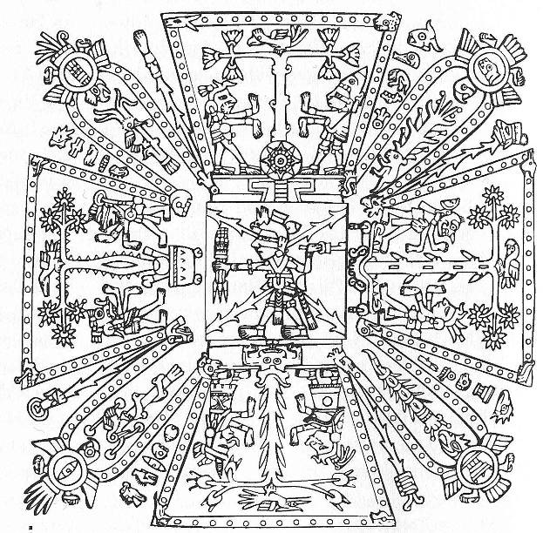

Index

The Situation – p. 1

Steiner’s Context – p. 4

Christ-Activity in the Pre-Columbian Far West – p. 5

Scrutinizing the Text, Images 1 & 2 – p. 8

Steiner’s Sources Examined – p. 16

A Possible Answer to a Vexing Riddle – p. 21

Meaning and Significance – p. 24

Coda and Summary – p. 28

Endnotes – p. 34

Supplementary material as included with Steiner’s texts – p. 37

Images, 3 to 28 – p. 51

Rudolf Steiner’s lecture-materials on the Mexican Mysteries – p. 76

Legends of Coyolxauhqui and Huitzilopochtli, Images 29 to 42, and themes – p. 115

Steinerian and Mesoamerican UnderWorlds – p. 126

Selections from R. J. Stewart – p. 137

Bibliography & Images credits – p. 144

The Situation

Having referred to the implications of Rudolf Steiner’s far-reaching indications on Mesoamerica throughout the preceding sections, it is now time to look a little more closely at those indications themselves (the full texts of which are quoted herein). Introducing the reader to those disturbing indications regarding the inner nature and spiritual destiny of America might seem straightforward in one respect; they are sparse. Many of them - and the majority of the most penetrating ones - are bundled up within a pair of similar lectures given in 1916. The lecture of Sept. 18, 1916 had to be repeated on Sept. 24, as there seemed to be general befuddlement on the part of too many in the audience. It is not known if things fared any better at that latter date, since that lecture is essentially a repeat of the former one. There is no record of any follow-up lectures dealing with the topics raised, nor of any immediate activity provoked in listeners by the material.
Also included in this Chapter are treatments of closely-related subjects by modern informed specialists. They are included to illustrate and expand upon certain aspects of Steiner’s comments and attitude, but ones which are not unique to his system – ones that are accentuated in this area but which I feel illustrate trends more widely, if more diffusely spread elsewhere in the more speculative fringes of modern spirituality. In-depth discussion of Steiner’s more provocative implications takes place elsewhere.
Some ink has been spilled by various later commentators who have drawn various conclusions form Steiner’s remarks on the “Mexican Mysteries”. Few reveal any conscientious examination of the source material, familiarity with the relevant cultures, or research into the contemporary literature or scholarship. Most offer observations which are simply paraphrases of Steiner’s own remarks. Whatever the faults of my analysis, I will not be repeating those mistakes: I break through the imaginal logjam that has piled up around this subject.
Intriguingly, what Steiner does not say about America is just as fascinating as what he does have to say about it – and it is this absent portion which is profoundly perplexing. In this area of investigation, as in no other, he demands the inner participation of the reader, and leads him or her beyond his or her previous limits of understanding. Deep implications are folded inbetween what he does say and what he does not say, and even if one reads between the lines, it is riddles that emerge! To do more than search for factoids or justification of previous (mis)conceptions demands intense inner work – original work – on the part of the one whose curiosity is provoked by Steiner’s indications.
Provoked is a good word for it. In 1916, the time from which these core lectures date, America was still a savage backwater for one who stood upon the tall shoulders of European culture, and the USA had not yet entered to tilt the balance in the Great War. Steiner never shrunk from a harsh evaluation of our historical record and of the future perils which it indicates, and his complex intuition of our ancient foundations was not well served by the rudimentary state of the archeological and anthropological sciences of his day (although there were resources which he did not make full use of, as we shall see).
Temperamentally, he was not sympathetic to the nuances of boisterous life in the Far West, and this tends to make appreciation of his insights difficult. For instance, he decried the coarse influences of jazz, the only truly American art form.
The benefits of inter-culturalism and inter-disciplinary scientific archeology were still to come. Some of his statements have not withstood the test of time, and this in itself is confounding for those who take his word as holy writ. His personal attitudes have frequently been taken as a given by novice acolytes. But these need not concern us overmuch, for few who have ventured opinions on the nature of pre-Columbian Mesoamerica have survived unscathed and the modern scholars maintain by adhering to an exceedingly cautious empiricism, or by eschewing eccentricity. For example, only recently has the Mayan hieroglyphic script begun to be deciphered; many a textbook has had to be rewritten as a result, many a popular theory relegated to crackpot status, many a famous authority proved wrong - yesterday‘s science can easily end up on tomorrow’s scrap heap. For decades, the dogma was that the Mayan temple-cities were arenas set aside for strictly ceremonial use, tended only by peaceful astronomer-kings, the surrounding populace admitted only during special events. We now know that they were thriving urban centers and that celebrating or planning war with neighboring feudal lords was a major and more-or-less constant preoccupation.
Steiner fares well as measured against such precedents. In addition, he never claimed to be continually in the state of clairvoyant seership, and he easily allowed as how errors were possible even then. Whether he was correct on all counts and in every respect is not of central concern in this; what is the focus here is the manner in which his indications can be grounded in contemporary scholarship and, reciprocally, how his indications can bring additional meaning to the cloud of disassociated details within that extensive body of knowledge. In spite of a great deal of entirely probably theories about the ground-level organization of Mesoamerican societies, few venture to envision an overarching picture of how their motivating world-views operated, competed, and changed with time and conditions.
What is most provocative in his observations is that which he sees as the core event in America’s destiny, the aftereffects of which are duly noted by scholars but whose causes are searched for within a cripplingly limited field of view. The consequences of the typical modern syndromes of over-specialization and compartmentalization are evident. Steiner, in these lectures, speaks to the meaning of history. He approaches the subject from the direction of its significance; from the whole to the parts: he tells the story, he is not content to remain with the details. His sense of the deep cycles and hidden currents of history allows him to go where the facts themselves are mute. His ability to talk, walk, and act with the gods themselves grants him a singular and broad perspective. His method may not be able to tell us everything we might wish to know, but it is at least a flexible addition to the inquirer’s toolbag. We shall see where using it may take us. Out of his firm grounding in the Middle-European Esoteric Tradition (in this section, I try and reserve the term “West” for what is local to the Americas) and as applied to the events in Mesoamerica at the time of Christ, he makes some astounding assertions: assertions which are totally unprecedented – even for him. Deeply positive at heart, they are never referred to again in the course of his furiously busy and extensive lecturing – another puzzle which begs for attention.
A large portion of his work is still not published in English, and there are no doubt midden-piles of uncollated notes, letters, reminiscences, and what-not that is extant in around and about Europe. Even though searches in the index of his Gesamtausgabe – the Index of Complete Collected Works - for major keywords related to the topics at hand reveal no unturned stones, it remains possible and hopeful that something of value may still turn up – an effort in cultural archeology for some enterprising soul!
For those familiar with Steiner’s legacy, it is this point about the singular nature of his Mexican Mystery comments which is most perplexing, for RS is famous not only for the allusive style of his statements, but also for the way in which he usually persists in circling back upon them from different vantage points throughout his career, in different places and to different audiences, at different times. As most of his public utterances have been recorded and published, it is possible for one so inclined to collate his varied observations on a given subject and generate a rather well-rounded impression of his perspectives on just about any given topic. This is a great benefit: oftentimes, an isolated observation may seem to be offensive to common sense or to the conventional wisdom, or several statements from different sources may seem to bluntly contradict each other. Only later might they reveal a higher reconciliation after some sustained reflection and recourse to yet other diverse references. In this way, a more mobile, well-rounded, and lifelike perspective is gained for complex topics not easily reducible to a check-list of attributes or a capsule definition. Steiner, like any good old-world taskmaster, makes one work for one’s supper; he honors the plastic nature of living reality, and this demand that the listener or reader do more than simply listen or read is an integral part of his teaching method.
With regards to Steiner’s essential comments about Spiritual America, we have no recourse to a fund of nuanced references, and his requirement that the reader participate in the process of constructing his or her own cognition of the subject is thus given little assistance. They stand alone with little direct corroboration from either himself or accepted academic scholarship, although scrupulous and unbiased examination of the existing data does allow of alternate interpretations which are congruent with Steiner’s statements, and if Steiner’s statements are treated in similarly generous, “Imaginative” according to the technical lexicon of his anthroposophy - fashion.
Steiner himself was adamant that no one accept his statements as authoritative: each listener or reader was under the obligation to test and try them out for themselves in the crucible of discrimination, conscience, and experience - especially since his transcribed lectures were published unreviewed and uncorrected by him (such disclaimers are frequently included in the forwards to their printed editions; that includes the ones here under discussion). Yet what is one to do when confronted by his assertion that in the years 30 – 33 AD, in Mexico, a conflict was waged over the process of the sacrificial death of Christ, and that the successful results of this encounter were decisive for the future of earth-evolution? One cannot easily co-opt this datum into whatever conceptual framework one may have already formulated; one must either confront it and its corollaries with a decisive intent, or find a way to dismiss it out of hand. Examination of this statement using a variety of perspectives indicates that this core insight is of the highest value and accuracy, standing out from the rest of the contextual material in which it is embedded, much of which it must be admitted is of a very different quality.
Not only is this an inherently complicating and confusing element, but the extent to which later followers and commentators have neglected to make this essential discrimination has muddied the waters considerably for the conscientious researcher.
In this installment we shall concentrate upon examining Steiner’s text and matters closely related to it. Following sections will address broader and deeper issues involving inner perspectives of local American Traditions.

Steiner’s Context

Steiner was a European, and while he lived and worked for the entire future of Earthly evolution, he worked for this from inside his own European culture. Although he had a cosmic Vision second to none and a job description that was staggering in its scope, he was not all things to all people. His mission was firmly contexted within the Traditions of Central Europe. Most of his many, if brief mentions of America are brutally critical and deplore its materialistic tendencies, and are made with respect to the USA’s corrosive influence upon European culture. On any subject he stretched the envelope of his Inspiration to its limits, bringing in the most wide-ranging influences. He also set up a crafty system of koan-like trip-wires within his legacy so that those who came afterwards would find themselves committed to expanding the scope and application of that Inspiration. This writer has gotten himself involved in one such web, at the center of which is the Spider-Woman of the American initiation-pathway – but more on that later.
The concerns of people in distant parts of the world had little relevance for the ordinary Central-European of 1916, although this was beginning to change. It is different nowadays. Our net of relationships and influences is much wider than it was then. Activated by the dynamic of profound respect for Dr. Steiner on the one hand, and “What in the $^#*& is he talking about, anyway”, on the other, I have worked the dialectic and, as a result of decades of inner work, research in the scholarly literature, traditional lore of Western spiritualities, and the rubbing of shoulders with Native Americans, their culture, and their Ancestors, all the while pervaded by the living Being of the American Land, certain understandings have developed, seeded in part by Steiner’s indications. Some of this is my own, dredged from some buried cranny of remembrance. Hence this work-in-progress. I hope that those who read it will be encouraged to do their own work, correct me on any item of fact, and offer their own observations. Future editions of this piece will incorporate and acknowledge any such contributions.
Conscientious students of Mesoamerica should not ignore Rudolf Steiner’s insights on the subject. While he certainly did not cover all the bases, he was sober and competent, and he may well have discovered the “missing link” which many have been looking for.
Christ-Activity in the Pre-Columbian Far West

This struggle in America over the Deed of Christ - what considerations must we bring to bear in order to be able to understand it? Here we are not totally hamstrung by an admittedly unsatisfactory fund of information about the exact details of Mexican life two thousand years ago, for just as the scientific professionals have generated an impressive amount of information about that life on the ground, we are able to know quite a bit about the larger and deeper nature and mission of Christ, thanks to an immense amount of very consistent material left to us by Rudolf Steiner and other significant individuals of our age who have opened the vaults of esotericism, releasing a fund of information every bit as significant as that contained in the Nag Hammadi and Qumran deposits. Revealing and enabling the mission of Christ was front and center for Steiner, and above all he dedicated his life to this cause, as it found expression in a myriad of avenues integral to the mass-culture of modern life. As a result of sifting through his indications and of doing the work of bringing them into relation with modern developments, it is possible to see where he was going with this, and what some of the implications might be for any particular set of circumstances…including the Mesoamerican ones. I have derived additional perspectives from the modern magical UnderWorld work of R. J. Stewart; it has been invaluable in facilitating my entry into the inner worlds of the Mesoamerican shaman, by correlating it with parallel practice inherent in the western-European one of my own ancestry. Although these latter vectors come from an entirely different direction than the “scientific” one, one can direct them to converge upon the same point. It’s all about how the world works, after all….
First of all, a review of Steiner’s overall indications regarding the activity of this being. We are told in the Bible that the Birth of Jesus was attended by a concerted effort to thwart it: Herod’s Massacre of the Innocents and the Holy Family’s flight into Egypt are well known stories. Christ is said to have later descended from the realm of the Father and to have conjoined with the person of Jesus, there to have lived for the three years of public life before passing into the bowels of the Earth. Steiner brings a wealth of detail to bear on all this, but in doing so the main structure and outlines of simple devotional faith hold steady and are brought into even clearer relief as a result, a benefit to those who seek to penetrate beyond the frequently superstitious public face of such things. We also are told from the Mythos that Christ died on the Cross, descended into the UnderWorld, and rose again on the third day. If, as Steiner indicates, a titanic struggle took place in Mexico around these events, this means that it was not the Birth of Christ but the purpose of his sacrificial Death that was under attack in the Western Hemisphere – and matters surrounding the Mystery-Fact of Death in general are known to have been central to Mesoamerican spiritual pathways. And what was this, that was so important about this deepest portion of his arc of incarnation, that aroused such furious opposition? What was it that happened in UnderWorld in that timeless Dreamtime of Easter Saturday? The Bible does not go into detail on this – it is not even deemed Taboo, it is simply glossed over except for a cryptic reference to the Harrowing of Hell (significant enough, if one pursues it) – and Steiner does not pursue it, either. Yet this is of the utmost importance, for out of what transpired during the decisive activity of the Easter Saturday “intermission” as he passed into the Earth, Easter Sunday and the Resurrection unfolded! The latter develops out of the former, inevitably. Even Jesaiah Ben-Aharon, an excellent representative of Steiner’s system of anthroposophy, in his discussion of this matter in his highly significant Spiritual Event of the Twentieth Century, admits of no access to this process. Indeed, the anthroposophical method in general simply does not go there (note Querido’s diagram, Fig. 41). The Steinerian map is bounded by warning signs consisting mainly of quotations from Steiner and parroted citations by others regarding the baleful lower-Threshold realm of “subnature.” The possible reasons for this are a matter for another discussion but reveal a serious dysfunction within anthroposophical doctrine, one latent within its early and incomplete phases, but one which has become with the passage of time the elephant in the room which goes unnoted. Regardless, these realities are inescapable for modern Americans, and hence, due to the USA’s geopolitics, for the rest of the world, although everyone and every region needs to find their relationship to them from out of their own legacy.
Here we enter into deep mysteries – American Mysteries. Not the Cosmic mysteries, but into the Earthly mysteries. They are different, and go far deeper than their turbulent boundary regions would suggest and dissuade. All around us they are revealing themselves as people from the most diverse backgrounds responding to the resurgence of powers from within the body of the planet. They are not exactly the same as what the Old Religions once dealt with, nor are they in opposition to what has been acquired since. The gist of this is implied by Steiner, but the times did not allow him to speak forthrightly about it. Observed with 20-20 hindsight, his circumlocutions are remarkably revealing. Christ came from the Father and died from the Father: “My God, my God, why hast thou forsaken me?” and was then laid in the Earth with women attending him going and coming speaks for itself. Although it is said as plainly as can be that his connection with the Father-God was severed, what is not spoken is that he fell, was received, into the arms of the Earth-Mother. This is left to us to derive for ourselves. From Her he received his regeneration; his rebirth. We have significant hints of this if we follow, in the traces of our own culture, the metamorphosis of Michelangelo’s Pieta into Raphael’s Madonna and Child – yes, I have the order correct.
There are many ways to arrive at this perspective. For example: a conscientious practice with the Our Father prayer leads inexorably to the same understanding; the downward drive of its verses leads beyond the confines of the prayer itself and elicits the response of the Mother from below into the radiating horizontal Directions.
All of this the American races knew, according to their own fashion, and it was not a hidden mystery, except for the precise initiatic details of their shamanic pathways. They knew the upsides and the downsides, the ins and the outs of the ways of the Earth, although not according to the secular science of their conquerors. But they were neither Edenic tribes, noble savages, nor doomed atavistic races. They were human beings, subject to all the confusions of the Fall and vagaries of human nature, but their circumstances were different, their wisdom was different, and their orientation was different than in Europe. However, they did know about how things happen when you go “down.”
Steiner knew that Christ’s ally in Mexico was an initiate fully experienced in UnderWorld realities and that the transformative encounter with Shadow and Double which every shaman undergoes was undergone on the most transpersonal, archetypal, and planetary fashion by Christ in his descent into the plutonian depths (a European analogue of this is the ancient Rite of the Sacrificial King as practiced within the cultures of the Celts). There were those others who drew their personal power from unregenerate realms of planetary Double; ancient and deeply impacted realms of twisted and thwarted energies. Even from the most casual forms of pop psychology we all know what happens when core internal energies are not allowed balanced expression or when impacted patterns are rudely challenged: what is repressed does not go away, nor does violence towards one’s infirmities bring about healing – here I refer to the realm of the microcosm within each individual. Christ worked on a vastly larger macrocosmic level –the organism of the Earth itself, of which we are a subset. For the Earth has had its developmental problems, too - as have we all. Not everything has been dealt with in ways which would meet with hindsight’s satisfaction, and over the course of aeons, the toxic residue had reached a point where something had to be done. Speaking of the state of the pre-Christian era, even the magical Priestess Dion Fortune – Steiner’s counterpart if he has one - has said: “…we must not forget that Christianity came as a corrective to a pagan world that was sick unto death with its own toxins.” This observation about paganism refers to the entirety of history prior to the time of Christ, not to any particular religion or cult, although they were all yearning to some extent because the invocation of their mythos had not yet attained completion (at which point a new round of cycle would begin). Even Buddhism is included in this, for having come into being before the full incarnation of Selfhood and its Avatar, it was bound to discount its potentials. Even in that late age, the shortest way to “enlightenment” was back the way we came - “renunciation” - away from full individuality rather than forward and into the future via full and total engagement.
Steiner minces no words when it comes to describing the excesses of corrupt Aztec culture or the depths of its dark roots and he had a deep understanding about how such things worked in general within the human psyche, but his approach tended towards the Apollonian and cerebral; his placement conspired to prevent him from engaging in the fashion which has become familiar in our times. He was definitely temperamentally unsuited for sympathetic appreciation of the Mesoamericans’ style of cultural expression and method of engagement. He balances this with a stunning revelation of the unsuspected wealth within the Mesoamerican experience, although he does not follow though by reconciling the two extremes of that spectrum. Perhaps it is the wild extremes of American experience themselves which challenged the methodical Steiner uncomfortably.
Let us begin by scrutinizing his statements and reviewing some of the anomalies which surface as a result of a close reading.

Exactly what did Steiner say, and how far can we go with it?

Scrutinizing the Text

First of all, the language. For instance: “Vitzliputzli.” This character’s name provokes no immediate associations, and a casual search for references in the dictionaries and lexicons is fruitless. It needs to be noted that while all Steiner’s terminology for Mesoamerican deities derives from the Aztec records (as translated and interpreted by the unappreciative Spanish, one must remember!), the events to which he refers date from both the early formative Olmec-Mayan-Teotihuacan era and the late-classic Aztec; 15th C. BC - 1st C. AD, and 16th C. AD, respectively. Evidence from the latter was presumed to indicate trends and actors in the former. Between the two, however, are vast gulfs and shifts which were not even suspected in Steiner’s day, gulfs more drastic in many respects than those between, say, 6th C. BC and 16th C. AD Italy, England, or Greece. Additionally, there is still no record of any language or script for the critical Olmec and Teotihuacan civilizations, and the prolific but enigmatic Maya hieroglyphs, only beginning to speak again during the last portion of the 20th C., was mute for all researchers in Steiner’s day – as it was even for the Maya themselves until very recently. The curtain of history had fallen with a mighty thunderclap upon that act in the world’s drama - the precise era to which Steiner’s remarks refer!
A tangential question: might this have been a cyclic recapitulation of Mesoamerica’s Atlantean roots? Prior and cyclic world-ending catastrophes and resultant migrations were a prominent feature of all Mesoamerican lore and part and parcel of their rather nonlinear sense of time. Perhaps the persistent of our own story of Atlantis’s watery demise – established firmly in the popular mind by no less than our own cultural grandfather Plato – converges on something of the same universal memory, however imperfectly retained? But this is a speculation which is not relevant, so we will leave it aside….

The language of the most recent English translation of Steiner’s Inner Impulses of Evolution is confounding in this regard of language, and glosses over significant problems. Let us note the spelling of significant names, comparing the German original to the English translation:

Amerika – America
Dschingis-Khan – Genghis Khan
Taotl – Teotl
Tezkatlipoka – Tezcatlipoca
Jahve – Jehovah
Mexiko – Mexico
Quetsalkoatl – Quetzalcoatl.

For any of these, there is no loss in the translation, only the elimination of a mild and charming quaintness. All are recognizable as what they are. Yet when we come to the following:

Vitzliputzli – ?

we note that the term has not been translated, but left in its original and unfamiliar form (Google “Vitzliputzli” or go to: http://search.netscape.com/ns/search?query=vitzliputzli for evidence to this effect).
It is no mystery that Huitzilopochtli is and has always been standardized modern English and Spanish usage for the original Nahuatl form of the name – one which is transliterated by loose convention into German as “Vitzliputzli” (Seler used “Uitzilopochtli” since the letters “U” and “V” were interchangeable, even in archaic English) - yet the editors did not follow that practice. Why not?
Perhaps because Huitzilopochtli was the demon-god and culture-hero of the Aztecs to whom multitudes were sacrificed in ritual murder, before whose temple the famously immense skull-rack with its countless trophies was displayed, and whose cult fueled an ideology of permanent war? How could this have been the same person whom Steiner describes as the ally and rescuer of our own, and the planet’s (by whatever name), culture-hero? The editors may have thought that it was better to retain the unfamiliar form of the name, one which entails it no unpleasant associations or difficult questions and which sidesteps the polluted popular conceptions of lurid and preposterous fantasy.

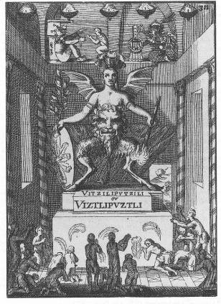
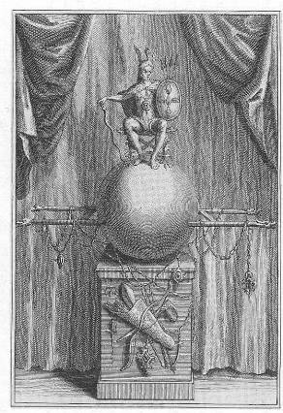
Fig. 1 Huitzilopochtli as a Caesar in Roman Fig. 2 Huitzilopochtli as a satanic demon, 1686
regalia, 1735 (note legionnaire’s camp stool). (note the spellings of his name).
I am told by Prof. Peter Furst that a naughty German boy was frequently called a “Vitzliputzli” - without any comprehension of the meaning of the term - by scolding mothers, even up into the 20th C. This probably derives from Goethe’s use of the term in his Faust epic, when he is referring to devilish entities.
Eduardo Matos Moctezuma, in his Alti Publishing edition of Treasures of the Great Temple, cites Sahagun's Florentine Codex references to "Vitzilopochtli."
Prof. Boone notes: “With this clear focus on Huitzilopochtli at the Templo Mayor and the god’s importance elsewhere in Aztec Mexico, it comes as a surprise to realize that the god’s physical form and visual image are largely unknown. Few sculptures of the deity have survived, and the paintings of him in the pictorial codices are relatively sparse and iconographically varied; the shortcomings in the artistic record perhaps explains why the god’s physical manifestation has remained so enigmatic.” (Incarnations, p. 2. All Boone quotations by kind permission.)

Yet sidestepping of the problem of nomenclature does not help to solve any others and establishes a thwarting pattern of avoidance, while tackling the question head-on provokes some interesting insights, as we shall see.

For many of 1916 the default presumption was that that Mesoamerican cultures stretched back uninterruptedly from the Aztec times of the 16th C. back into pre-Classic cultures of the 1st C. and beyond, and that the gods and deities which were worshipped by those whom the Spanish met and chronicled were the same who occupied the pantheon during all earlier eras. In the absence of contrary indications, this was a perfectly normal presumption, one proven since to be mostly wrong, but the one to which Steiner’s age subscribed with little caution. The problem here arose because there were few if any indications of any sort; the map here was almost as blank as the heart of darkest Africa, and the meager information that was available was frequently distorted beyond recognition by sheer ineptitude, aggressive religious antipathy, and utterly uncurious projection. Hence, in lieu of any other convenient options (but for reasons which will become clear, and which don’t seem all that bad since we still have no better alternatives!) Steiner subscribes to convention and selects the name of the Aztec’s unchallenged culture hero and war-god – Huitzilopochtli – and applies it to our mysterious avatar. Regardless of which were his sources, any of them would have informed him straight off that Huitzilopochtli was a demonic entity of the first order. Why, then, would he have used that baleful name without any caveats to his listeners? His window of opportunity to speak of such things must have been narrow, indeed, and he must have trusted in those who came after to do the necessary work of contributing the missing details. That’s us.
Using the name of “Huitzilopochtli”/”Vitzliputzli” may have been an inevitable choice for him, but one which we, a century later, should be very cautious about employing unless we understand what it signifies. Under the circumstances, and without a better option, those of us in the English-speaking world could do worse than to use the German form of the name as used by Steiner, since it does separate the early from the late aspect rather decisively. Later on, we will consider another parallel option, one that comes from the Maya.
One good reason for Steiner to have used it is that the Aztec lore of Huitzilopochtli dates his exploits to a distant era long before the Aztecs’ own history. In the fashion of the day, a person’s exploits attained reverence and permanence in memory only in so far as they were overlaid with the resonance of prior, vaster, and more divine progenitors. Hence there were many “Montezumas”, just as there are many “Popes”. If the Aztecs revered a Huitzilopochtli, it is more than probable that this was so because there were other “Huitzilopochtli’s” before him. The most probable first Huitzilopochtli would have been the one who would have been present at the destruction of their last world-age and the creation of the present one - this was the same exact era in which, in Palestine, Jesus was the vehicle for Christ, and which, in the formative era of 1st C A.D. Teotihuacan, the gods of the old age immolated themselves so that ours could emerge from the pyre in its present form.
Additionally, there are some significant insights that can be developed by pondering the factors which played into the possible metamorphoses of our 1st C. initiate as Steiner describes him into that of the terminal culture which appropriated his legacy for its own legitimization. Was Steiner aware of this possibility? Most probably, but he does not mention this entirely typical dynamic. One can only observe the uses to which “Jesus” is put nowadays. One can assume Steiner allowed for the syndrome here since he certainly did elsewhere when he discussed the dynamics of other cultures and religions. But little has been done to consider the implications of this metamorphosis – implications that are avoided by “Vitzliputzli”; but use of which isolates that individual from any illuminating associations, pedigree, or context.
Furthermore, since Steiner was unable to be specific as to exactly where in Mexico or in which of its many cultures this remarkable deed of Christ’s advocate took place, we are unable to infer directly from him whether this person was Olmec, Zapotec, Mayan, Huichol or other. Mexico was – and is – a big place with more opportunities for cultural diversity than most. (In a later section we will consider an Izapan hypothesis). A prominent Mexican scholar has this to say about the convention of “Mesoamerica” (this would have been Steiner’s “Mexico”:

The Boundaries of Mesoamerica

I. What we call Mesoamerica was a historical reality. It was a sequence, spanning a thousand years, of strongly linked societies.
2. Obviously the complexity of the interrelated societies was heterogeneous, as much in the succession of events across a thousand years as in the simultaneous existence of societies developing in different ways.
3. The ties established among these societies were diverse and changeable. The social relationships that gave rise to Mesoamerica are not limited to one, permanent, universal type.
4. Although during certain epochs and some regions of Mesoamerica some kinds of relationships prevailed over others, the essence of Mesoamerica derives from the whole complex of relationships, their combinations, relative strengths, and not merely from the dominant type.
5. Therefore what is Mesoamerica cannot be discovered by the presence of characteristic relationships or traits at all times and places. The totality of relationships is not an average of constants but a historical succession.
6. The dominance of some relationships over others was not a matter of chance. It obeyed the above-mentioned common course of history.
7. Relationships among the various Mesoamerican societies gave rise not only to similarities among them, but also to differences and limitations due to asymmetrical interdependencies.
8. There was no obligatory coincidence in the extent or duration of the common elements in different areas of social behavior. For instance similarities in the field of politics that might have existed among various Mesoamerican peoples in a given epoch did not necessarily imply that there were similarities in the artistic field over the same period. Nor did political relationships last the same length of time as artistic ones. If we block out on maps of Mesoamerica the various common elements, the colors for the different elements would not overlap in a uniform way. This would also be true if we drew them on chronological scales. This is due to the fact that between one social area and another there was no mandatory reciprocal correspondence, because this coordination, although firm, could involve multiple, rich variables.

These are some of the understandings necessary for the study of Mesoamerican myth and its continuity. Let us take up briefly some of the points mentioned. In the age-old history of Mesoamerica, the ties among the various peoples living there are particularly noticeable from the beginning of the sedentary period. This enables us to identify the origin of Mesoamerica with sedentary agriculture, even though the connections began in even remoter times. The decisive step in the formation of Mesoamerica was the domestication of corn between 6000 and 5000 B.C. The slow process of settling down would come later and, with it, the development of agricultural techniques, which made advanced farmers of the Mesoamericans.
Relations among the ethnic groups who occupied the area between 25 degrees and 10 degrees north latitude had to be varied and changeable. Through history the Mesoamericans formed societies differing widely in complexity, from primitive farming villages to populations of high density made possible by intensive agricultural technology; from simply structured groups to stratified societies forming centralized states. Their ties were economic, political, religious, and cultural in the broadest sense of the word. Geographical diversity and specialization in production originally brought about a simple exchange of goods, foreshadowing later commercial routes and, later still, the establishment of markets and even suprastate organizations for production. Politically Mesoamerican ethnic groups associated through alliances, often strengthened by kinship or marriage, and also through wars, conquest, and consolidation (in epochs of major development) of tributary systems. Political complexity reached its peak with the founding of governments based not exclusively on blood ties but on territorial domination over populations differing in ethnicity and language. From the conflicts arising among neighboring nations, resulted regulatory norms that culminated in tribunals formed by several dominant nations. Ethnic and linguistic ties were important in all of these alliances, sometimes as conditions favorable to harmonious relationships, at other times to justify political consolidations through hidden or outright conquests.
The intensity of links of either kind created a joint cultural creation in which ideology in its widest forms of expression served to defend interests in agreement or in conflict. In this way a common Mesoamerican culture was built, of which the Olmec, Teotihuacan, Maya, Zapotec, Mixtec, Toltec, Mexica, Huastec, Totonac, Tarasca, and many other cultures are merely variants created by particular traditions in different regions and historical periods. A common history and local histories interacted dialectically o form a Mesoamerican world vision in which the variants acquired extraordinary individual peculiarities.
Institutions such as markets, war, or courts produced and were regulated by norms, traditions, and organizations, including societies at various stages of development. In time these norms and institutions crossed state boundaries. Institutions overlapped in multiple, reciprocal dependencies and mingled to form several complexes. Among the functions of some political organization was the regulation of internal and external exchange; others permitted the existence of organized merchants; others placed them under their aegis. Conquests could be justified as means of guaranteeing the existence of politico legal institutions. At times tribute was disguised as offerings to the gods of allied peoples. Trade routes served as paths for military penetration.
It is not possible to conceive of Mesoamerica as the product of uniform and permanent types of cohesive structures. Within its territory the influence of different relationships varied, sometimes simultaneous, sometimes successive, the profound dominating ones, as well as therefore apparent ones that overlaid them. The shifting existence of one and another made Mesoamerica an area of evanescent horizons, above all in the northern regions. What is “Mesoamerican" vanishes, evaporates, along the northern and southern boundaries and what might be considered typical in some regions is lacking in others, in which different cultural elements mark the "Mesoamericanism." They do not spread like colors of continuous and uniform intensity, nor characterized the same hues. Mesoamerica was a continuum of a historical character which neither in time nor in space owed its unity to the same factors.

- Alfredo Lopez Austin, The Myths of the Opossum, pp. 12 – 14.

Another problem of language is reflected in the matter of “Taotl” whom Steiner describes as the supreme and most ancient god of the Mexican pantheon, the bearer of the Atlantean legacy (from another citation: “Taotl is a Being who as a cosmic, universal spirit weaves in the clouds, lives in the lightning and the thunder.) While we concur with the commentator Dr. Koslik in his observation that this is very similar to the generic “teotl” suffix in the Nahuatl language, this does not assist us much, for the question remains: “Who was the deity to whom Steiner refers – as it appeared in the 1st C. A.D.?” Could this be the significant “Storm God” of Teotihuacan (the name pulled out of a hat by modern researchers) who persisted as the most ancient god Tlaloc of the Aztecs, who shared shrines at the top of Tenochtitlan’s much-later 16th C. Templo Mayor pyramid together with Huitzilopochtli? At any rate, it is a leap to capitalize the “T” in “Taotl”, for “teotl” not a proper noun, but a qualifying suffix signifying a god aspect of any other supersensible being (e.g.: Ometeoltl, Huehueteotl, Tlazolteotl, Cinteotl, etc.). To derive anything more than the most general speculations from this single similarity is unwarranted, just as increasing the resolution on a halftone photograph past a certain point does not yield any additional information; it only increases the grain. One might just as easily draw conclusions from an apparent similarity of “teotl” to the “turtle” of Turtle Island, or compare the rather loosely-tethered speculations regarding the generic “Tonantzin” entity of Guadalupana lore based upon phonetic similarity between the Spanish name and those of various Aztec goddesses (the Spaniards knew Guadalupe by that name long before the New World was discovered).
Yet the intuition may have been responding to something by these associations. Steiner’s attempt to indicate something significant by pointing to such features should be taken seriously, although a fundamentalist literalism should be avoided. “Teotl” does have implications of exceedingly ancient roots, since the first two deities mentioned belong to the most ancient rank of world-forming beings.
Furthermore, to associate “teotl” with the “Great Spirit” of Native American lore is probably not too far from the mark, as far as it goes, but we should be leery of thinking that we really know anything specific or substantial as a result: there were hundreds of cultures who believed in a Great Spirit of one sort or another, each emphasized one individualistic and revealing set of characteristics. The only thing we can be very sure of is that those conceptions varied widely.
Boone notes: “After the Conquest, teotl was universally translated by the Spanish as “god”, “saint”, or sometimes “demon,” but as Arild Hvildfeldt has admirably demonstrated, its actual meaning is something close to the Polynesian idea of mana, a sacred and impersonal force or a concentration of power.” (Incarnations, p. 4)
Onward into the fog…which begins to dispel under the effect of our persistent attention.

Second, as we have alluded, there is the almost inevitable if subtle conflation of the time-periods involved; a situation that continues to bedevil modern researchers. Let us note the back jacket cover statement that appeared in the first English edition of Steiner’s lecture-cycle, as it nicely illustrates the problem:

…We hear of how…forces, opposed to humanity, threatened to reach a tragic climax in the bloody Aztec mysteries of ancient Mexico, until they were thwarted by the heroic efforts of a Mexican Sun-initiate.

This statement is completely garbled and reflects an abject confusion of two entirely different sets of circumstances. Steiner clearly states that the events of the crisis and its successful resolution took place in the first part of the 1st C. AD. He further states that all succeeding crises, whatever their scope or danger, were nothing compared to what they would have been if the prototypical 1st C. crisis had not been successfully dealt with. According to him, the negative aspect of the much-later Aztec phenomenon was merely an echo, a feeble afterthought of certain ancient retrograde Mesoamerican tendencies. Yet in this editorial summary the inverted Aztec phenomenon is substituted for the essential one which took place a millennia-and-a-half before! The simple historical fact that the Azteca entered the Valley of Central Mexico in the 14th Century - circa 1332 A.D., from out of unidentified northern wastelands, but did not attain to regional hegemony until a century later (much like the Inca, who also only enjoyed ascendance for a mere score of decades) has difficulty registering for those who prefer to think that the history of people in the Americas only began for real in 1492.
The problem here – and it is a problem of which academics and scholars are keenly aware – is: to what extent can we understand the seminal early-CE Olmec-related cultures by what we think we know about the late-CE cultures of the Aztec and Maya? I say “think” we know because of the paucity of original sources of information: the Spaniards were excellent and voluminous chroniclers, but all of it was in the service of conquest and Inquisition, when it was not outright genocide. Lopez Austin’s cautions, cited earlier, are equally relevant in this context.
So: Huitzilopochtli/Vitzliputzli. What are we to make of this? We shall have to tease at this knot from multiple directions. We have indicated one of them: the direction of time, where aspects of a highly-charged matter seem to change and invert, given opportunity.
The texture of this tendency can be illustrated by the parallel example of the Spaniards’ conquering Jesus…who was this? Would the Jesus Christ of c. 30 A.D. recognize himself in the imperial apocalyptic Jesus encountered by the heretics and pagans caught up in the meat-grinder of European conversion-by-conquest? “Kill them all, God will know his own!” was one rallying cry of a papal commander – and this was against fellow Christians! I suggest that similar processes of perversion were at work on both sides of the Atlantic. The question of exactly what these might have been and how they might have operated in specific circumstances will have to be postponed for the time being.

Third, there is the matter of sources. Where did Steiner get his historical information, upon which his Imaginations are based? One may grant that Steiner had privileged sources of information not available to the non-initiate while also maintaining that he did not always speak as one or draw exclusively on those resources. In any particular instance, as he explained, an initiate may be no better informed than any other contemporary, well-educated or not. In others, an initiate may be without even a simple opinion, preserving his/her credibility by wisely remaining silent. Even on the same subject, one such may mix sources, as do we all on occasion, being solid on the essentials but fuzzy on the details, good in the core intuition but not drawing upon the best of available supporting documentation.
In the case of Steiner’s remarks about ancient American spirituality, one can feel that Steiner was under a difficult obligation to speak distinctly about certain crucial features – difficult also because of being acutely aware of his own personal unsuitability for this task. Obstructive forces were present then as they were at other points in his career, not least the obtuseness of many of his followers. Also, as we have noted, the supportive context of historical science and archeological detective work was rudimentary. For every mystic, visionary or crackpot who may have been lucky enough to hit a nail or two on the head with their free speculations about “Lost Worlds”, there are scores who have struck out. Facts are stubborn things for those who invest in grandiose visions, and that tail frequently wags the dog. The astral and popular-mind residue of such fantasies would have been a major stumbling block for one who had to contend with them in the course of trying to apprehend with subtle senses the “truth” of such affairs. Rudolf Steiner had a difficult row to hoe!
The store of facts at Steiner’s disposal was meagre, and he cannot be seriously faulted for accepting, in part, the authority of the few who wrote about such things in his day. Furthermore, there was little consensus as to who were the professionals; all the authorities were self-educated and self-appointed. Hardly any bothered to consult with indigenous Wisdom-Keepers, and fewer still found avenues for expression of what they might have thereby learned. Seler himself never set foot on the ground that he studied. The compartmentalization and specialization process was well on the way to sequestering behind almost insurmountable barriers what real cross-culturalizing knowledge there was.

Steiner’s Sources Examined

On the subject of pre-Colombian Mexico, it is known that Rudolf Steiner had several sources of exoteric information available to him: Ernst Forstemann, Eduard Georg Seler, Bernardino de Sahagun, and Charles William Heckethorn. The first two were giants in their field of Mesoamerican studies (primarily regarding the Aztecs) and contemporaries of Rudolf Steiner’s; the former based in Dresden, the latter, like Steiner in those same years, a Berliner. Although modern scholars have carried their work forward, refuting some of it in the process, there is no one who is not glad to acknowledge a great debt of gratitude to them and their influence in the field. (They were perhaps the first to develop their ideas from a dispassionate scientific examination of the source material, instead of starting by looking for evidence which might used to support speculative agendas.) Many of the surviving Mexican codices were first examined and commented on by them; their work product was very large, well-documented, and published. The third, Sahagun, was a Spanish chronicler who may or may not have been translated into German in Steiner’s day, although it is likely since Seler and Forstemann would have arranged for it in their researches. Unfortunately, Steiner seems to have made a poor choice in his selection of whom to rely upon as an authority. While probably correct in his fine-detail criticism of contemporary scientific trends (his criticism of the then-infant field of psychology and psychotherapy was based in part upon his prescient intuition that it would soon tend to degenerate into a manipulated technology for behavior-modification and mind-control accommodation to increasingly inhuman conditions, a prediction largely born out by society’s dependence upon pharmaceutical accommodation to of depression, anxiety, and other situation-induced disorders, extending even into childhood), this seems to have led him to avoid engagement with the founders of these developing fields. In that vein, there is a reference in which he states:

There was a personality who lived in the later period of Mexican civilisation and was connected with the utterly decadent, pseudo-magical Mystery cults of Mexico; with an intense thirst for knowledge he studied everything with close and meticulous exactitude. My attention was attracted to him through having made the acquaintance some years ago of a curious man who is still engaged in a primitive form of study of the decadent superstitions of the Mexican Mysteries. Such lore is of negligible importance, because anyone who studies these things at the present time is studying pure superstition; it has all become decadent today….

It seems likely, from the textual and societal context, that this “curious individual” would have been either Forstemann or Seler, although evidence of any such encounter is lacking. It would be consistent for Steiner if it was, for he also declined personal encounter with Freud, Jung, and Krishnamurti, not to mention the great assortment of first-generation atomic scientists, who were all very active in Central Europe during this time. Generous to a fault with other figures in other fields, here he seems to have rejected the possibility that mighty oaks might one day grow from tiny acorns. The mentors whom he does laud are not the ones whom history has made popular or who stand at the head of significant modern cultural trends. What it seems he did do in our present instance, however, is take the bulk of his information about the outer aspects of Mexican life and spiritual practice from the very dubious Heckethorn.
Heckethorn is referenced in a footnote for the German edition of the relevant lectures as a source for Steiner’s information, upon the evidence that he had a copy of a book by the man in his library. Although this alone would not be proof that he relied on it, the peculiar tone and selected strange details of Mexican religious practice are too similar to be simple coincidence. Most of what Steiner had to say on the subject could be paraphrased from Heckethorn’s brief descriptions and much of that finds its way into Steiner’s text almost verbatim. For some strange reason Heckethorn has credibility in anthroposophical circles - he is cited as a corroborating authority elsewhere by anthroposophic editors, for instance he is footnoted over fifteen times and quoted for over fifteen pages by Hella Weisberger in her edition of Steiner’s significant The Temple Legend series of lectures.
Unfortunately, by those who respect him, with Steiner there is a tendency to uncritically accept anything associated with name, and this tendency is most vexing in matters concerning his remarks concerning America – especially since this goes against his own explicit instructions to his listeners and readers. Hence it is baffling to this writer that such a crank, even one as broadly versed as Heckethorn, could be cited as support for one such as Steiner, and most improbable that Steiner himself could have relied upon him for information. Yet it appears that he did, as a close comparison of Steiner’s and Heckethorn’s texts reveal.
Perhaps the simplest explanation is the most likely: Steiner made a poor choice, due to overlapping prejudices which made him careless also as to other issues such as enter into this affair. In other words, he was predisposed to accept the coarsest and most critical interpretation of things Mexican, and only allowed for exception under conclusive weight of contrary indications. We shall look into this matter at some length, for the reader should not be expected to take this writer’s word for it.
Explanations for Heckethorn’s credibility in Anthroposophic circles range from the likelihood that modern readers have simply not read him, to the fact that few have looked outside of meager, barren, and self-referential anthroposophic commentary to examine alternative sources and theories. In the meantime, this is one of those difficulties that should not, but nevertheless do exist, and it is better to simply live with it, sustaining and not denying the tension, until such time as new information or new insights arise. The circumstances, as far as I have been able to determine, are as follows:

It need not be disputed that this book did actually exist as part of Steiner's library; it is quite reasonable and possible that it did: it enjoyed a huge vogue when first published in 1875, and again when it was revised and enlarged for an 1897 second edition. By 1904, when it appeared in a German edition, it would have been hard to ignore. A serious researcher would not have wanted to be without it, for whatever reason, even if only as a curious specimen of its type: an encyclopedic compendium of secret lore (note the full title of the book as cited in endnote 12) that would have sat well on shelves alongside the wide variety of Theosophical Society-related offerings which many of Steiner’s followers would not have been without.
The cautions against Heckethorn stem both from internal fault and from philosophical bias. That warning flags from one or the other would have failed to have alerted Steiner's attention is most improbable. Even the modern publisher calls it "entertaining", "opinionated", "slipshod", and states that: “It very well may be that Heckethorn had sources for all his weird suggestions, but their conspicuous absence raises the eyebrows of all but the most credulous.” (pp. 1-2). In the minor and brief section devoted to Mesoamerican lore his style is particularly lurid, well suited to the macabre nature of the subject - ritual human sacrifice. Little is said about anything else. Here it is as if the Middle-European culture was noted solely for the excesses of the Nazi concentration camps, while ignoring the legacy of Tauler, Erasmus, St. Francis, Bach, Mozart, Beethoven, Goethe - and Steiner. Surely the Mexicans had their equivalents, since it was birthplace to one of the world’s five independently developed great civilizations (along with Egypt, Mesopotamia, China, and Peru), but to take this into account would not serve Heckethorn’s intent of titillating the prejudices of his readers.
Regarding factual veracity, Heckethorn claims that the "religious system of the Mexicans" designated Viracocha as the creator. Notwithstanding the fact that there is no one "religious system of the Mexicans" (again note Lopez Austin) - Viracocha is a deity exclusive to the South American Andean cultures.
One must give credit where credit is due, however, and it must be admitted that Heckethorn is right on the money in many of his tabloid-style speculations – which may be accurate only because of wide-ranging plagiarizing of other, more reputable, sources combined with a fervent and sensitive, if erratic, imagination. He certainly had no on-the-ground experience in this area. He was a strange talent and curiosity.
At any rate, 4+ pages of text devoted to the subject out of a total of 356 pages of sensationalism devoted to other matters mainly concerned with Masonic conspiracy theory can hardly be considered serious source material, especially as there is no documentation or references given for any of what he has to say on the subject. But that is not germane to the issue of whether or not Steiner may have used it for a possible source for his comments.
It is in the area of bias that evidence appears which renders it especially mind-boggling that Steiner might have taken Heckethorn's ideas at face value. Note Heckethorn’s weird ideas on other subjects, subjects on which he claims to be an authority, but ones on which Steiner himself was an authentic authority:

When the story of the Egyptian Horus had...been elaborated into the myth of Christ, the latter was at once fitted out with mysteries and initiations thereunto.... But the story of the Transfiguration on the Mount is an imperfect description of the holding of a quasi-masonic lodge.... (p. 103)

In all the ancient mysteries we have seen a representation of the death of the sun; according to some writers, this ceremony was imitated in the Christian Mysteries by the symbolical slaying of a child, which, in the lower degrees, of course meant the death of Christ….
Then the real mystery was unveiled, and the astronomical meaning of Christianity...was laid bare.... Thus to them the Seven Churches in Asia were the seven months from March to September.... Christ represented the sun, and His first miracle is turning water into wine, which the sun does every year; His agony in Gethsemane was the juice of the grape put in the wine-press; His descent into hell was the sun in the winter season; His crucifixion on Calvary (calvus = bald = shorn of His rays) His crossing of the equator in the autumn; and his crucifixion in Egypt (Rev. xi. 8) His crossing it in the Spring. The beheading of John the Baptist was shown to them to be John, Janus, or Aquarius, having his head cut off by the line of the horizon on the 29th August, wherefore his festival occurs on that day.... (p. 104-106)

Such is Heckethorn's comprehension of the Christian Mythos, which one as educated and initiated as Steiner could hardly have read even as entertainment, the caricature descending past farce and tragedy into utter banality; one which could not have served to lend credibility to Heckethorn’s judgments about matters so alien to all as those about ancient Mexico. One must also consider Steiner's harsh attitude concerning contemporary things Masonic in considering whether he would have been predisposed to give this author's other speculations any benefit of the doubt. Steiner knew enough about Masonic history and agendas - typical differences of opinion notwithstanding - to be able to have a completely well-formed judgment about Heckethorn's quasi-lunatic appreciation of them, which form the consistent theme in his monomaniacal world-view, as presented in his book.
Heckethorn was also a bald-faced racist in the old-fashioned hypertrophied imperialistic mode:

The true comprehension of Nature [for Heckethorn, Nature = the only and ultimate Reality = the astronomical facts pertaining to the Course of the Seasons] was the prerogative of the most highly developed of all races of men...the Aryan races....
"So highly favored, precisely because Nature in so highly favored a spot could only develop in course of time a superior type; which being, as it were, the quintessence of that copious Nature, was one with it, and therefore able to apprehend it and its fulness. For as the powers of Nature have brought forth plants and animals of different degrees of development and perfection, so they have produced various types of men in various stages of development; the most perfect being, as already mentioned, the Aryan or Caucasian type, the only one that has a history, and the one that deserves our attention when inquiring into the mental history of mankind. For even where the Caucasian comes into contact and intermingles with a dark race, as in India and Egypt, it is the white man with whom the higher and historical development begins. (pp. 5-6).

What can one say, except that similar biases were pervasive throughout the milieu of the time – including the smaller circles of that age’s occultism, whose agents were all-too-often in explicit service to agendas ranging from simple national imperialism what was later delicately put as “the white man’s burden” (Dee and Kipling are examples, respectively)? To what extent was Steiner influenced by winds from that quarter in his pronouncements concerning happenings in ancient Mexico? Rudolf Steiner, a turn-of-the-century Middle European of humble, rural, and conservative origins, but initiated into rarified mental realms of philosophical and metaphysical inquiry, does seem to have been without the temperamental sympathy for the more shall we say dramatic Mexican sensibilities that engage the Will (elsewhere we will discuss the peculiar fact that for all his vast amount of material generated concerning angelic orders, he only on one set of occasions mentions the Archangel who is above all the presiding being of the Will in the Far West – Uriel, and even then, brings in some very unusual associations). Was he perhaps insufficiently careful, even careless, in speaking of them without sufficient preparation? Was he perhaps incapable or unwilling to do so because that would have brought him into a closer - and uncomfortable - encounter with uncomfortable aspects of his own personality, his Anthroposophical Society’s and Europe’s social dynamic; issues that would have involved direct confrontation with all kinds of Doubles and psychological complexes, elements so entwined with matters intimately American?
Much energy has been expended trying to uncover root causes for the weak role played by the Anthroposophical Society in the world and in America especially, between the lack of congruence between the Anthroposophical Society and the sources of its Inspiration, and its generally enervating internal atmosphere. An immersion with the root issues involved in the "Mexican Mysteries" can shed a bright light on the subject. But pursuing this topic would lead us too far afield (see Section IV of this series, Short Circuit for this), although most of our discussion will prove to be relevant for one who wishes to consider the implications.

Returning to our discussion of sources, we can summarize by saying that Steiner had less backup than he – or anyone else in his position – would have liked. It was an unsatisfactory situation.
But Steiner had access to sources of information about ancient cultures other than physical remains. He, like the adepts, initiates, magi, wizards, and shamans of yore, could walk and talk with the gods. When he accessed Mesoamerica on this level, he really plucked the plum from the pudding. To have located a civilization-shifting Christ-event in Mexico, contemporaneous with the Bible-referenced one in Palestine, is more than a flash of insight. It is a solid communication from a full adept in the Tradition. Sustained reflection upon this item reveals an entirely different level of insight than is apparent in the other, more peripheral indications that surround it.
There are several ways of “proving” a proposition. One is by internal consistency and by consistency of correlates. One is by the support of factual evidence. One is by manifest elegance. And one is by the fertile and illuminating spin-offs that it may provoke; the new vistas of inquiry which it may open up and new questions the answers to which reflect well or ill on the original premise. Utility value, in other words. For the latter, the immediate issue is more a matter of “is the theory useful” rather than “is it correct” – or, as Wittgenstein once responded, “Is it true enough?” On all counts, Steiner’s basic thesis qualifies for serious consideration.
For instance, the conundrum of singular Teotihuacan’s simple existence, inscrutable to all more orthodox authorities, suddenly snaps into focus – and it requires no absurdities other than the relinquishment of the materialist superstition that the gods and spiritual forces of the world are unreal human projections, or beliefs manufactured for social engineering by an elite. If one assumes, as we have noted Dr. Pasztory as doing (American Chapters I): “If one considers that gods and religion are human creations”, she herself, from intellectual honesty, has to continue in the very same sentence to deny the sufficiency of that proposition without offering replacement: “this explanation of the phenomenon [of Teotihuacan] is inadequate both psychologically and sociologically.” Her admittedly weak explanation (the compelling power of ritual in the employ of a showman) is unsatisfactory, but she, like all other researchers who have conscientiously grounded themselves in the material evidence, and hence are unwilling to indulge in seeming fancy, has nothing better to offer to explain the fact of Teotihuacan. And our thesis is that, to an extent, she is perfectly correct - only for us the showman was for real.

A Possible Answer to a Vexing Riddle

The vexing matter of Steiner’s sources looms especially large in one particular detail of ritual human sacrifice as it was practiced in pre-Colombian Mexico – and even into the transitional early post-Invasion era. As Dr. Koslik observes in his Introduction to the lecture-cycle, there is a contradiction between Steiner’s statement that it was the stomach that was removed, and all other sources, both Spanish records and Aztec codices, which testify and indicate that it was the heart that was the object of excision. While not of great significance to non-Steinerites, it is a stumbling-block to those of them who are familiar only with the anthroposophic material and who attempt to reference it in other contexts. This small, but to some occultly significant, contradiction has not resolved itself with time, and becomes even more complicated by the fact that Steiner does not acknowledge any practice of heart-removal, while Heckethorn, Steiner’s most evident source for his more circumstantial details, only refers to the accepted heart-removal. To all other commentators it remains completely unknown how Steiner arrived at his conclusion that it was the stomach that was excised, unless it is due to the exercise of esoteric faculties, something that, unfairly for the uncommitted, renders it immune to examination. Dr. Koslik’s theory remains the least unsatisfactory, especially since he brings to our attention the very interesting statuette of Xolotl (the nahualli, or double, of Quetzalcoatl) that first came to the public’s attention in 1904. Interestingly enough, this was due to the agency of Dr. Seler. Dr. Steiner might easily have seen it, since it may then have been exhibited in Stuttgart, Germany, which is where Seler examined it and where it is still on display.
Statements by Steiner conjoined with knowledge of Aztec practice allow for a possible link between the alleged rituals of human sacrifice allied with stomach excision and the presiding deity Quetzalcoatl when and if one takes into account the possible effects of manipulating the astral and etheric components of the organ of the stomach as mooted by anthroposophical theory. Without Steiner having any obvious opportunity of knowing that Xolotl and Quetzalcoatl were joined together at the hip, so to speak (more accurately, at the spine), the configuration of the figurine tends to vouch for the possibility of this idea. Furthermore, it would be exceedingly unlikely that ritual stomach-excision was not practiced at some time in some place, since the inhabitants of that part of the continent were second-to-none in their sophisticated repertoire of torturing skills and were known to have ritually excised or mutilated just about everything else at one time or another, including the entire garment of the skin. On the other hand, the greenstone object is of late Aztec provenance, while Dr. Koslik’s suggestion of additional and deeply secret stomach-excision rituals would have to apply retroactively to the late-B.C. “Vitzliputzli” era - practices for which no such evidence exists and which involves an assumption that we have invalidated. Heart-sacrifice, on the other hand, has been a documented fixture of Mesoamerican ritual life since Day One. The problem has thus remained.

Additional investigation reveals the following:

The footnote #58 in the German edition of the lecture cycle in which Steiner’s difficult statement about stomach-excision takes place says, in part:

Von hier stammt auch das van Rudolf Steiner erwahnte Detail, dass die
Priester den Opfern den Magen ausschnitten, was verschiedentlich - als angeblich nicht mit der Oberlieferung ubereinstimmend - beanstandet warden ist.

In English, it reads (as embedded in contextual material):

Taotl: For external sources of information concerning the Aztecs and their customs, as well as concerning the names of their Gods, Rudolf Steiner used the book by Charles William Heckethorn, Geheime Gesellschaften, Geheimbunde und Geheimlehren, Leipzig 1900 (The Secret Societies, Secret Brotherhoods and Secret Teachings of All Ages and Countries)…. From here Rudolf Steiner obtained the detail that he mentioned that the priests cut out the victim's stomach, an assertion that is variously objected to as apparently not corresponding to the traditions that have been passed down to our time. (as translated for this paper by James Hindes)

I was amazed upon first reading this translation, for no other commentator on the subject has taken notice of the german original (the footnotes have been excised for the English edition), nor referred to it as a possible explanation for Steiner’s remark and I, after some dozens or so readings of Heckethorn’s text, had noticed nothing of the sort. What was going on here? Going back to Heckethorn’s original English edition, I reread it with closer scrutiny. A dim bulb began to glow. What is most interesting about this passage is that it is misleading; Heckethorn does not mean to imply that the stomach was excised. What he does say is:

The high priest then opened his [the victim’s] stomach with the knife, and tearing out his heart, held it up to the sun, and then threw it before the idol in one of the chapels on the top of the great pyramid where the rite was performed.

An alternate translation of the critical German sentence of footnote #58 might read:

This is the origin of the detail mentioned by Rudolf Steiner that the priests cut open the victims' stomachs, which has been criticized on various occasions as apparently not in accordance with recorded tradition.
(Frank Thomas Smith, trans.)

This is more in accord with the gist of Heckethorn’s statement, but illustrates the pitfall the editor of Steiner’s text might have encountered: there has been confusion between cutting “open” (or into) the victim’s stomach (abdomen) and cutting “out” the organ of the stomach.

While I do not have a copy of the German edition of Heckethorn's book to refer to, it is quite possible that Steiner made the same mistake as did his modern editors, especially if the translation into german was not sufficiently precise. Even if it was exactly precise, the problem of a possible pollution of his lecture text remains, one which no literal translation can solve.
To belabor the obvious, what is clearly intended by Heckethorn is that the victim’s belly was cut open to allow access to the heart from below and underneath the protective breastbone, not that the organ of the stomach was removed. In this one instance, Heckethorn’s description, along with other details not quoted here, corresponds exactly with all other reports. Here I believe we have a solution to “the question of the stomach" in Steiner's "Mexican Mysteries" lectures.
(Although it is known that on occasion the victim’s breastbone was cut through in order to access the heart more directly and violently, it is also known that this was not invariably done.)

To repeat and to sum up on this point: I believe it reasonable to deduce that Steiner borrowed the form and associations of the name of “Vitzliputzli” from both Heckethorn and popular Central European cultural sources, accepting additional dubious elements of the former along with those already existing in the latter, and had no obvious reservations about its double application to the culture-heroes of early and late-period civilizations. Some difficult work is entailed and remains to be done in tracing the devolution of one into the other. Without such scrutiny, there exists a persistent conceptual and imaginal knot; a simple literalism simply will not suffice, as it seems to do for many who read the material.

Thus, evaluating all considerations, I consider that the case that Steiner relied upon Heckethorn is strengthened, although the question of why he would have done so is no closer to solution. As I have tried to emphasize at all times, these details merely lend colour to the story of how Steiner came to tell this tale. On the main points of his description about Christ's activity in Mesoamerica, his seership was in full sail, and entirely reliable, as I can attest from my own investigations. For those who might entertain naïve notions that everything he said must have invariably derived from infallible supersensible perception, that conscientious testing of his reports is somehow tantamount to subversive disloyalty, or that uninformed opinion masquerading as belief or Faith is the same as knowledge, experience, or authority, I must confess a lack of sympathy with such notions.

Meaning and Significance

Fourthly, we must deal with the overarching matter of Meaning, one which, although it encompasses all the foregoing, goes beyond them. Taking into account all those factors which we have discussed, we must decide what Steiner tried to express in the course of being constrained by them. Let us consider this in terms of the specific and fascinating instance of Quetzalcoatl, who is frequently paired in the native lore with Tezcatlipoca. Our Steiner declares:

…different mysteries were founded that were designed to counteract the excesses of the Taotl mysteries. These were mysteries in which a being lived…this being was Tezkatlipoka. That was the name given to the being who, though he belonged to a much lower hierarchy, was partly connected through his qualities with the Jehovah god. He worked in the Western Hemisphere against those grisly mysteries of which we have spoken.
“The teachings of Tezcatlipoca soon escaped from the mysteries and were spread abroad exoterically. Thus, in those regions of the earth, the teachings of Tezcatlipoca were actually the most exoteric, while those of Taotl were the most esoteric, since they were only obtained in the manner described above [cultic ritual by an elite priesthood]. The ahrimanic powers sought to “save” humanity, however — I am now speaking as Ahriman though of it — from the god Tezcatlipoca. Another spirit was set up against him who, for the Western Hemisphere, had much in common with the spirit whom Goethe described as Mephistopheles [a.k.a.: Ahriman, with some Luciferic qualities]. He was indeed his kin. This spirit was designated with a word that sounded like Quetsalkoatl. He was a spirit who, for this time and part of the earth, was similar to Mephistopheles, although Mephistopheles displayed much more of a soul nature. Quetzalcoatl also never appeared directly incarnated. His symbol was similar to the Mercury staff to be found in the Eastern Hemisphere, and he was, for the Western Hemisphere, the spirit who could disseminate malignant diseases through certain magic forces. He could inflict them upon those whom he wished to injure in order to separate them from the relatively good god, Tezcatlipoca.

And, from elsewhere:

Tetzkatlipoka was a kind of Serpent God with whom men felt themselves astrally connected.

Steiner did not get this information on Tezcatlipoca from Heckethorn – another riddle. Ethnographically, it is, in coarse and rudimentary fashion, rather accurate, although there is much more that could - and has - been said on the subject. For instance, Quetzalcoatl is, according to Nahua mythology, one of four Tezcatlipocas, the presiding deities of the Four Quarters, the basic armature of all creation. Thus for Mesoamerica, Tezcatlipoca occupies a very exalted station, and is not a minor deity, as Steiner characterizes him. However, one can only wonder what he might have gone on to say if he had been able.

So: Meaning. What did Steiner intend to convey with these remarks? Are Quetzalcoatl and Tezcatlipoca to be considered as representatives of dualistically good and evil forces, respectively villain and benefactor, or as partners who work opposite sides of the same dynamic? An example of the former would be the Good Guys and the Bad Guys in the Hollywood Westerns or neo-con geopolitical ideology, an example of the latter would be the relationship between Plato and Aristotle. Unfortunately, his brief asides are just that: too brief. It is known that the earlier Mesoamerican civilizations subscribed to the latter more sophisticated view of a dynamic complementarity which only occasionally flared into outright conflict, whereas the late-cycle Aztecs seem to have been impelled into an escalating reactivity of irreconcilable conflict.
And, again, which Quetzalcoatl and Tezcatlipoca are we talking about: the beings of popular 16th C. Aztec religion as perceived by the trampling Spanish, the original prototypes in core mythology and Ancestral Imagination going back to the Olmec, the beings themselves before they become projected into either – or the fabulous Quetzalcoatls and Tezcatlipocas of the poorly-informed back-home European mind?
Again: to what extent does this include Steiner?
Although we may never know the answer to these questions, I suspect that he knew both more and less about these subjects than he is generally credited. Less, because he cannot be credited with access to a common fund of scholarship that simply did not exist in his time, and more, because of his deep appreciation for the inner nature of the human psyche and religious soul, and for the remarkably profound perception that stands, above and beyond all other lesser and annoying considerations, at the core of his American Vision.
There is, however, yet another Quetzalcoatl. This is the Quetzalcoatl of 21st. C. New Age and popular Chicano and Mexican culture. If in the modern mind there is a being in the Mesoamerican pantheon universally regarded as utterly positive and benevolent, it is Quetzalcoatl – and that this is so is attested by the pervasive presence in the historical record of his avatar Ce Acatl Topiltzin Quetzalcoatl of Toltec fame. To further complicate matters, in the 18th and 19th C, there was considerable conviction that Quetzalcoatl was, in reality, none other than St. Thomas the Apostle, who, it was said, had gone to the Orient (India > “Indians”) to proselytize to the heathen.
Tezcatlipoca may have been the focus of popular cults in unspecified pre-Columbian times, for all deities had had their places in the ritual calendar, and many modern authorities confirm this. On the other hand, the serpent-aspect applies most obviously to Quetzalcoatl, while Tezcatlipoca was not considered to be a particularly benign deity by most Mesoamericans, even though his unanticipatable and catabolic functions earned him great respect. Is it possible that Steiner got his attributions reversed or applied names deriving from one era to the inverted deity-aspects of other eras? In support of these possibilities is the fact that it is Quetzalcoatl who has as his most prominent motif that of the feathered serpent – in fact, that is what his name means; he was the Serpent-God ne plus ultra. On the other hand, the Mayan equivalent of Tezcatlipoca (K’awil or Tohil, aka God “K” or GII) comes equipped with a significant serpent-foot (significantly found originally in 1st-C. Izapan representation – more on this later). Or have the attributions themselves reversed over the course of time, as we have seen take place with Vitzliputzli-Huitzilopochtli and that of Jesus Christ Himself…for whose sake the Jews and Muslims were expelled from Spain in 1492 with fervid zeal, and on whose behalf the Conquistadors and Franciscans were sent to scour the New World? Many peoples on the receiving end of the Christian dispensation have had no difficulty - if they still survive - with conflating the Cross and the Swastika. Both of these loaded symbols have had positive and negative aspects emphasized at different times.
(As an aside which some may find provocatively relevant, Quetzalcoatl, who is identified by European association with the planet Mercury, is identified by Mesoamerica as Venus – and anthroposophic astrology – “astrosophy” holds that the associations of Mercury and Venus have been reversed!)
In Steiner’s favor, it must be said that the Mesoamerican deities were multi-valent: they were multifaceted in ways that are totally confounding for the “a place for everything and everything in its place” and strict linear-hierarchical mentality of the European mind. Every deity gloried in multiply contradictory internal aspects and exchanged them in the many different kinds of relationships with those with whom it was partnered, like physical elements whose effect varies wildly dependant on which other compounds they are allied with. Yes, Quetzalcoatl and Tezcatlipoca were often paired as adversaries, but in indigenous mythology they also assisted each other in the creation of the world, being regents of successive world-ages. In favor of Steiner’s positive estimation for Tezcatlipoca, two of Huitzilopochtli’s common appellations were “Blue Tezcatlipoca” and “Tezcatlipoca of the South”, although these are attributions unknown in RS’s day – unless he had scanned specialist papers by Seler. Unfortunately, the significance and subtleties of such aliases has been mostly lost, and we simply do not know where Steiner came by his information, or the subtleties of what he meant to indicate by it. What we may confidently assume is that he did mean something significant when he spoke of these matters and that continued pursuit of that intent may yield further results.
After all this had been worked through, a very interesting prospect was opened up by something in Boone’s (Incarnations of the Aztec Supernatural) citation of Yolotl Gonzalez de Lesur’s analysis, in which he suggests that “Huitzilopochtli originated as a human tribal leader [famous in and for their epochal migrations] who was then deified during the journey and merged with an ancient god (El Dios Huitzilopochtli en la Peregrinacion Mexica de Aztlan a Tula). From this context, it appears reasonable - especially considering the frequent serpent-foot attribute of many of the few surviving Huitzilopochtli representations - that this “ancient god” was none other than Tezcatlipoca, and that it was this Tezcatlipoca which inspired the famous 1st C. avatar that Steiner identifies as “Vitzliputzli.” Something about Boone’s presentation set off a train of associations that is still continuing and it will be interesting to continue with them….

As for determining what Steiner meant from what he is reported to have said, this has an additional complication which has already been mentioned, but it bears repeating for those of us who are bent on teasing every word and phrase: unless otherwise noted, such transcriptions cannot be considered to be totally reliable. Most of his compiled lecture-cycle publications are preceded by a disclaimer from him advising that the contents are compiled from uncorrected notes, and that the material cannot be considered as completely reliable (some have been reviewed, corrected, and authorized by him; if so, this is usually noted). As mentioned at the outset, many listening to the material had trouble hearing it. What if the transcriber of the lectures was one of those people? If the material was difficult for Steiner to present, how must it have sounded to those in the audience?!
Related to that is this: Rudolf Steiner’s indications are typically: 1. highly nuanced, 2. inseparable from the immediate context, 3. not only well-informed but well-informed from an extremely insightful, unique, and peculiar vantage point, and, 4. always directed towards a specific intent. In short, there is always a very precise point to be made; if the context alters, so also does the apparent judgment he is making. We see this in the instances where he addresses various aspects of Masonry, the legacy of Rome, the modern scientific method, the rise of individuality and self-consciousness, the influence of Arabic thought upon European civilization, and many others: for him there is no such thing as an unmixed blessing or a crisis devoid of possibilities. It is indeed unfortunate that Steiner did not have other, more relaxed opportunities in which to expand on his GA 171 comments, or to approach them from a context which was not focused on interpreting various assaults upon European culture.

For all these reasons, scrutiny can only hover about Steiner’s text; it would be a mistake to parse it too closely. Yet, sympathy – simpatico – can reveal as much in its way as analytical scholarship does in its own fashion. Steiner’s methodology of training in Imagination, Inspiration, and Intuition is, essentially, only a disciplined development of becoming inwardly responsive to the “objective subjectivity” of the Other - an intensive listening, in other words, of which the initial stages are Information and Interest. Without good Information, one’s Imagination is bound to go haywire, as has happened to Le Plongeon and Thompson with the Maya, but without Imagination, one does not go anywhere. Let us see where the dynamic interplay between the two can take us.

There is now the requisite critical mass of evidence from all fields of exoteric investigation into Mesoamerica that theories deriving from practice in the Mesoamerican spiritual Traditions themselves, as well as those deriving from practice in equivalent European-derived esoteric disciplines can find a fruitful synesthesia which will be helpful for understanding the forces that play through our own modern situation. Steiner’s indications are an excellent place to start, notwithstanding the previous cautions, for they are based in a profoundly original and far-seeing point of view. Almost all of my objections amount to a caution against hasty conclusions, sloppy thinking, and naïve associations on the part of the reader. In the first section we have, among many other things, looked into the fit between Rudolf Steiner’s larger-scale indications and what is generally known about Mesoamerican spirituality and history, and their significance for us in 21st C. USA. Later, we will make reference to the theoretical and practical utility of other observations of his as they relate to the shamanic practice of our 1st C. culture-hero. Although these Chapters are not meant to be an introduction to Steiner’s legacy, I feel that it is helpful to cite supporting indications of from him from time to time if they are relevant, considering the grievous under-utilization of his work by those who could seemingly benefit from doing so – if they knew about it. They are simply too valuable to ignore. My remarks in this Chapter are only a few which could be made in response to his “Mexican Mystery” material, but they deal with the major discussion-points which occur in Steinerian circles.

Coda and Summary

Premise: The Deed of Christ was an event of both of planetary and personal significance. Although the biblical record concerns itself with events in Palestine, elements of the positive American Mystery Tradition proved triumphant in the parallel historical events of 1st C. CE in Mexico, in which an initiate’s sacred shamanism was decisive in facilitating the Deed of Christ towards the completion of his full incarnation and resurrection within the body of the Earth.

Corollaries: there are streams of what could be called essential Christianity present in local indigenous Traditions which, although they may have no traceable historical links to the forms originating in the Middle Eastern locale, and developing particularly in Europe, nonetheless are an integral part of a future global culture. In similar fashion, universally effective pathways of dealing with disassociated energies which have been highly developed in America have their analogues elsewhere - even in European culture - in different guise.
Also: it is incumbent and proper for us, as spiritual citizens of this country, to familiarize ourselves with, and begin to access out of these varied but allied forms of consciousness; those treasures held in trust for us by our ancestors in these times of end-cycle decay and collapse. In doing so, one may hope to work with such difficult dynamics instead of flailing uselessly against their outer forms of terrible aspect.

Crucial to an effective appreciation of these facts is an intuitive grasp of the method of working of this mysterious historical person who is known only by the name used by Steiner; the same name used by the 16th C. Aztecs for their culture-hero: Vitzliputzli /Huitzilopochtli.
Here we have an instance of one of the obstacles set in place to deter and dissuade inquiry. Another is entirely proper white middle-class guilt, which is a Threshold Guardian of an especially poignant and pernicious sort. There are others, some originating from ethnocentric elements within European culture itself. Some of these obstacles are meant to prevent the well-intentioned but unready from self-inflicted harm, other obstacles are defenses set up by those who are intent of protecting their positions of privilege. Some seeming obstacles are not even that; only patience is needed until the time is ripe. One must be wise enough to know the difference and to have a sufficiently varied repertoire of skills for dealing appropriately with each individual instance that is encountered.
All these, however, need be no more than annoying distractions, for as the adversarial forces continue to mobilize in furthering the Advent of Ahriman, so also are the powers of sacred magic rising to meet the challenge. Anyone who desires to meet them is invited to do so. But be warned; the learning curve is steep.

Here, in this continent especially, these sacred powers take the form of those belonging to the domain of the Mother and the Goddess, for it was at her hands, and by their agency that the solar being received his Resurrection in the UnderWorld. During the time between the Friday events of the Death of Christ on the Cross – attended, significantly, by the women of his entourage - and the laying of his body in the Tomb, and his reappearance to Mary Magdalene on Easter Sunday, he was lost to biblical sight. Even in the esoteric Traditions of Europe, little is known, and less said (see endnote 3). Yet in the West, the realm of the UnderWorld was always at the focus of the greatest attentions of their magi. Of course, here also progressive and retrograde forces swirled within those InnerWorlds, and within the areas of the body of the Earth that
corresponded to them.
Alien terrain for those accustomed to contemplating experientially distant celestial realms by philosophical means, the chthonic UnderWorld seethes with powerful tides of intimate Will. The adepts of the West – and our 1st C. initiate most of all – were magicians; shamans; their transformational magic was spirituality of the Will, their arena the overlapping planetary and personal Doubles.

VISION UPDATED

In Cuicuilco, the dark magician draws upon deep chthonic powers and energies, seeking to overwhelm the human and biological order of mutually-sustaining relationships. His visions are those of Atlantis, his lineage is of those who lived there. The volcano Xitle is the cauldron. Last-century B.C. Cuicuilco is a large metropolis, ascending to empire of a very dark sort.

Not too far away lies Teotihuacan, some way up a feeder valley. Two towns of 5,000 souls each, it is conscious of its placement 180 degrees opposite Cuicuilco on the other side of the great basin lake of the Valley of Mexico. Are its inhabitants Mexica Gnostics, local variants of Zarathustrian warrior-agriculturalists, Essene-type apocalyptics, or some unique brand of collective visionaries, or simply a normal minor settlement? Regardless, they held the potential for a selfless occult balance to the inherently out-of-balance schemes breeding in Cuicuilco. This may have been due to the presence of a sacred spring and cave which would have been a famous local feature. How long had the two been squaring off, what feints, circlings, and pre-echoes had occurred in times past, leading up to this crucial time? Or perhaps the little town of Teotihuacan – called by another name before this event – was simply trying to get by.

As his magical apotheosis approaches, the dark wizard encounters an unanticipated obstruction. Gradually he realizes that he faces significant opposition, and that it comes from an unexpected quarter. No longer a minor irritant or stray thread, there is something coming from an outlying area that constitutes a serious threat to his occult agenda. His sight becomes focused upon an individual whom we shall call “our initiate.”

This person had originally hailed from distant Izapa, where significant impulses for the Olmec civilization had emanated; spiritual impulses above all, although the 260-day calendar system had also originated from that latitude. Nourished by that venerated center, our initiate had journeyed to the Highland Basin of Mexico to fulfill his destiny, one that his people had long prepared for one like him.
Welcomed in little proto-Teotihuacan, our initiate began to garner his inner and outer forces. Militarily, there was no hope of a frontal attack, nor would that have been his method. He realized that means create ends, and that there was no future for problem-creating solutions. It would need to be a struggle on the Inner Planes, where forces behind both conflicting tendencies were strongest and most capable of access. Yet even there, and most especially there, our initiate had allies; allies from other races and streams of evolution, ones who were not honored or allowed by the dark wizard.

So, as the dark shaman raised his power in Cuicuilco to a pitch from which it could not be withdrawn, our initiate of sacred magic also raised his power, a power which was not his, but a power which was the inherent divine power coursing through all creation. The dark shaman’s power could only be an altered portion of this, and, when the two currents faced each other off, there could only be one result – as long as our initiate did not falter in his trust. Falter he did not, and the power raised in Cuicuilco, having reached a critical state, did not vent in directed focus, but burst its limits and destroyed its entire locale. Now, in the 20th C., archeological excavation has to be conducted using dynamite, for Xitle is known to have had a single catastrophic eruption in this exact same period.

In contradistinction to the barely public events in Palestine occurring at the same time, with few, if any, comprehending the occult realities of what was happening, in Mexico at this time it was a fully public drama. That our white shaman would triumph so decisively and extravagantly over his opponent was an omen of such profundity that no one could deny it for centuries. No coercion, stratagems, or environmental crises were necessary to induce multitudes to come to Teotihuacan, and, indeed, in the course of a few decades, Teotihuacan became how it is remembered by all: the central locus in Mesoamerica of the Turning Point in Time…”The Birthplace of the Gods.”
As the fully enacted Rite of the Sacrificial King was in climax in Palestine, there were those who served it loyally in Mexico. And serve it well they did.

As these events became landmarks in the past, the impulse arose to venerate the memory and Ancestry of our initiate. And, so, what we know as the Ciudadela arose in the second century of Teotihuacan’s career. A center of initiation into the pathway of our initiate, its Temple represented the power flowing along the central axis of all the worlds – worlds which our initiate had joined in balance and flowing harmony at the decisive moment – as the Feathered Serpent: Quetzalcoatl, as the Aztecs over a millenium later would term it. The emblem of personal attunement for them was the Xiuhcoatl, or Fire Serpent - as was, in similar fashion, the Cross for those across the Atlantic - and so we see Huitzilopochtli, his gruesomely distorted Aztec echo, still wielding the Xiuhcoatl as his scepter. Hence we find representations of the Fire Serpent alternating with those of the Feathered Serpent around the famously magnificent walls of the Ciudadela. A version of this same totem occurs in the ubiquitous Manikin Scepter, emblematic of the serpent-footed God K’awil, wielded by the Mayan adepts of the southern reaches.
Yet such a power as the Central Fire cannot be accessed by rote or technique; only by need, the releasing sacrifice of one’s own heart, grace responds as it will. Hence, such an attempt to institutionalize the impulse as would seem reasonable and inevitable to some was bound to meet with concerted opposition from more experienced souls. Thus the later addition of another pyramid erected immediately in front of the Ciudadela, blocking its frontal aspect, is evidence of conflicting tendencies in the honoring of the legacy of the past.

These internal divisions increased over time, held together against the relentless undertow of lower human nature only by the pellucid nature of its founding event and its continuing Inspiration. Many aspects of a noble impulse solidly implanted within its legacy are evident: an anonymous priesthood and ruling class, generous and non-coercive living conditions for at least the vast majority of its 200,000 inhabitants, an at least outwardly stable and long-lasting social order, the lack of an overly-large power center in its warrior class, the generally benign nature of its sacred rituals, the elevation of goddess-entities of great beauty to positions of major – even ultimate - prominence, evidence of high and plastic art-forms throughout all sectors of the metropolis, a multi-cultural life that graciously included barrios for most of the known regional cultures of the day, ambassadorial outposts in distant areas which acted as centers for cultural influence, and, lastly but not at all least, an enduring reputation for purity and intensity of vision that was never presumed to be equaled.
Yet it struggled to maintain itself at this generally successful level of intention. Human sacrifice was never not a part of its religious life, although it never approached the pitch of paranoid frenzy attained at the time of the Conquest. Certain impulses of regimentation and standardization were probably premature and not employed without unfortunate side-effects. Evidence exists which indicates that its empire was maintained and expanded by means of some elements of military conquest – recent investigations have revealed previously unexpected dominating influences from Teotihuacan in the formation of Classic Maya civilization. The Atlantean monumentality of its public works can seem overwhelming to our modern sensibilities – was it so for those who lived there? Our initiate, though pure at the time of the decisive event, could not insure continuance of this purity; such insurance does not exist, and attempts to fix a spiritual impulse in time and space always prove counterproductive – to say the least. Yet Teotihuacan succeeded remarkable well; so well that is, that there are no precedents or imitators for such a grand experiment in social engineering.

And when it failed to work as intended, those in charge still had the guts and wit to pull the plug and enlist the population in a last gesture of social deconstruction. Hence the wide-scale evidence for ritual destruction of its ceremonial centers on both a city-wide and local level. The deconsecration was so effective that never again was Teotihuacan ever reoccupied on a consistent and wide-spread basis, although even the much-later Aztec rulers paid homage to it by making regular ritual processions to “The Birthplace of the Gods” and looted its mythos and artifacts for their own legitimization.

In the succeeding Toltec civilization, which was headquartered in Tula, not too far to the northwest of the Valley of Teotihuacan, an attempt of a still-undefined nature was made to resurrect the impulse which had given rise to such a magnificent culture. Although it is not known for certain how successful – or unsuccessful - they were, it can be presumed that it was not done as effectively as before: Tula reigned for only half as long as did Teotihuacan. Yet the most famous personage in all Mesoamerica: Ce Acatl Topiltzin Quetzalcoatl, was he who attempted to lift the Toltec impulse to the highest possible level by reembodying the impulse of his probably still-famous predecessor. Famed for his attempts to limit the expanding practice of human sacrifice and other excesses, he ran afoul of entrenched interests, and, duplicating the archetypal trajectory of all reformist heroes, he was exiled – but not without a promise/threat of return.

When the third-phase Aztecs barbarians arrived (as émigré Anasazi from the North?) with an opportunistic intention to appropriate the legacy of our initiate, the impulse was so exhausted that it was easy to manipulate the traces that had survived above ground. Perhaps Cortez actually was the returned Quetzalcoatl, come to clean the Temple of Culture in the only possible way: by tearing it down until not a stone rested upon a stone. Could he have intuited the asuric nature of the powers that lay behind the outer pomp and circumstance? Afterwards, what appeared out of the ashes was the same goddess who was the basis for this cycle in the first place; the Mother, the Great Goddess, Spider Woman, now divest of all devouring aspect, as the cornucopia of all grace and succor: La Guadaloupana.
For, as the task of our initiate was to clear the way for the passage of the Son of the Father to reestablish the cosmic axis mundi by passing through death and receiving resurrection from the Mother, so did the Teotihuacanos worship the Great Mother above all others. One could make a good case that they were Christians in the truest but idiosyncratic fashion. What was striven for in the heretical sects or remnant pagan cells of Europe was the norm in Mesoamerica, whereas the inevitable deviancies of later Mesoamerica cultures were totally uncontextable for the Europeans who first encountered them. Double met Double in a collision of mutual incomprehension unprecedented in human history.

When we consider such a method of activity, so subtle and deep, we may have a clue to another of Steiner’s perplexing indications: that the “black magician” ended up crucified. The riddle of this crucifixion (not an item of contention among Steiner’s anthroposophists and which is not a form of sacrifice or torture known to be employed by the people of that time) finds a solution if one considers this as being an inner-plane event, where loosing balance in such a decisive struggle would cause a “backfire” resulting in a fatal dismemberment across the Four Directions (i.e.: the Cross of the Elements).

Much work needs to be done to extract even a partial measure of the potential value of Steiner’s remarks on this issue. Furthermore, basic questions having nothing to do with Steiner’s indications still need to be asked and addressed, for instance; assuming that the Mesoamerican deities are linked with archetypal constellations in the human psyche and natural world, what are the correlates in European vocabulary to Quetzalcoatl, Tezcatlipoca, Tlaloc, Xipe Totec, Hunrakan, Itzamna, etc.? Once identified, we could get perspective on their nature by looking at how their counterparts acted and interrelated in the lore of other cultures. Some would reveal themselves to be purely local entities, others transcultural, gaining relief and texture by being manifested in alternate fashion elsewhere.

In closing, it remains to be said that the peoples who retain this lore as their legacy are still, after centuries of the most severe and ruthless genocide, alive and retaining their connections to the reality of it. Their Elders and Wisdom-keepers are teaching and sharing to a remarkable and humbling extent.

Following the endnotes are the explanatory material included for the English edition of Steiner’s Mexican Mystery lectures, followed by the source texts themselves. The first of the three lectures (Sept. 17) is included for context and to facilitate, for those unfamiliar with it, familiarity with Steiner’s unusual style. The actual material on the events in America are in the following two lectures (Sept. 18 & 24).

Endnotes ? Quotation marks are used to indicate the problematical nature of the ideas which naïve and credulous speculators bring to the subject, many of which are sheer projection.
“America” as used throughout American Chapters has two very different, sometimes opposed, meaning. One denotes the entity of the political State of the USA. The other refers to the conglomeration of nations which comprise the cultural and spiritual environment of the Western hemisphere. In modern times, the former tends to co-opt the latter, a tendency resisted by many. In this passage, I intend both meanings. In other passages, the meaning will hopefully be clear from the context.
Jesaiah Ben-Aharon, The Spiritual Event of the Twentieth Century. Temple Lodge, 1993, 1996, p. 46: “The result of what we lost sight of in the sub-earthly depth below…”
As in his Introduction to Steiner’s Spiritual Beings in the Heavenly Bodies and in the Kingdoms of Nature, GA 136. Anthroposophic Press, 1992, lectures from 1912, Helsinki, p. 16.
As detailed mainly in Section IV of this series, Short Circuit.
Dion Fortune, The Mystical Qabalah, p. 175-176. Samuel Weiser, Inc. 1996 (from 1935).
Steiner, Karmic Relationships, Vol. II, GA 236, lecture XII of May 29, 1924. Rudolf Steiner Press, 1974, pp. 192-193, for comments which would be considered unsuitable nowadays.
T. H. Meyer, in his Clairvoyance and Consciousness - The Tao Impulse in Evolution (Temple Lodge, 1991) gets a lot of good mileage out of “Taotl” – “Tao” – “Tau”-cross similarities, but his intuition on the subject must remain as interesting speculation as it is so derivative of Steiner and references to any supporting evidence of scholarship is lacking.
Dr. Frederic Koslik, Introduction to the English-language edition of Inner Impulses, included in the Appendix to this Section. “Teotl” is a generic suffix which signifies godhood.
Arild Hvidfeldt, Teotl and Ixiptlatli – Some Central Concepts in Ancient Mexican Religion, 1958. as cited by Boone, Incarnations…..
Eduard Seler, Gesammelte Abhandlungen, 1902 – 1923, Berlin, and see note 9.
Charles William Heckethorn, The Secret Societies of All Ages and Countries: Embracing the Mysteries Andanavia, the Cabalists, Early Christians, Heretics, Assassins, Thugs, Templars, the Vehm and Inquisition, Mystics, Rosicrucians, Illuminati, Freemasons, Skopzi, Camorristi, Carbonari, Nihilists, and Other Sects. Kessinger Publishing Co, from 1875 & 1897 (2nd ed.). German edition published 1900.
The general background of Mesoamerican scholarship in the late19th and early 20th C. is as follows: With the publication of stone monuments and other remains, late-nineteenth-century scholars began to incorporate archaeological finds into the study of pre-Hispanic codices and colonial texts. Among the most brilliant was Ernst Forstemann, then chief librarian of the Royal Public Library at Dresden and caretaker of the Maya Codex Dresden. His ground-breaking research on this codex and other manuscripts provided fundamental insights into the nature of ancient Maya calendrics, mathematics and writing, including the all-important base date of 4 Ahau 8 Cumku for the great Maya Long Count, clearly an event of vast mythological importance for the ancient Maya. Forstemann's pioneering work made it possible for Joseph Goodman and others to determine the base date of 3II4 BC for the present Long Count cycle. The delineation of the Long Count system also demonstrated that the majority of Maya sites and monuments dated well before the Late Postclassic period of Spanish contact. A contemporary of Forstemann, Eduard Georg Seler was born in I849 in what was then Prussia. Seler was one of the most brilliant and prolific scholars to work with the manuscripts and art of ancient Mexico. Along with an encyclopedic understanding of native sources and culture, Seler possessed a keen visual eye and made many important identifications in the ancient codices and sculpture. Although Seler worked successfully with ancient Maya religion and art, he is best known for his studies of central Mexican codices, most notably the Borgia Group. Seler was generously assisted in his research by the wealthy American Joseph Florimond, who bore the papal title of Duc du Loubat. Wishing to finance not only the publication of accurate facsimiles of ancient and early colonial pictorial manuscripts but also their interpretation, Florimond founded a chair for Seler at the University of Berlin in I899. Thanks to his support, Seler published major commentaries to four screenfold codices, the Aubin Tonalamatl, the Fejervary-Mayer, the Vaticanus B and finally the Codex Borgia, the last and greatest of the Seler commentaries. Many of Seler's articles appear in his five-volume collected works, the Gesammelte Abhandlungen zur Amerikqnischen Sprach-und Altertumskunde. The late nineteenth- and early twentieth-century regime of Porfirio Diaz marked an important period for the study of Aztec language and culture in Mexico. Many carefully edited and sumptuous volumes pertaining to Aztec history and culture derive from this epoch, including the many works of Joaquin Garcia Icazbalceta. One of the most renowned Mexican scholars was Francisco del Paso y Troncoso, a skilled translator of Classical Nahuatl who published many important texts on Aztec religion. In I899 he produced a facsimile edition and commentary to the most important Aztec screenfold, the Codex: Borbonicus. But his major interest was the massive corpus of Sahagun-tine material. Paso y Troncoso scoured the libraries of Europe in search of sixteenth-century Aztec documents. He worked in Madrid and Florence from I892 to I9I6, never once returning to Mexico. Unfortunately, a combination of factors, including the Mexican Revolution, First World War, and his own compulsive insistence on detailed notes, prevented much of his work from being adequately published. The study of Aztec religion continued to thrive during the first half of the twentieth century, with former Seler students among the more prominent scholars, including Walter Lehmann and Walter Krickeberg. Another German, Hermann Beyer, was also strongly influenced by the approach and findings of Seler. One of Beyer's students was the Mexican Alfonso Caso, one of the greatest Mesoamerican archaeologists of the twentieth century and an expert in highland Mexican writing, calendrics and religion. By the end of the Porfiriato, archaeological excavations were underway in many areas of Mexico. Some of the first controlled excavations in Mexico were begun in I909 by Manuel Gamio, a student of the famed American anthropologist Franz Boas. In I922 Gamio published a massive work on the site and present community of Teotihuacan, including his excavations at the famed Temple of Quetzalcoatl. However, the chronological relationship of the Aztecs, Toltecs and Teotihuacan was still poorly understood, and for many years Teotihuacan was considered the great Tollan of Aztec legend. In I94I the ethnohistorian Wigberto Jimenez Moreno established that Tula was the real Tollan of the Toltecs, and it then became possible to determine the development of central Mexican culture from Teotihuacan to Tula and finally to the Aztecs. - from: Karl Taube: Aztec and Maya Myths. U. of Texas Press, 1993, by kind permission
Rudolf Steiner, Karmic Relationships, Vol. II, p. 192. This derogatory reference to the history of the “personality” mentioned is one of the very few references by Steiner to the “Mexican Mysteries” outside of GA 171, although the comments about Mexico are repeated almost verbatim in several later Karmic Relationships lecture-cycles. The reference to the “curious man” is unique to this citation, however.
Steiner, The Temple Legend - From the Contents of the Esoteric School, (GA 93). Lectures from May 23, 1904 to January 2, 1906. Rudolf Steiner Press, 1997. This is an equal curiosity, as there are many more reputable sources of information for the Masons, both historical and internal, than Heckethorn.
Esther Pasztory, Teotihuacan – An Experiment in Living. U. of Oklahoma Press, 1997, p. 201. Also, revealingly: “The gods signify the personified powers of nature”: p. 206. She does have an excellent section on Seler: pp. 64 – 72. Overall, the book is in a class by itself, notwithstanding the limitations noted.
Eduard Seler, The Green Stone Idol of the Stuttgart Museum. From Collected Works in Mesoamerican Linguistics and Archeology, Labyrinths, 1993 (from the German of 1904). Quetzalcoatl is the embodiment of Venus as Morning Star, whereas Xolotl is the counterpart aspect of Venus as Evening Star.
Editor, Steiner’s Innere Entwicklungsimpulse der Menschenheit, GA 171. Rudolf Steiner Verlag, 1984. Magen: the organ of the stomach, Bauchweh: belly, Unterlieb: abdomen. Steiner’s note-taker uses magen in all these references.
Steiner, Inner Impulses of Evolution, lecture of Sept. 18.
Steiner, Karmic Relationships, Vol. VII, GA 239, lecture 3 of June 9, 1924. Rudolf Steiner Press, 1973, p. 49. This is the only known reference by Steiner to Tezcatlipoca outside Inner Impulses.
Benjamin Keen, The Aztec Image in Western Thought. Rutgers U. Press, 1971. Fascinating portraits and documentation of the volatile perception of Aztec reality and how it would shift as it reflected trends and fads in European politics, culture, and philosophy. It seems that the history of the subject has been that speculation has been in inverse proportion to the amount of information available, careening between rational reduction and romantic projection.
The revered ruler of Toltec Tula, d. c. 976 A.D. after being deposed by agents of Tezcatlipoca, or perhaps survived in exile to Yucatec Chichen Itza. Aztec prophecy conflated his return with that of Cortez, with disastrous consequences. See also Tony Shearer’s Lord of the Dawn, Naturegraph Publishing, for a good exposition of this modern enthusiasm, significant in the genesis of the Harmonic Convergence of 1987.
“But it must be borne in mind that faulty passages do occur in these reports not revised by myself.”: R. Steiner. Supplementary material included with the English edition of Steiner’s GA 171 lectures. FOREWORD to the English edition of 1984: The cycle of lectures now being published for the first time in English has always presented some difficulties because of the two lectures on the Mexican Mysteries, which form an important part of it. In these lectures Rudolf Steiner provides some historical material that not only cannot be confirmed - like the prehistorical material given in Occult Science and elsewhere - but appears to be even contrary to what is available to conventional archaeologists and historians. In particular, there are two major areas where at first sight Steiner would seem to have been in error, and there appear also to be some errors in detail about the characteristics of some Mexican deities cited by name. It is certain therefore that critics of Rudolf Steiner will cite these anomalies and label them errors, in the process attempting to discredit the kind of spiritual investigation engaged in by him. To the best of my knowledge - which is admittedly not complete - in no other lectures given by Steiner at any time are there any comparable divergences from accepted historical fact. With regard to the other material taken from the Akasha Chronicle it must be said that much of it is startling and of very great interest. But this is impossible to check or confirm from the historical and archeological material available to us, but there is also nothing in the historical record that can be said to refute it. In view of the fact that these lectures have long been available in German, and some use has been made of them in English language publications such as Carl Stegman's The Other America, it seems necessary now to come to grips with these apparent anomalies or errors. Rudolf Steiner gives the name of Vitzlipochtli [this is not accurate with regards to the German text, although it is a reasonable transliteration; it is unknown how Easton came by this] to a great initiate of the white path who succeeds in having a powerful black magician crucified at the same period of time when Christ Jesus was crucified on the Hill of Golgotha. This name, as it was transcribed in 1916 in Dornach where the lectures were given, is so close to that of the evil god of the Aztecs some 1300 years later that the two names must be regarded as the same. This evil god (Uitzlipochtli or Huitzilopochtli) required human sacrifices, which were accompanied by the tearing out of the hearts of the victims. Steiner gives a different name to the evil god and says nothing here of the heart, but insists that it was torn out; and he even adds that this continued to be true in the time of the Spanish Conquest at the beginning of the 16th century A.D., for which also all evidence of any kinds is lacking. It is by no means impossible that all Steiner's statements are perfectly correct, but that evidence is unavailable because of the maintenance of absolute secrecy in such dreadful mystery rites as these. It is also more than possible that a bellicose conquering people changed, over the period of some thirteen centuries, the image of their god man of the period of the Mystery of Golgotha into an evil god of war. In addition, over the same period the tearing out of the stomach (the seat of the will) could have become the tearing out of the heart (the seat of the feeling). It is not necessary for us to be able to prove or confirm what Steiner tells us from the Akasha Chronicle, but it does seem worthwhile trying to show that what he says is not inconsistent with, and not contrary to what is revealed by the very sparse surviving records, literary archeological - and it is entirely fair to stress the many centuries that elapsed between the events referred to by Steiner and the Spanish Conquest when most of the information was assembled by Spanish investigators, who obtained it by questioning the Aztecs of that period. It was therefore decided to ask Frédéric C. Kozlik, docteur-ès-lettres, an anthroposophist who is familiar with the Mexican historical and archeological material, to write an introduction for these two lectures, mentioning such evidence as he has been able to assemble that may be considered to support Steiner's statements, particularly those that appear to be contrary to what is officially accepted as history, and presenting such arguments as seemed fitting to him to show why it is quite possible even for an erudite scholar to accept what Steiner says in preference to going along with the official history, so often called by Steiner a fable convenue. It may be noted that in an article written subsequent to this introduction Dr. Kozlik suggests that two different rites existed in Mexico, one involving the excision of the heart and the other of the stomach. His article was published in #11 of the Goetheanum News, March 11, 1984. The introduction which follows was translated by me from his rather dense and packed French that I have in places, with his approval and collaboration, simplified and even paraphrased to make it, as we hope, more readily comprehensible by a non-specialist readership. Dr. Kozlik wishes to make it clear that he is not trying to prove anything that Dr. Steiner said, but only to offer hypotheses consistent both with the evidence and with Steiner's revelations. It will be for the readers themselves to determine how far they are willing to go along with him on the basis of what he has presented. Colmar, March, 1984 Stewart C. Easton From the back cover of the English-language Anthroposophic Press edition: “The history presented in most modern textbooks is a collection of external facts, arranged chronologically, which seem to have occurred without rhyme or reason. Rudolf Steiner takes these facts fully into account in this work, but he also goes beyond them to describe the inner impulses at work which make the intense drama of human development understandable. “These lectures take us to ancient Greece to witness the struggle with the spirit of groundless fantasy, and to ancient Rome and the struggle against the forces of centralized political domination. We hear of how these two forces, opposed to humanity, threatened to reach a tragic climax in the bloody Aztec mysteries of ancient Mexico, until they were thwarted by the heroic efforts of a Mexican Sun-initiate. “Steiner also describes the effects of these ancient conflicts - physical and spiritual - as reflected in European history. The Knights Templar and their persecution by Philip the Fair, the run-in between Sir Thomas More and King Henry VIII, and the healing wisdom of the Rosicrucians and in the works of Goethe are all dealt with. It is thus possible, through these lectures, to concretely experience part of the on-going drama of human development.” INTRODUCTION to the English edition of 1984: The lectures of 18th and 24th September, 1916 on pre-Columbian America, to which this introduction is devoted, contain one obvious and central contradiction: on the one hand there is the universally accepted knowledge that on the occasion of human sacrifices it was the heart that was plucked out, while Steiner on the other states clearly that it was the stomach. So in all that follows we shall have two purposes in mind. It is not our intention to make use of all the documents that are available to us, but rather to deal in a precise manner with a few of them which seem to provide some confirmation of Steiner's statements. We shall then conclude by providing the reader with some thoughts of a methodological nature about the study of the oral and visual evidence for pre-Columbian Mexican spirituality. Before embarking on the subject itself it seems to us to be most important to consider at some length a few of the characteristics of the existing documents. First of all, they are very scarce, and they contain many gaps. The architectural remains, the stonework and crafts in general have provided some substantial information on Middle American culture, whereas the written documents, what we may call in general the conceptual material, is very poor. Three, or possibly four Maya manuscripts survive, which may or may not be correctly deciphered, as against 27 others destroyed by Fray Diego de Landa in 1562, all the documents described for example by Alonso Ponce in 1588, some or all of which he may have seen, together with all those described by José de Acosta in 1590 and Pedro Sanchez de Aguilar in 1639. Most of the manuscripts assembled by later collectors such as the Frenchman Abbé Charles Etienne Brasseur de Bourbourg were lost, as well as those destroyed in 1847 during the civil war in Yucatan, the so-called “war of the castes.” Such a total of manuscripts is beyond computation, and to these must be added the numberless chronicles destroyed in Upper Yucatan in 1870. The Mexican manuscripts in the strict sense of the word have experienced similar vicissitudes, though from a historical viewpoint they were even more spectacular. The fifteen “codices” in our possession, even if we include other texts such as the monumental collection of Sahagun and the Annals of Cuauhtitlan, are only a few remnants of what at one time was a vast corpus. Itzcoatl, the fourth Aztec king (1427-1440) commanded all the documents of the subject peoples to be destroyed, while Juan de Zumarraga, the first bishop of Mexico, was responsible for the auto-da-fe in 1528 of a “small mountain” of manuscripts heaped up by missionaries in the marketplace of Tezcoco. Even though we examine with the greatest care the few crumbs that remain in the hope of extracting as much information from them as possible, it must be recognized that for purely statistical reasons they cannot provide any kind of an overall panorama of the cultural reality of Mexico in the historical sense of the term. And this remains true even when we take into account also such useful material as is to be gleaned from the iconography of the stonework or general ornamentation, which is necessarily fragmentary. However ingenious those investigators who rely on these documents may be, they will never be able to extract from them what is not there - and there can be no doubt that what is missing is the greatest part of Mexican culture. For this reason it is not logically possible to use this tiny fragment of pre-Columbian history for the purpose of trying to refute the work of a spiritual investigator. We shall now proceed to a point by point comparison between the indications given by Steiner in his two lectures on the subject, and the various documents that are available. The most important is the Codex Florentin of Sahagun (here abbreviated to Sah.) in the remarkable Anglo-Nahuatl edition of Anderson and Dibble published from 1950 to 1961 by the University of New Mexico at Santa Fe (General History of the Things of New Spain). Steiner places the original Meso-American mysteries long before the beginning of our era. For this epoch, which covers the pre-classical and probably also the classical periods, all documents are therefore lacking. Moreover, we many easily imagine that the iconography evidence, as for example for the second period of Teotihuacan, will scarcely offer us any indications because of the secret character of this high (if degraded) initiation. It seems hopeless to expect to find external traces of this initiation in view of the fact that most Mexican art was of a public nature, whether employed for the ornamentation of the temples or for such artisinal products as pottery. Since the veil of secrecy regarding initiation could have been lifted only as the result of a betrayal, it is in the highest degree unlikely that anything bearing on it could have survived. And it was precisely at the period we are discussing that the Mysteries reached their highest point, not when the cult of Taotl was in decline. It my well be that there was such a decline after the destruction of the great black magician mentioned by Steiner, and that this was accompanied by the growth of theocracy - for which the architectural and theological vigor of Teotihuacan II and III provides evidence. With regard to objects having an esoteric character and for this reason not public, the case might be different. We shall return to this point later, while always keeping in mind Juan de Zumarraga's boast that he destroyed 20,000 “idols.” The only indications that it would be reasonable to look for are oral traditions from very much earlier transcribed into the Nahuatl language at a time when such knowledge was no longer forbidden. It is of course a well known fact that the failure to commit oral literature to writing has the effect of preserving it better than when it is, as we say, “fixed” in writing. Even if transmission by word of mouth involves numerous changes, especially in a period when an earlier original spirituality is in decline, nevertheless oral transmission does still contain an inner impulse necessarily lacking in a written document. Steiner begins by speaking of Taotl: “Before the discovery of America, there were mysteries of the most varied kind in the western hemisphere.... Like a single central power whom all followed and obeyed, a kind of spectral spirit was revered.... This spirit was called by a name that sounded something like Taotl.” The Florentine manuscript contains in several places the word teutl (e is the vowel preferred by modern scholars) god, or teteuh, gods, in the categorical meaning of the term. “First Chapter, which telleth of the highest of the gods (teteuh). “Second Chapter, which telleth of the god (teutl)...” (Sah. I). The same word is used by the Aztecs in addressing Cortés: “May the god (in teutl) deign to hear...” (Sah. XII). In taking account of Steiner's indications we are faced with a process of abstraction that developed in the course of time, by which the “single central power” spoken of by Steiner and common to all the mysteries has become the collective “concept” of the gods. Such a process extending over thousands of years seems plausible to us. The second point, which we shall examine, concerns Uitzilopochtli (or Vitzliputzli, as the name was transcribed in Steiner's account). In the lecture of September 18th the words appear: “At a certain time a being was born in Central America who set himself a definite task within this culture. The old ... inhabitants of Mexico ... said that he had entered the world as the son of a virgin, who had conceived him through super earthly powers, inasmuch as it was a feathered being (called in the lecture of 24th September a “bird”) from the heavens who impregnated her.” The later lecture also makes it clear that “Vitzliputzli was a human being, a being who appeared in a physical body.” So it is a question here of the incarnation of a spiritual being who was not a human being in the usual sense of the term. It was only his incarnation in a physical body that made him similar to men. This corresponds very exactly with what is to be found in the Codex Florentin (Sah. I): “First Chapter, which telleth of the highest of the gods whom they worshipped ... Uitzilopochtli ... was only a common man...” The legend to which Steiner refers forms an integral part of the Codex (Sah. III): “And once... feathers descended upon her — what was like a ball of feathers.... Thereupon by means of them Coatlicue conceived [Uitzilopochtli].” The following are the principal features of the mission of Uitzilopochtli, as Steiner gives them, in connection with the great initiate of the Toatl cults, whom he does not name: “At this time in Central America a man was born who was destined by birth to become a high initiate of Taotl... This was one of the greatest black magicians, if not the greatest ever to tread the earth...” “Then a conflict began between this super-magician and the being to whom a virgin birth was ascribed, and one finds from one's research that it lasted for three years.... The three-year conflict ended when Vitzliputzli was able to have the great magician crucified, and not only through the crucifixion to annihilate his body but also to place his soul under a ban, by this means rendering its activities powerless as well as its knowledge. Thus the knowledge assimilated by the great magician of Taotl was killed.” The continuation of the legend quoted by Steiner deals with the way Uitzilopochtli came into the world (Sah. III). “At Coatepec ... there lived a woman named Coatlicue, mother of the Centzonuitznaua. And their elder sister was named Coyolxauhqui... Coyolxauhqui said to them: `My elder brothers, she hath dishonored us. We [can] only kill our mother...' And upon this the Centzonuitznaua... when they had expressed their determination that they would kill their mother, because she had brought about an affront, much exerted themselves... But one who was named Quauitlicac... informed Uitzilopochtli [who was not yet born]. And Uitzilopochtli said to Quauitlicac `...I already know [what I shall do'... “Then Quauitlicac said to him: `...At last they arrive here'... And Uitzilopochtli just then was born... He pierced Coyolxauhqui, and then quickly struck off her head... And Uitzilopochtli then arose; he pursued, gave full attention to the Centzonuitznaua; he pursued all of them around Coatepetl. Four times he chased them all around... he indeed destroyed them; he indeed annihilated them; he indeed exterminated them ... And only very few fled his presence.” It is startling to recognize how well these lines agree with what Steiner has given, and how fifteen centuries of oral tradition have only slightly altered the facts made available by occult investigation. According to Steiner's indications regarding the differences between white and black magic, the latter includes a strong dose of egoism, and permits the magician to investigate his own future for selfish aims (a practice, as Steiner often pointed out, forbidden to true occultists). The legend confirms this element of black magic when it speaks of the foreseeing of the birth of the man who is to fight against the forces of evil, and of the attempt made to prevent his incarnation. This is clearly shown in the dialogue between Quauitlicac and Uitzilopochtli who, though not yet born, is fully conscious of his own mission. The three-year struggle indicated by Steiner has a good correspondence with the four times that the Centzonuitznauas were chased around Coatepetl, before they were finally wiped out. Since the great Taotl initiate would naturally be supported by a powerful troop of helpers all equally devoted to evil, the legend confirms that this was indeed the case when it speaks of how the Centzonuitznaua - i.e., the multitude of the Uitznaua - were “exterminated,” and “very few fled his presence” (i.e., not all), thus confirming that the mysteries continued to exist, even though, as indicated by Steiner, they had lost the greater part of their power. One further remark on this subject, to be taken into consideration only as a possibility, a hypothesis. Steiner does not indicate the name of the great initiated black magician. The legend, however, is most explicit on the matter. The feminine personage (this would be part of the alteration over the centuries) who was the first to wish to prevent Uitzilopochtli from coming into the world, and who was the first to be killed (pierced, as the legend says, in this suggesting the crucifixion) since she was the principal enemy, is Coyolxauhqui (Coyolli meaning fish-hook and xauhqui meaning adorned or decorated). Might this not be the name, or a corruption of the name of the great black magician? And indeed it may be easily imagined that a personage of this kind did not take part personally in the struggle against Uitzilopochtli and his forces, but was only the inspirer of the war waged by his (her?) troops to preserve his knowledge and power intact against the most deadly of his enemies. The only real contradiction in our hypothesis results from the reversing of the time sequence. According to Steiner it was at the end of the Three Years' War that the black magician was put to death, whereas in our quotation the death of Coyolxauhqui occurred before the final disastrous conflict. This could be a question of one more alteration, or one could perhaps entertain the hypothesis that the magician's name was Uitznaua, or, more likely, a variant of this name-Uitznaua being a plural word designating a Mexican tribe. The Aztec rites at the period of the Conquest were only a vestige of what was “flourishing” at the beginning of our era. In view of the particular character of these rites it is in keeping with them that a demonical character should have been attributed to Uitzilopochtli. As Sahagun says, “Uitzilopochtli was ... an omen of evil.” (Sah. I). But their transitory character by comparison with the original orientation of these rites in the past might well have resulted in an all-embracing syncretism, combined with fear and veneration toward Uitzilopochtli. And indeed the documents do give evidence of this mixture. The “diabolical” Uitzilopochtli is at the same time the god of a paradise that is fervently desired. As Cortés says in his Third Letter: “They all desired to die and go to `Ochilibus' (Uitzilopochtli) in heaven, who was awaiting them...” This attitude is also to be found in their desire to be impregnated by this divinity as demonstrated in numerous religious ceremonies. “And of those who ate it, it was said, “they keep the god.” (Sah. III). Steiner's third statement gives us information about Tezcatlipoca: “Many opposing sects were founded with the objective of countering this devilish cult (of Taotl). One such sect was that of Tezcatlipoca. He too was a being who did not appear in a physical body, but who was known to many of the Mexican initiates, in spite of the fact that he lived only in an etheric body.” Compare this with the story as told by Sahagun: “Third Chapter, which telleth of the god named Tezcatlipoca ... he was considered a true god...” (Sah. I). “...even as an only god they believed in him ... he was invisible, just like the night, the wind. When sometimes he called out to one, just like a shadow did he speak.”(Sah. III). By contrast with Uitzilopochtli who was both god and man, Tezcatlipoca is a real, veritable god, a clear confirmation of what Steiner says. This is reinforced by a striking agreement: The initiate (that is, “one,” i.e., aca (somebody) perceives “just like a shadow” (can iuhquj ceoalli, literally, only like shadow), that is to say, the etheric, the etheric body being remarkably suggested by the nahuatl term. Ceoalli means “the shadow made by the body when it intercepts the light;” not a shadow in the abstract sense, but something that is similar to the physical without actually being physical. Let us continue with Sahagun: “When he (Tezcatlipoca) walked on the earth, he quickened vice and sin. He introduced anguish and affliction. He brought discord among people.... But sometimes he bestowed riches — wealth, heroism, valor....” (Sah. I). Since the point of view here is the same as that attributed to Taotl, it is natural that Tezcatlipoca should be seen as spreading evil in all its forms. But as in the case of Uitzilopochtli it is clear that there has been a noticeable syncretism, as may be seen in the way “sometimes” Tezcatlipoca (in quenman) benefits human beings. Quetzalcoatl is the fifth being mentioned by Steiner: “Another sect venerated Quetzalcoatl. He too was a being who lived only in an etheric body.” (24/9). “He had much in common with the spirit whom Goethe described as Mephistopheles.” (18/9). Bearing in mind that the great temple of Teotihuacan, belonging to the period with which we are concerned, was dedicated in part to Quetzalcoatl, we read as follows in Sahagun: “Fifth Chapter, which telleth of the god named Quetzalcoatl.... Quetzalcoatl — he was the wind.” (Sah. I). “Third Chapter, which telleth the tale of Quetzalcoatl, who was a great wizard.... This Quetzalcoatl they considered as a god; he was thought a god.... And the Toltecs, his vassals, were highly skilled. Nothing was difficult when they did it.... Indeed these (crafts)... proceeded from Quetzalcoatl.... And these Toltecs were very rich; they were wealthy. Never were they poor. They lacked nothing in their homes.” (Sah. III). While taking note of the use of the same word “wind” (ehecatl) to characterize the substance of both Quetzalcoatl and Tezcatlipoca, a substance that we have identified as “etheric” in the sense indicated by Steiner, we may think we are also in the presence of a resume of the gifts acquired by Faust by virtue of his position as “vassal” of Mephistopheles - the word maceualli meaning “vassal” just as well as its more usual meanings of “merit” or “reward.” We find also in the legends the antagonism between Tezcatlipoca and Quetzalcoatl, as indicated by Steiner. For example in the Annals of Cuauhtitlan there is mention of “Quetzalcoatl vanquished by the sorcery of Tezcatlipoca,” again equating him with Taotl as well as referring to his defeat, as described by Steiner. This antagonism may also be seen in certain rites, as when, for example, a priest playing the part of Quetzalcoatl “kills” the statue representing Uitzilopochtli: “And upon the next day the body of Uitzilopochtli died. And he who slew him was (the priest known as) Quetzalcoatl. (Sah. III). The mention in the Codex Florentin of the vassals of Quetzalcoatl, that is to say of a kind of clan devoted to this divinity, implies the existence of a division of opinion among the Mexicans. It is possible to glimpse this dichotomy in the prayer addressed to the “good” Tezcatlipoca: “O lord of the war ... pity me; give me what I require as my sustenance, my strength, of thy sweetness, thy fragrance.” (Sah. III). Then, a few lines later, we learn that: “And also of Totlacuan (Tezcatlipoca) they said that he also gave men misery, affliction ... he stoned them with plagues, which were great and grave...” Having in mind the text of Steiner it would seem that we are here faced with an attribution of the evil deeds of Quetzalcoatl to Tezcatlipoca. But as the point of view adopted in the Codex is primarily that of Taotl, it is in keeping with this that, as was the case of Uitzilopochtli, the enemy should be clothed with the attributes of evil. Another important agreement between Steiner and the traditions is provided by the cosmogony: the first era (Four Ocelot) of the great ages was presided over by Tezcatlipoca, then the second (Four Winds) was rules by Quetzalcoatl, in this in conformity with the “sending” of Quetzalcoatl, in order to combat the already existing influence of Tezcatlipoca. We shall now broach the subject of the ritual of the excision - of the stomach, according to Steiner; of the heart, according to what is to be found in all the widely known documents on the subject. But before continuing, let us mention one detail that is in fact of crucial importance; we have found in Steiner's personal library a book in which the tearing out of the heart is related. As Steiner all through his life gave evidence of a capacity for reading that is quite extraordinary, it is entirely reasonable to conclude that he knew about this rite of the tearing out of the heart. In 1904, in #22 of the ethnological review Globus, Fischer for the first time, as far as we know, brought to the attention of the world a figurine in nephritic stone, which we reproduce here [the image is removed from the text and is reproduced below]. This statuette of unknown origin, now in the Linden Museum of Stuttgart, shows two openings hollowed out one above the other. The upper orifice, which penetrates into the body to a distance of 80 mm, begins at the sternum and ascends at an angle of about 45º and constitutes a cavity that is almost spherical. Its opening has a diameter of 16 mm and when it is 5 mm into the body it is enlarged to 22 mm. Fischer, as well as Seler in his 1904 communication to the Congress of Americanists, confirms that this is a cavity that reminds us of the rite of the tearing out of the heart. We indeed share this opinion, especially in view of the fact that the usual method for plucking out the heart is via an incision under the sternum, the priest having to thrust his hand upwards to grasp the heart. That this was his method of taking hold of it is confirmed by the inclination upwards of about 45º of the cavity, and its roundness corresponds likewise to the global form of the heart. The second cavity, less deep than the first - penetrating only 40 mm into the body - is oval, and its opening has the dimensions of 11.5 by 18 mm. It also becomes wider in the interior. From being 10 mm at the orifice its diameter is widened to 28 mm. By contrast with the upper cavity - that of the heart - it ascends only very slightly. Seler, not having any definite argument to put forward, supposes that the second cavity merely indicates the absence of the navel or umbilical cord. Now bearing in mind the way in which the first cavity corresponds to the heart and the manner in which it was torn out, from an anatomical point of view it is clearly the stomach that corresponds to this ovoid cavity - the stomach, unlike the heart, being directly accessible as soon as the excision is made. Hence the depth, as well as the very slight upward inclination by comparison with the heart. We may also make the observation that the two organs, slightly off center toward the left in the human body, correspond very well to the two openings made one above the other. The detailed analysis made by Seler of this figurine, which is carefully and totally covered with symbols, arrives at the conclusion that the statuette - aside from its connection with Xolotl and Tlaloc - represents Tlauizcalpantecutli, the god of the planet Venus. But an unusual feature, and noted as such by Seler, is that this is here a divinity with the attributes of Quetzalcoatl. Unusual though this may be it is not, however, unique, for the Codex Borgia - as Seler points out in the same analysis - shows Quetzalcoatl emerging from the mouth of the god of the Wind as the planet Venus. And as the Wind god is Quetzalcoatl himself we have here a kind of double within the duality Quetzalcoatl-Venus. The nephritic figurine therefore presents us, in what is certainly very esoteric symbolism, an unexpected link, as far as our present documents are concerned, between Quetzalcoatl, god of the planet Venus, and the tearing out of the stomach - a conjecture that we go so far as to regard as almost certain. And since the planet Venus is among other things the seat of the Luciferic forces this idol is a noteworthy illustration of the Ahriman-Lucifer duality linked to the tearing out of the stomach as it is also to the tearing out of the heart. This is, from an occult point of view, an insignificant inference from the indications given by Steiner. There remains one last problem which, for the moment, is still awaiting solution: the indication by Steiner that Europeans were put to death by having their stomachs torn out - and the remarks with which Steiner follows this statement constitute the real riddle here. “The fact is even know to history,” he tells us and “this is a matter of historical knowledge.” Though we cannot pretend to resolve this contradiction, we may propose two directions for research along the lines we have followed here. Either Steiner is quoting some historical work without naming it - perhaps a book available only in German - which tells of the association mentioned above. Or else Steiner, after examining some iconographic elements of the documents concluded that the stomach was the organ referred to when it was tacitly traditionally accepted as being the heart. In the new (1984) German edition of the present cycle the editor tells us that Rudolf Steiner's library contained a book by Charles V. Heckethorn entitled Geheime Gesellschaften, Geheimbünde und Geheimlehren, in which both the excisions, the heart and the stomach, are referred to, and these were said to have been practiced on the Spaniards as well as on others. However, this book, which is not a historical but a popular work, contains descriptions that are very approximate and no doubt partly imagined; and it is clear that Heckethorn has not read Sahagun's work edited by Bustamente in Spanish in 1829 and in French by Siméon in 1888. In view of the fact that Steiner provides very precise descriptions that are not those given by Heckethorn, nor those that have come down to us in any historical documents known to us, we do not believe that Steiner, as the editor says in a footnote, relied on this book, especially when we keep in mind that it is absolutely not a “historical” reference book. So the problem remains still unsolved. To conclude we should like to begin the second part of our discussion by outlining a number of reflections on the subject of the methodology of the study of what are commonly called “mythologies.” It is possible in a schematic but not altogether incorrect manner to separate two fundamentally different tendencies. The first adopts an anthroposophical viewpoint, held by only an almost negligible minority of officially recognized scholars. These hold that mythologies are the remnants of what were once clairvoyantly perceived facts, that is to say, a perceptible and comprehensible universe, formerly perceived in pictures. This approach was inaugurated by Steiner on the basis of his own personal investigations, which he only later compared with what had survived from ancient cultures. Today the anthroposophist, or someone who wishes to follow this path but lacks the capacities possessed by Steiner, aside from using his awakened sensibilities which can indeed be of real help to him, can only place the totality of what Steiner has taught about the spiritual world over against the mythological facts as they are revealed by the various traditions. The second path is the one taken by almost all current studies. The spiritual world is invariably regarded as nothing but the subjective creation of the individual and no effort is therefore made to look for anything truly suprasensible. Looked at from a strictly logical point of view, which ought to predominate in any scientific study, it is entirely legitimate to regard mythical facts as purely subjective, in the absence of clear, controlled and understandable suprasensible perceptions. But such premises must they always be looked upon solely as working hypotheses, and never as untouchable dogmas overruling all other considerations. Indeed the difference between hypothesis and dogma is fundamental. A hypothesis as such never loses sight of its contrary hypothesis, and results alone can eventually eliminate one of the premises. Another unscientific defect may be noted in the attribution of an exclusively subjective character to mythologies: from the point of view of logic the inability to perceive the suprasensible cannot lead one to affirm that such perception does not exist! A man blind from birth cannot do otherwise than recognize that for him colors do not exist. But the same blind man would commit an egregious error in elementary logic if he were to conclude that in the case of everyone else colors are also subjective and not perceived, and if he were to insist also that the names given to colors are therefore meaningless! Although this example may be a little crude it is nevertheless a fair picture of the abnormal situation in which every science that claims to be serious finds itself at the present time. A second feature of this orientation is its conceptual framework which results in a poverty of concepts that most of the time drives one to despair. Thus Coyolxauhqui is abstractly associated with both “moon” and “goddess” to make her “goddess of the moon.” But what does this association mean in reality? The unlikely ceremony of flaying (practiced in the Mexican rites) is supposed to be a “commemoration” of the simple process of husking the ears of corn - and this, in spite of the varied and extraordinary social consequences, the frenzied emotions of the participants, and the outlandish reversal of the natural order of things involved in a rite of this kind! A well-known reaction to this type of excessively naive speculation exists today in all those tendencies comprised under the general name of structuralism, especially in the works of Levi-Strauss, who looks upon mythology as nothing but imaginative pictures constructed out of the social and geographical realities of a given epoch. If we examine closely the “studies” of Levi-Strauss we find they are based on a kind of fundamental dogmatism. They give the illusion of being impeccably scientific, but in fact they lead to a bewildering series of vicious circles. Instead of regarding materialism as simply a working hypothesis yet to be proved, materialism is put forward as a dogma, and conclusions are then deduced from the original dogmatic content. The logical worth of this kind of procedure can be illustrated from the following picture. Let us imagine an ethnologist blind from birth who is investigating a tribe made up persons with more or less seriously defective eyesight, who are the distant descendants of ancestors whose sight was normal. His informant will tell him about the round shape of the sun and explain that it is the source of heat, the latter being the only aspect of the sun that is perceptible to the blind ethnologist. Since the ethnologist denies the existence of any other kind of perception than his own he will seek to “explain” the round shape of the sun by taking under consideration all the other facts he can find associated with the sun - what the structuralists call the infrastructures. It is easy to imagine that there may be “real” facts in the sense in which the ethnologist conceives of them, which will permit him to associate the source of heat with the round shape of the sun. His learned work of explanation will certainly be coherent and in a certain way irrefutable, but it will be at the same time absurd, the round shape being simply the result of ordinary perception, shared by everyone except the ethnologist! Broadly speaking, that is the “scientific” edifice which is all we possess to explain the entire realm of mythology! The objection might be raised that we are doing no better than the men whose work we are criticizing. Instead of the dogma of subjectivism we are substituting an equally dogmatic objectivism. Yet in fact there is a crucial difference. We are dealing here with two different conceptual frameworks, one provided by materialism and the other by anthroposophy, neither of them being of course perfected and completed systems. Faced with the data of mythology the first approaches them in a negative way, dogmatically rejecting what they claim to be, namely descriptions of real and not subjective facts, such as life after death, spirits, divinities and the like. By contrast the second approaches them positively. It tries to approach the data of mythology by entering into this material from within, so to speak, making use of a series of concepts which correspond exactly to the mythological symbols, not in an arbitrary manner but as the necessary complement to the percepts of which the symbols themselves are the reflected images. One can then raise the objection that the Steinerian system is just as subjective as the mythologies, and therefore lacks all objective validity. Aside from the fact that once the Steinerian system is known this objection might well disappear, the difference between the two conceptual systems might also be demonstrated objectively. This could be done on a statistical basis, the general principle applicable to all research that makes use of models. The most coherent model is regarded as that which takes in the largest number of phenomena, and is therefore superior to any other model that covers fewer facts. Take, for example, the Aztec rite of flaying. Is there at the present time any serious psychological system that is coherent and applicable over a wide range of phenomena that can offer any explanation of how it could be that the unlikely sequence of tortures, murders, and rites so repulsive as to be scarcely imaginable, should have been the commemoration of the husking of a plant??? This pretended similarity between the flaying of a human being and the husking of a plant is surely an idea so far-fetched as to be totally worthless. Anthroposophical concepts are of course not waiting passively to be made use of for mythological studies, including studies of the kind just mentioned. But when the first steps in this direction have been taken, only then will the time come when we can talk of a confrontation between the facts and the fundamental teachings of anthroposophy - not a confrontation between anthroposophy and the present materialistic edifice constructed from the beginning out of pure dogmatism, but an undogmatic examination of the material and non-material remains (for example mythology, popular stories and the like) just as they were at the time of their original discovery. This examination should not be based on the dogmatic notions prevalent at that time, which, as far as present day popular and scholarly opinion is concerned, have indeed endured to this day. Materialism possesses no concept capable of being applied in a positive manner to Uitzilopochtli, who was both a god and at the same time only a man. It is obliged to flatten out the original texts, thus implicitly showing its contempt for their authors; and it can only condescendingly refrain from paying any attention to what appears to it as at most a piece of poetic imagery - for example, Tezcatlipoca appearing like a shadow. This bespeaks neither a true scientific spirit, nor does it show any sign of a true respect for others. When will all this change? Frédéric Kozlik France, 1984 *Lecture given Sep. 11, 1916 contained in volume 272 of the bibliographic survey of Steiner's works. It has not been published in English translation. Dr. Koslik, d. Sept. 22, 1989, was director of the “Paul of Tarsus” branch of the Anthroposophical Society in Alsace, France. Following the next passage, we paste a full-color picture of the figurine referred to by Dr. Koslik, published in black & white halftone in the Anthroposophic Press edition, along with some additional illustrations. We also include a short description of the term “Mesoamerica” which emphasizes its complexity, supporting our contention that generalizing from Rudolf Steiner’s broad characterizations is a tricky proposition: The Boundaries of Mesoamerica I. What we call Mesoamerica was a historical reality. It was a sequence, spanning a thousand years, of strongly linked societies. 2. Obviously the complexity of the interrelated societies was heterogeneous, as much in the succession of events across a thousand years as in the simultaneous existence of societies developing in different ways. 3. The ties established among these societies were diverse and changeable. The social relationships that gave rise to Mesoamerica are not limited to one, permanent, universal type. 4. Although during certain epochs and some regions of Mesoamerica some kinds of relationships prevailed over others, the essence of Mesoamerica derives from the whole complex of relationships, their combinations, relative strengths, and not merely from the dominant type. 5. Therefore what is Mesoamerica cannot be discovered by the presence of characteristic relationships or traits at all times and places. The totality of relationships is not an average of constants but a historical succession. 6. The dominance of some relationships over others was not a matter of chance It obeyed the above-mentioned common course of history. 7. Relationships among the various Mesoamerican societies gave rise not only to similarities among them, but also to differences and limitations due to asymmetrical interdependencies. 8. There was no obligatory coincidence in the extent or duration of the common elements in different areas of social behavior. For instance similarities in the field of politics that might have existed among various Mesoamerican peoples in a given epoch did not necessarily imply that there were similarities in the artistic field over the same period. Nor did political relationships last the same length of time as artistic ones. If we block out on maps of Mesoamerica the various common elements, the colors for the different elements would not overlap in a uniform way. This would also be true if we drew them on chronological scales. This is due to the fact that between one social area and another there was no mandatory reciprocal correspondence, because this coordination, although firm, could involve multiple, rich variables. These are some of the understandings necessary for the study of Mesoamerican myth and its continuity. Let us take up briefly some of the points mentioned. In the age-old history of Mesoamerica, the ties among the various peoples living there are particularly noticeable from the beginning of the sedentary period. This enables us to identify the origin of Mesoamerica with sedentary agriculture, even though the connections began in even remoter times. The decisive step in the formation of Mesoamerica was the domestication of corn between 6000 and 5000 B.C. The slow process of settling down would come later and, with it, the development of agricultural techniques, which made advanced farmers of the Mesoamericans. Relations among the ethnic groups who occupied the area between 25 degrees and 10 degrees north latitude had to be varied and changeable. Through history the Mesoamericans formed societies differing widely in complexity, from primitive farming villages to populations of high density made possible by intensive agricultural technology; from simply structured groups to stratified societies forming centralized states. Their ties were economic, political, religious, and cultural in the broadest sense of the word. Geographical diversity and specialization in production originally brought about a simple exchange of goods, foreshadowing later commercial routes and, later still, the establishment of markets and even suprastate organizations for production. Politically Mesoamerican ethnic groups associated through alliances, often strengthened by kinship or marriage, and also through wars, conquest, and consolidation (in epochs of major development) of tributary systems. Political complexity reached its peak with the founding of governments based not exclusively on blood ties but on territorial domination over populations differing in ethnicity and language. From the conflicts arising among neighboring nations, resulted regulatory norms that culminated in tribunals formed by several dominant nations. Ethnic and linguistic ties were important in all of these alliances, sometimes as conditions favorable to harmonious relationships, at other times to justify political consolidations through hidden or outright conquests. The intensity of links of either kind created a joint cultural creation in which ideology in its widest forms of expression served to defend interests in agreement or in conflict. In this way a common Mesoamerican culture was built, of which the Olmec, Teotihuacan, Maya, Zapotec, Mixtec, Toltec, Mexica, Huastec, Totonac, Tarasca, and many other cultures are merely variants created by particular traditions in different regions and historical periods. A common history and local histories interacted dialectically o form a Mesoamerican world vision in which the variants acquired extraordinary individual peculiarities. Institutions such as markets, war, or courts produced and were regulated by norms, traditions, and organizations, including societies at various stages of development. In time these norms and institutions crossed state boundaries. Institutions overlapped in multiple, reciprocal dependencies and mingled to form several complexes. Among the functions of some political organization was the regulation of internal and external exchange; others permitted the existence of organized merchants; others placed them under their aegis. Conquests could be justified as means of guaranteeing the existence of politico legal institutions. At times tribute was disguised as offerings to the gods of allied peoples. Trade routes served as paths for military penetration. It is not possible to conceive of Mesoamerica as the product of uniform and permanent types of cohesive structures. Within its territory the' influence of different relationships varied, sometimes simultaneous, sometimes successive, the profound dominating ones, as well as therefore apparent ones that overlaid them. The shifting existence of one and another made Mesoamerica an area of evanescent horizons, above all in the northern regions. What is “Mesoamerican" vanishes, evaporates, along the northern and southern boundaries and what might be considered typical in some regions is lacking in others, in which different cultural elements mark the "Mesoamericanism." They do not spread like colors of continuous and uniform intensity, nor characterized the same hues. Mesoamerica was a continuum of a historical character which neither in time nor in space owed its unity to the same factors. - from Alfredo Lopez Austin, The Myths of the Opossum – Pathways of Mesoamerican Mythology, U. of New Mexico Press, 1993 (from the Mexican edition of 1990), pp. 12 – 14. Images 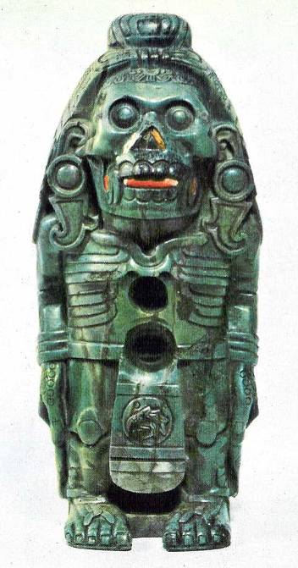 Fig. 3 This is the figurine referred to by Dr. Koslik in his introductory essay, reproduced there in black & white halftone. The listing for it in the Wurttemburgisches Landesmuseum, Stuttgart, identifies it as: “Skeletal figure, greenstone with inlaid shell, 22.8 x 12 cm”. 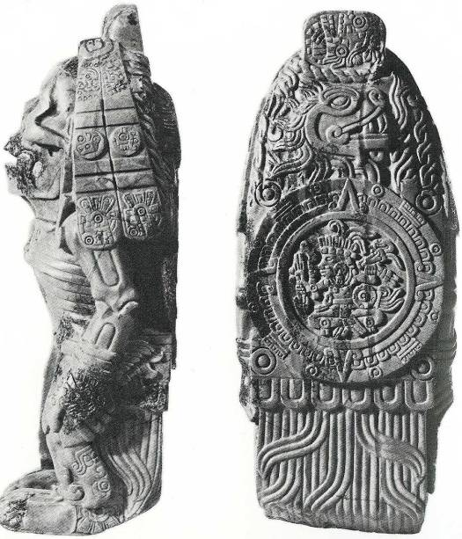 Fig. 4 Side and rear views of the same figurine, from Pasztory: Aztec Art, p. 258. In it, she says: “The Stuttgart figure belongs in the category of standing deity sculptures, but there is no exact parallel to it. Male skeletal gods are few in Aztec art and this figure does not resemble any of them: it stands with its arms hanging at its sides like the Atlantean figures at Tula and their Aztec copies. Its hair is tied in a topknot and two wide ribbons hang down at either side, ornamented with glyphs and symbols. Carved in relief on the back is an eagle in profile, with a sun disk at the center; in the disk sits a youthful warrior holding weapons, presumably the sun deity; on the base of the sculpture is the earth monster. The figure bears twelve glyphs on its hair ribbons, loincloth, hands, and back, but none of them identifies it conclusively: the dates I Deer, I Rain, I Monkey, and I House on the ribbons, and I Eagle on the loincloth, are all days on which the cihuate-teo, female monsters, descended at the crossroads. Seler identified the figure as Xolotl (1902-23, III, pp. 392-409), the deformed twin of Quetzalcoatl, but this is not a deformed figure. Seler's other interpretation was with Tlahuizcalpantecuhtli, the planet Venus in its manifestation as the evening star, and symbols of the night sky and the planet Venus can be seen on the hair ribbons and the forehead. The earplugs with comma-shaped pendants are Quetzalcoatl's usual insignia in the codices. “The sculpture may represent not a deity but a concept, expressed in part by the glyphs we cannot interpret. It is remarkable that of the twelve glyphs not one refers to an important date associated with Mexica power, such as I Flintknife. Moreover, while Quetzalcoatl is seen as a benevolent legendary ancestral figure on most Aztec monuments, here he is associated with symbols of destruction. The sun disk is on an eagle, which represents the setting sun; it is unclear whether the number 4 refers to the eagle or to the sun disk. But the skeletal figure signifies the underworld and the night sky; the glyphs of the descent of the cihuateteo represent impending disaster; the entire composition can be read as the death of the sun at night.” While a fascinating object, there are two additional problems with using it as evidence for Steiner’s stomach-excision thesis: it does not represent a human being, and it belongs to a culture-era at least 1,500 years later than the events referred to by him. 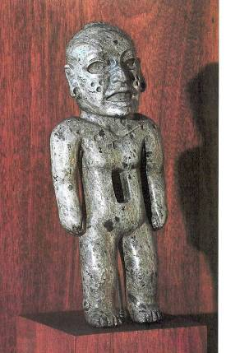 Fig. 5 While the noted double cavity of the Xolotl figure is unique, there is evidence that the very common single cavity belonging to a great variety of representations was used as a receptacle for a decorative inlay, as were the eyes and mouth, now lost on this figure, or for other kinds of ritual objects. This small piece derives from the much earlier Teotihuacan period (c. 100 – 700 AD). Its function and representational intent is unknown. 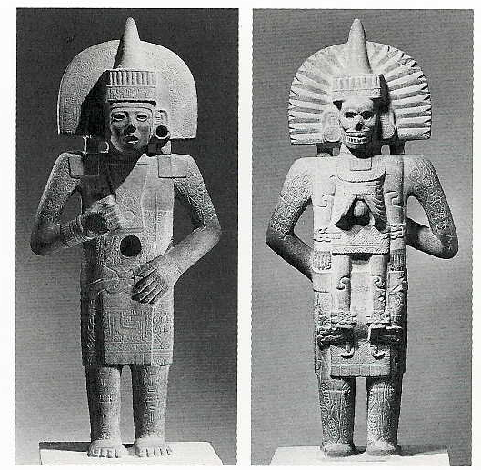 Fig. 6 Another figurine, shown if frontal and obverse views, this time from the early post-Classic (c. 1,000 AD) period Huastec culture of the Veracruz coast, showing a feature similar to the one proceeding. Its function and significance is also unknown. Such priest or deity-figures are suspected to have had mirrors inlaid in the central cavity. The death-forces of the Double are carried like a burden on his back by this possible initiate. 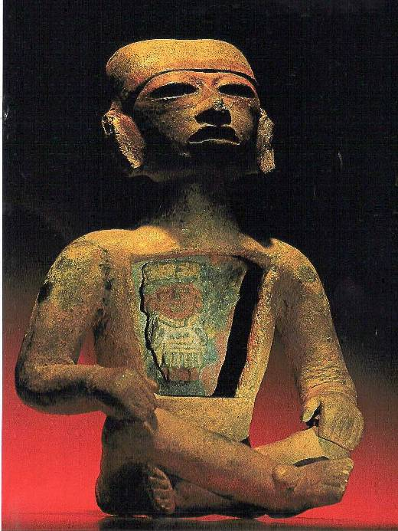 Fig. 7 From Teotihuacan. This figure with an open chest cavity does not appear to have sacrificial associations. Many figurines from this era open up even further to reveal entire families and colonies of miniature people residing within. 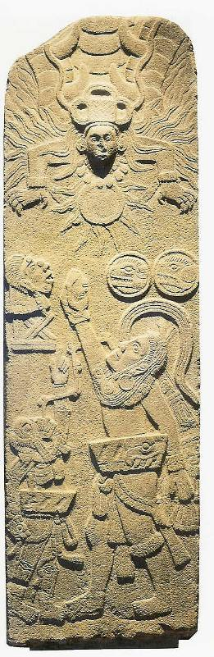 Fig. 8 Stela 3, from Bilbao, Guatemala, c. 600 A.D. A ballplayer and a death god, both in ballgame geaar, reach toward a scorpion sun to offer a human heart.” The Sun, undisputed icon of the source of life in European mythology, was for Mesoamerica an unmixed blessing. The light of the sun brings about separation into objects for what were subjects united in the spaceless darkness of Night. Many Europeans felt this also, for instance the German poet Novalis, who wrote his famous Hymns to the Night. Light enhances developmental processes of all sorts, usually ones that entail separation, and time to chart their courses. What begins must end, but what is united with Darkness is eternal, for before there was Light and Creation, all was enfolded within the womb of Darkness. But for the mode of objective existence we need the sun, so homage must be paid, and what is Ceasar’s must be rendered. Hence the bloody and continual rites necessary to placate a ravenous solar deity. Recent environmental developments connected with the depletion of the ozone layer have demonstrated the corrosive, even deadly, nature of solar radiation, a factor with which space travelers must contend in its full amplitude during times of solar flares. 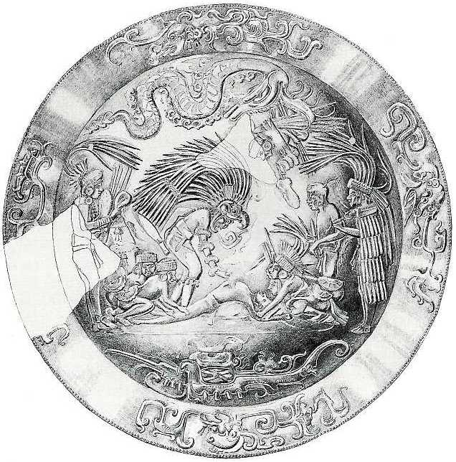 Fig. 9 Gold repousse disk dredged from the Sacred Cenote, Chichen Itza (Yucatan), dating from a period intermediate between the Teotihuacan and the Aztec, showing Toltec warriors using typical sacrificial technique in the waging of war against the Mayas. Note the writhing serpent overhead. 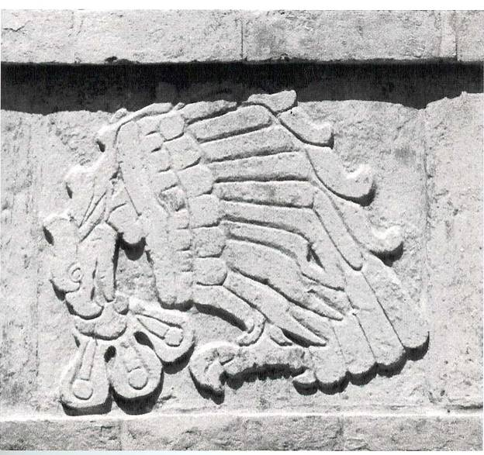 Fig. 10 Bas-relief of eagle eating heart from Pyramid B at Tula. Tula was the capital of the Toltec empire, c. 900 – 1200 AD, Valley of Mexico. 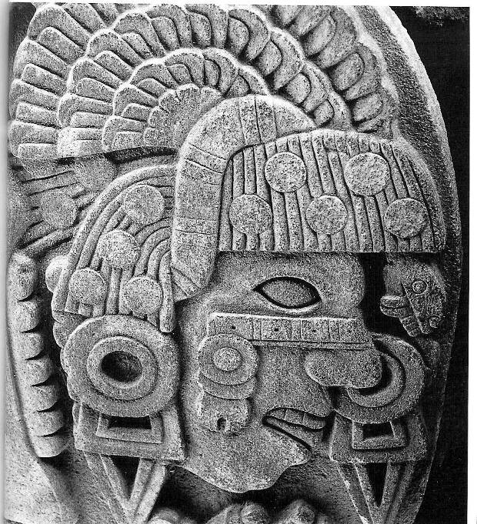 Fig. 11 Detail of Coyolxauhqui, adversary of Huitzilopochtli; see following plate. 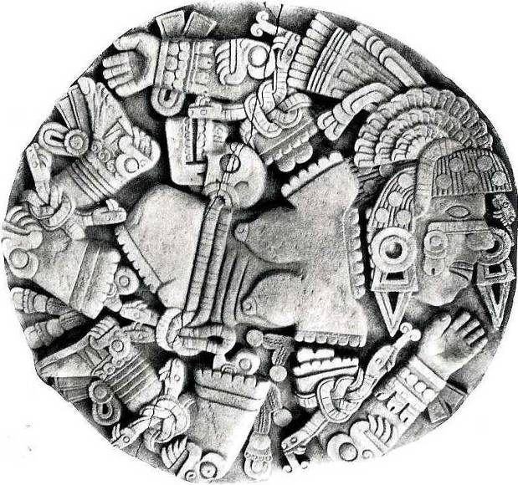 Fig. 12 Coyolxauhqui, Aztec; relief on stone disc, recovered from foot of Templo Mayor, Tenochtitlan. Diam. 3.3m. Dated from approx. 1469. Coyolxauhqui, as related in the origin-legend of Huitzilopochtli, was his evil sister, who tried to have him killed at birth. He, however, turned the tables on her and had her dismembered - as represented in this exceptional piece. The mutilated bodies of the ritual victims, sacrificed upon the crests of the pyramids, were cast down the temple steps to fall upon this stone, thus reenacting the foundation-myth. No doubt the resident population and visiting dignitaries were impressed. In the last major calendar-ending ceremony before the Spanish arrived to halt such proceedings, it is said that the number of victims dispatched was in the five figures, and this is not refuted by native accounts. 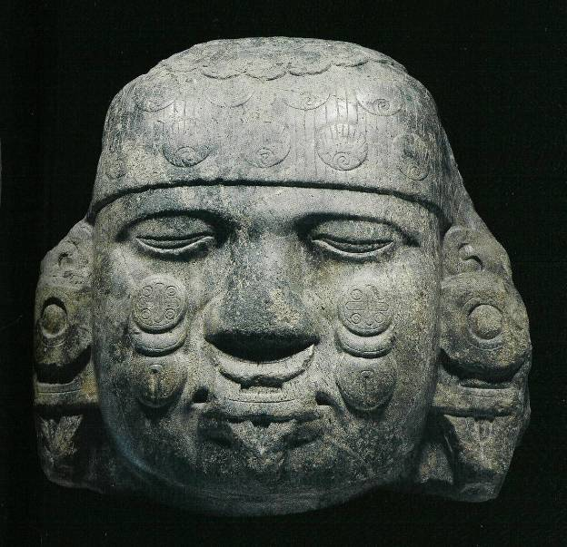 Fig. 13 Coyolxauhqui; greenstone, Aztec. The items on her cheeks represent bells, balls of down adorn her hair. Her nose-ornament is a common decorative element in Mesoamerica. 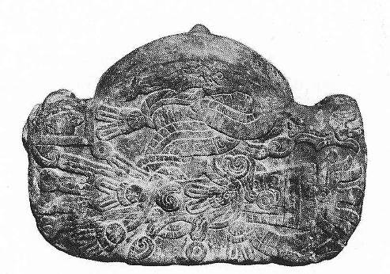 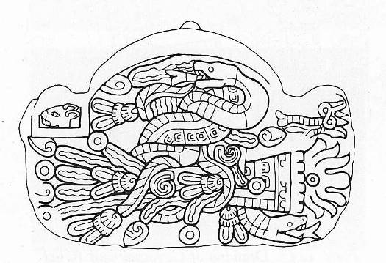 Figs. 14 & 15 Photograph and drawing of the underside of the Coyolxauhqui head of Fig. 13. The relief depicts two serpents intertwined with a stream of water, a stream of fire, and a rope with plumes. The glyph for 1 Rabbit is in the left corner. 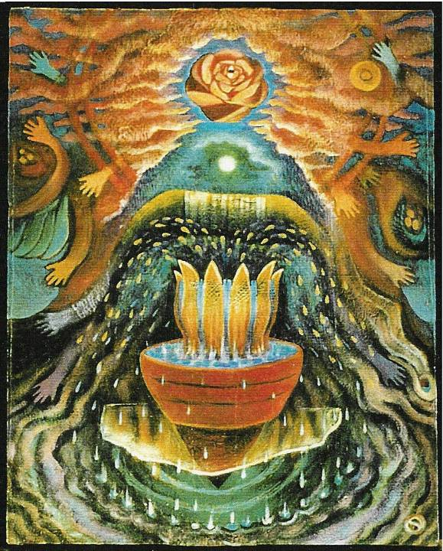 Fig. 16 Another perspective on the UnderWorld, by contemporary Santa Fe artist Susan Jay. In it, she depicts with startling fidelity, but without overt intent, the “watery mountain”, or altepetl, of the Nahua. The motif of the “magic mountain” is universal, and particularly common in Mesoamerica. 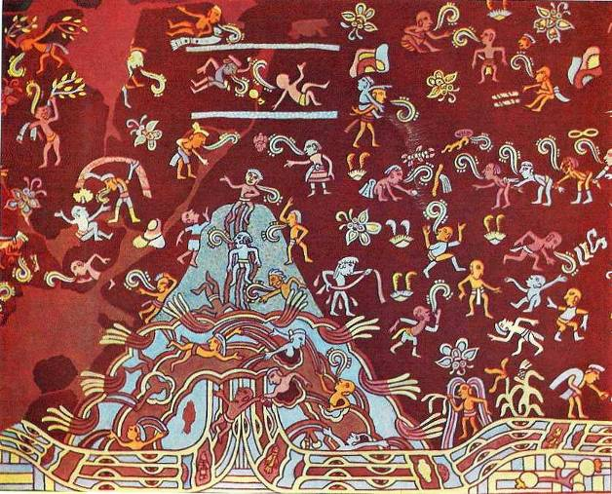 Fig 17 The fecund altepetl as depicted in a mural in Tepantitla, Teotihuacan, restored detail from the following image # 15. Note the unintended similarity of blessedness to the previous image. 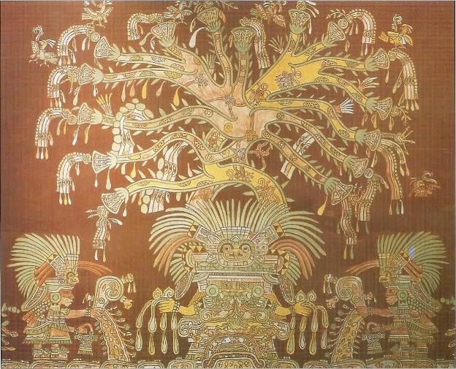 Fig. 18 The Great Goddess of Teotihuacan,Tepantitla barrio mura (reproduction, retouched), with Tree of Life growing from her head. Underneath, on the same wall, is the altepetl of Fig. 14. Small spiders populate the Tree. 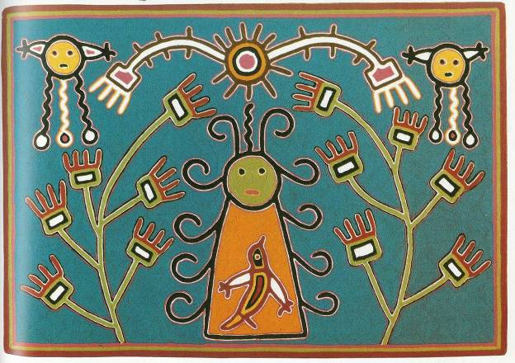 Fig. 19 Not all Mexican deities were devouring or imposing. A Huichol Corn Goddess, c. 20th C. Yarn Painting by Crescenio Perez Robles, Nayarit, Mexico 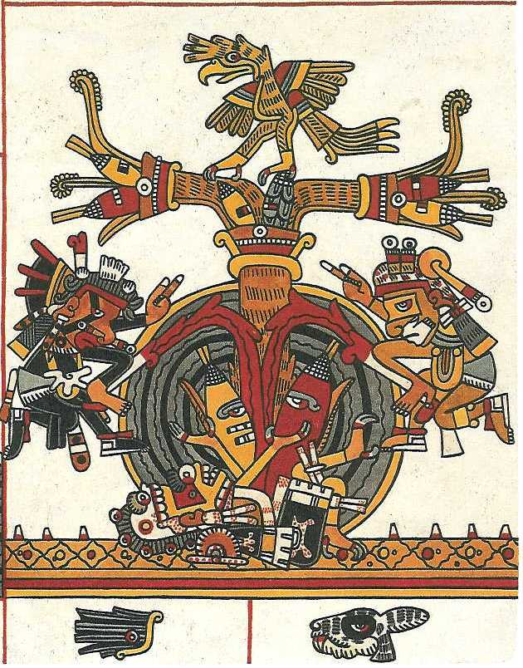 Fig. 20 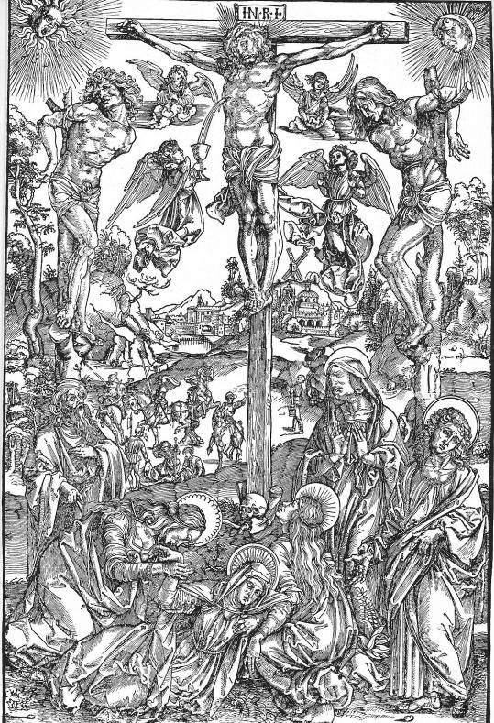 Fig. 21 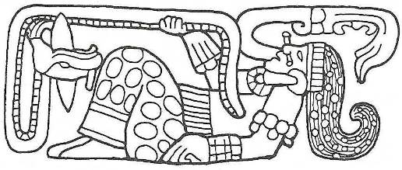 Fig. 22 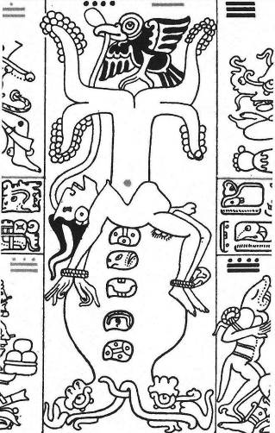 Fig. 23 Figs. 20 – 23 Of Fig. 20, Campbell has this to say: “Tree of the Middle Place. Painting from Codex Borgia, Mexico, c. A.D. 1500. Rising from the body of an earth goddess recumbent on the spines of the caiman, or alligator, of the abyss, the Tree, encircled by the World Sea, is surmounted by a quetzal bird of bright plumage. Two streams of blood pour into the goddess, and from her body rise two ears of maize, a yellow and a red. The gods in attendance are Ouetzalcoatl, the Feathered Serpent, god of the breath of life (of whom the quetzal bird is an attribute), and Macuilxochitl, known also as 5 Flowers, lord of the dance and music, and of play. Personifying the fertile earth, this goddess of life out of death is normally identified by a skull or skeletal jaw, which may be represented either as her head or as a kind of crown. She is known as the Maize Stalk Drinking Blood; also as 9 Grass. She is the mother of the gods and is in legend associated with a place called Skull'2 (that is, Place of the Skull). Compare Calvary (Latin calvaria, "skull"), also Golgotha (Aramaic gulgultha, "skull"), i.e. Place of the Skull. In Mesoamerican art generally, skulls, skeletal jaws, and skeletonization appear as symbols not simply of death, but of generation and fertility out of death. As noticed by Jill Leslie Furst, treating this goddess in a monograph entitled The Skull as Fertility Symbol: ‘The apparent contradiction between fertility, generation and rebirth on the one hand and bones on the other is in fact perfectly comprehensible in the context of general Native Mesoamerican ideology, in which the skeletal remains were-and in fact, here and there continue to be-regarded as the seat of the essential life force and the metaphorical seed from which the individual, whether human, animal, or plant, is reborn.’ ” – p. 36. For Fig. 21, note that Durer is faithful to the meaning of “Golgotha” and that he faithfully indicates this in exactly the same fashion as our anonymous Mexican artist. Durer is known to have been profoundly impressed and affected by the items brought back and put on display by the returnees from the New World expeditions, but his theology remained devoutly orthodox. One difference between this and the previous image is that in the former, blood is shed onto the Tree, on the latter, blood is shed from the Tree. Could the lance be related to the Xiuhcoatl? Figs. 22 & 23: more vignettes on the same theme, which is very common, not esoteric, in Mesoamerican mythology. The births are mystical and world-creating. 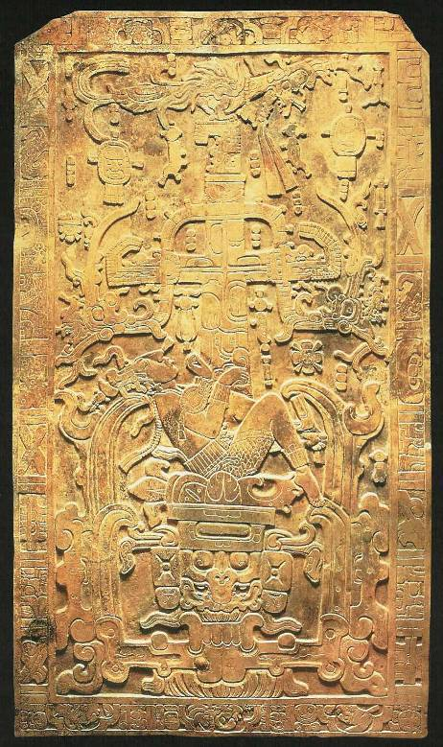 Fig. 24 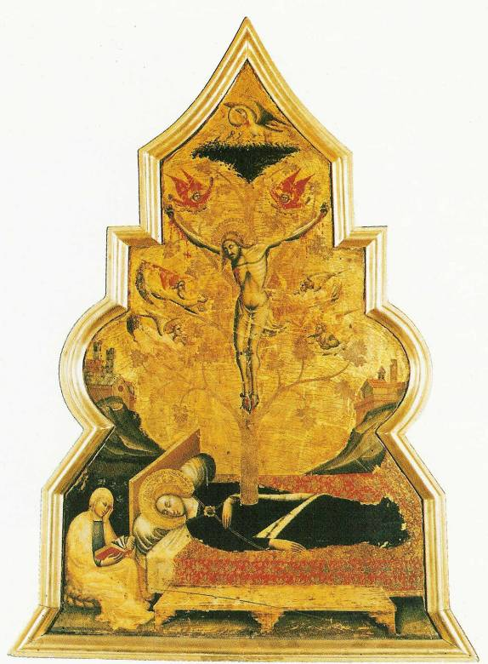 Fig. 25 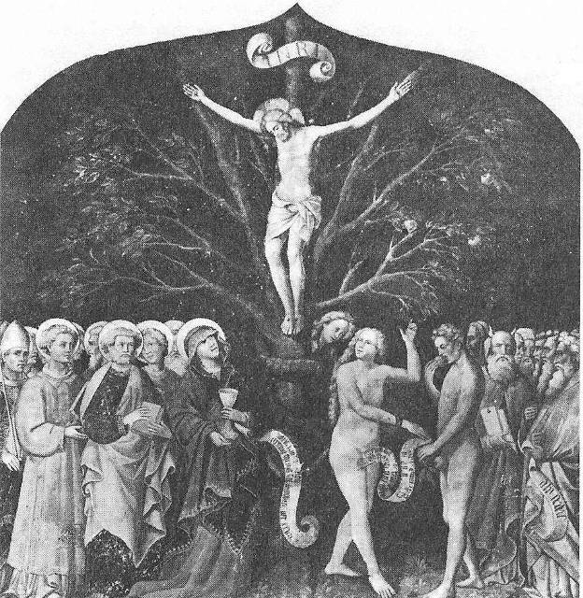 Fig. 26 Figs. 24 - 26 Trees of Death, Trees of Life. Fig. 24 -The lid to Lord Pacal’s sarcophagus - depicts his descent to the UnderWorld and simultaneous rebirth as the Mayan World-Tree. It is the contention of this piece that whether before or after the time and deed of Christ, the Mesoamerican shamans participated in this archetypal metamorphosis. More on this throughout American Chapters. In Fig. 25 note the bird - as in Figs. 20, 23, & 24 - a pelican, drawing blood from its breast, perched at the top of the tree, rising from the Virgin Mother of the World. In Fig. 26, note that the serpent has been invited to the party, as it is also in Figs. 23 & 24. 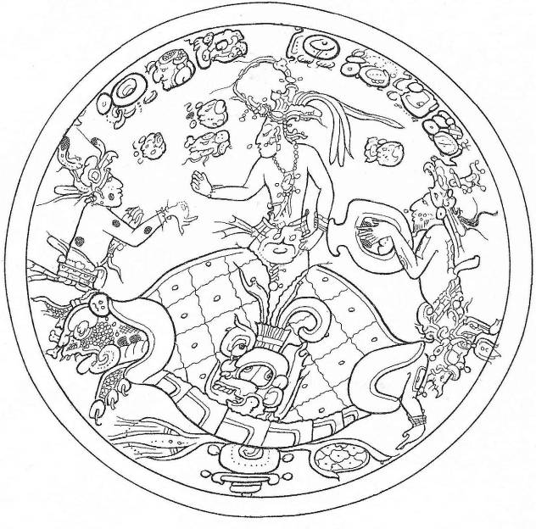 Fig. 27 The Maize God emerges reborn from the carapace of a turtle. North America is known as “Turtle Island” by indigenous people. It is likely that the Maize God is the American depiction of the ever-rising Christ. Fig. 28 is a fine example of the Maize God from Classical Mayan Copan. 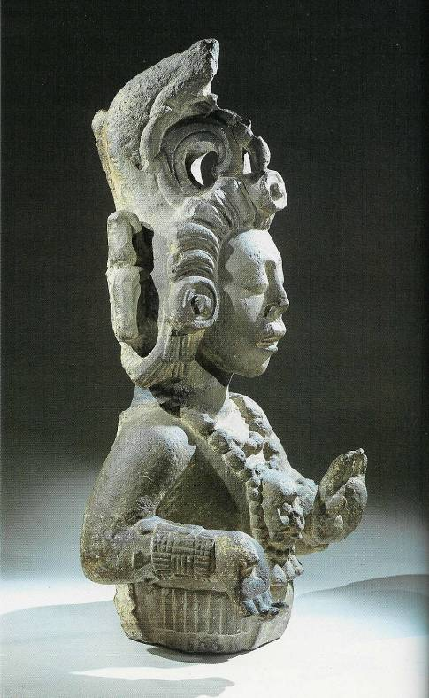 Fig. 28 Rudolf Steiner’s lectures on Mesoamerican practices: the “Mexican Mysteries” The Influence of Luciferic and Ahrimanic Beings on Historical Development. The Clear Perception of the Sensory World and Free Imaginations as the Task of Our Time. Genghis Khan and the Discovery of America Dornach, September 17, 1916 Yesterday, we tried to characterize the forces that permeated Greece and Rome in order to obtain an idea of the influences that have been carried over from the fourth into the fifth post-Atlantean age, and we gave some indication of where we have to look today for signs of continued activity of the forces of the fourth post-Atlantean age. I want to ask you now to turn your attention once again to our description of the civilizations of Greece and Rome. In the way it developed, the civilization of Greece was a source of great disappointment to the luciferic powers. One can, of course, only say these things out of imaginative cognition, and this will also be true of what is to be presented to you today. The development of Greek civilization was a great disappointment to the luciferic powers because they expected something quite different from it. Think what this means. They had expected the civilization of Greece, the fourth epoch of post-Atlantean times, to bring into being for them all they had striven for during Atlantean times. On Atlantis they had developed certain activities, certain influences and forces and they had expected to see the fruits of their labors appear in the fourth post-Atlantean epoch. What was it they were really looking for? To speak of such a matter lets us look right into the luciferic soul. We come to know this luciferic life that continually strives, hoping that certain results may ensue, but that continually meets with fresh disappointment. A logician would naturally ask, “Why do not these luciferic powers stop trying? Why do they not see that they must be forever and repeatedly disappointed?” Such a conclusion would be human, not luciferic, wisdom. At any rate, the luciferic powers have yet to come to his conclusion. On the contrary, it is their practice to redouble their efforts whenever they experience disappointment. What was it, then, that the luciferic powers expected from this fourth post-Atlantean age? They wanted to obtain mastery of all the soul forces of the Greek people, those soul forces that were, as we have seen, directed to carrying over the ancient imaginations of the Chaldean-Egyptian period, and to incorporate them into the creations of their own fantasy. The luciferic powers made it their endeavor to work so strongly on the human beings of the Greek civilization that their imaginations, refined and distilled to fantasy, should fill their whole being. The Greeks would then have lost themselves in a soul world, in an everyday thinking, feeling and willing that would have consisted entirely of those subtle imaginations that had become complete fantasy. If the Greeks had developed nothing in their souls but these imaginations refined to fantasy, if these enticing imaginations had come to fill their souls completely, the luciferic powers would have been able to lift the Greeks and a great part of humanity out of human evolution to place them in their own luciferic world. This was the intention of the luciferic powers. From the Atlantean epoch on, it had been their hope to achieve in the fourth post-Atlantean age what they had failed to do in Atlantis. Humanity, at the stage it had then reached, would have been incorporated into the cosmos. They wanted nothing less than to create for themselves a separate world were earthly gravity did not exist but were human beings would dwell with absolute supersensible lightness, entirely given up to a life of fantasy. It was the hope of the luciferic beings to create a planetary body, which would contain those members of humanity who had reached this highest development of the fantasy life. They made every endeavor to lead the souls of the Greeks away from the earth. Had they succeeded, these souls would gradually have forsaken the earth. The bodies that still came to birth would have been degenerate. Egoless beings would have been born, the earth would have fallen into decadence and a special luciferic kingdom would have begun. This did not come to pass. Why? This condition did not come about because, mingled with the “self-deifying madness” of Greek poetry, to quote Plato, was the genius and greatness of Greek philosophy and wisdom. The Greek philosophers - Heraclitus, Thales, Anaximenes, Anaximander, Parmenides, Socrates, Plato and Aristotle - saved Greek civilization from being completely spiritualized in a life of fantasy. They kept the Greeks on earth, providing the strongest forces that kept Greece within earthly evolution. In considering the course of history, we must always take into account the forces that lie behind physical reality and are the true causes of all that happens. It was, then, in this way that Greece was preserved for earthly evolution. Now, the luciferic beings would have been unable to achieve anything at all without the help of the ahrimanic beings. In all their intentions and hope they reckoned on their support. Indeed, it must always be that two forces strive together in this kind of working. Just as the luciferic beings were disappointed in Greece, so were the ahrimanic beings disappointed in Rome and the way it developed. The luciferic beings wanted to lead Grecian souls away from the earth-planet and the ahrimanic beings wanted to contribute their efforts to the end that the Roman civilization would assume a particular form. The ahrimanic beings exerted their strongest efforts in Rome, just as the luciferic beings did in Greece. They calculated that a certain hardening would arise on earth brought about by an entirely blind obedience and subjection to Rome. What did the ahrimanic powers want to accomplish in Rome? They wanted to establish a Roman Empire that would extend over the whole of the then known world, embracing within it every human activity. It would be directed entirely from Rome with the strictest centralization and the utmost development of the rule of might. They sought to establish a widely flung state machinery that would include and make subject to it all religious and artistic life. Its goal would be to stamp out all individuality. Every people and human being would comprise merely some small part of this mighty state machine. Thanks to the clarity of its philosophers, however, Greece was not lulled into the luciferic dream, nor could Rome be hardened as these ahrimanic powers desired, because in Rome, too, something was working against them. This was described in the last lecture as Roman ideals, but the legal, political and military ideals that were then developing could not have withstood Ahriman alone. Within the Roman civilization the ahrimanic powers gathered for a stupendous onslaught. That attempt was like a repetition of their attempt made in Atlantean times, and it developed infinitely strong powers and forces. It was only from another side that Ahriman's intention was hindered. It was, at first, prevented by something that, at first sight, might be regarded as a lower trait in the Roman character, but that was not the case. As a matter of fact, the Romans had need of what I may have seemed to describe in the last lecture with some antipathy. They needed their ruthlessness, stubborn egoism, that continuous stirring up of emotions, to be able to march against the ahrimanic powers. Roman history - I beg you expressly to note this - is not a revelation of the ahrimanic powers. Although they stand in the background, it is a fight against them. If it is all confused and self-seeking, seeming to tend more and more toward a politicalization of the whole world, it is because only in this way could Ahriman's mechanizing be resisted. All this alone, however, would not have been of much avail. Rome had also received Christianity, which in Rome would have assumed a form that would have given Ahriman a splendid opportunity to achieve his aim since, through the spiritual decline of a Roman rule that had been transformed into a papacy, the mechanizing of culture could have been accomplished. So another external power had to be brought against Ahriman, who works with much more external means than Lucifer. Ahriman, as we have seen, diverted the forces of Christianity to his own service. Another power had to be brought against him. This was the onslaught of the Germanic tribes caused by the migration of peoples in Europe. Through this onslaught on Rome, the mechanizing of the world under a single, all-embracing Roman Empire was hindered. If you will study all that took place in the migration of these peoples, you will find that you can get a true insight into it when you see it from this point of view. Whenever the migration of peoples occurs in the Roman world, Roman history is not thereby brought to an end, but the ahrimanic powers, combated throughout their history by the Romans, are repelled. Thus did Ahriman meet with his disappointment, as Lucifer had met with his. But they will take up their tasks again in the fifth post-Atlantean age with all the more determination. Here is the point at which we must gain an understanding of the forces that are operative in our age, insofar as such an understanding is possible today. The fourth post-Atlantean age extends both backwards and forwards from its central point in 333 A.D. It ended about 1413 A.D. and it began about 747 B.C. These are of course, approximate dates. I have just told you that the disappointment of Lucifer and Ahriman in the forms the Greek and Roman civilizations had assumed, has led them to make still stronger efforts in our fifth post-Atlantean age. Their efforts are already at work in the human forces that have been active from the fifteenth century. It does not matter whether something occurs a few decades earlier or later. In outer physical reality, which takes on the form of the “great illusion,” things are sometimes misplaced. The fact that the Roman civilization could be retained in the evolution of humanity as it was due to the events brought about by the migrations of the peoples. If Rome had developed in such a way that a great all-embracing mechanized empire had arisen, it would only have been habitable for egoless human beings who would have remained on earth after Lucifer had drawn out their souls on the path of Greek culture and art. You see how Ahriman and Lucifer work together. Lucifer wants to take men's souls away and found a planet with them of his own. Ahriman has to help him. While Lucifer sucks the juice out of the lemon, as it were, Ahriman presses it out, thereby hardening what remains. This is what he tried to do to the civilization of Rome. Here we have an important cosmic process going on - all due to the intention and resolve of luciferic and ahrimanic powers. As I have said, they were disappointed. They have continued their efforts, however, and our fifth post-Atlantean age has yet to learn how strong these attacks are. They are now only beginning but they will become stronger and stronger. This age must learn, too, that the necessity to understand these attacks will become ever greater. At the beginning of an age the backward beings cannot work strongly. As yet, we are only in the beginning, and even though it became manifest only later, the luciferic and ahrimanic powers began to exert their forces before the expiration of the fourth post-Atlantean age. To understand how these powers work in the fifth post-Atlantean age, we must turn our attention for a moment to what is intended for man in the right and normal course of his evolution. It is rightfully intended that he shall take a further step forward. The step taken by humanity in the fourth post-Atlantean age is revealed in the culture of the Greeks and in the political development of the Romans, and it was through the battle with Lucifer and Ahriman that what was intended actually came about. These opposing forces are always such that they fit into the progressive plan of the world. They belong to it and are needed there as opposing forces. But what special qualities are the men of the fifth post-Atlantean age, our own, to develop? We know that this is the age of the development of the consciousness soul and that, to accomplish this, a number of forces - soul and bodily forces - must be active. First, a clear perception of the sense world is necessary. This did not exist in earlier times because, as you know, a visionary, imaginative element continuously played into the human soul. The Greeks still possessed fantasy but, as we have seen, after fantasy and imagination had taken possession of humanity, as it did of the Greeks, it then became necessary for men to develop the faculty to see the world of external nature without the illumination of a vision standing behind it. We need not imagine that such a vision has to be a materialistic one. That point of view is itself an ahrimanically perverted perception of sense reality. As indicated before, observation of sense reality is one task incumbent upon the human soul in our fifth post-Atlantean age. The other task is to unfold free imaginations side by side with the clear view of reality - in a way, a kind of repetition of the Egypto-Chaldean age. To date, humanity has not progressed too far in this task. Free imaginations as sought through spiritual science means imaginations not as they were in the third post-Atlantean age, but unfettered and undistilled into fantasy. It means imaginations in which man moves as freely as he does only in his intellect. That, then, is the other task of the fifth post-Atlantean age. The unfoldment of these two faculties will lead to a right development of the consciousness soul in our present epoch. Goethe had a beautiful understanding of this clear perception, which, contrary to the materialistic point of view, he described as his “primal phenomenon” (Urphänomen). You will find that this has been dealt with at length in Goethe's writings, and I have spoken of it in my explanation of the primal phenomenon. His is a clear, pure perception of reality and of his primal phenomenon. Goethe not only gave the first impulse for perceptions free of any visions but also for free imaginations.* What he has given us in his Faust, even though it has not yet gone far in the direction of spiritual science, and in comparison with spiritual science is still more or less instinctive, is nevertheless the first impulse to a free imaginative life. It is no mere world of fantasy, yet we have seen how deep this world of fantasy really is that develops in free imaginations in the wonderful drama, Faust. (This distinction between pure perception free of memory pictures and visions on the one hand and an objective imagination which begins with brain-free thinking on the other is developed in Boundaries of Natural Science, Anthroposophic Press, 1983) So, over against this primal phenomenon, we have what Goethe calls typical intellectual perception. You will find it described in detail in my book, The Riddle of Man. This mode of thought must continue to develop. The men of the fifth post-Atlantean epoch, however, must not merely behold reality. They must be able to live with reality. They must get busy, like Goethe, and, working in quite a different way from that of the materialistic physicists, really make such use of their laboratory apparatus that it produces the primal phenomenon for them. They will then have to devise some way of getting the primal phenomenon into practical life. As you know, it is at home in, and holds sway throughout, nature. The intentions of humanity that come from free imaginations will have to be included in this primal phenomenon of nature. On the one hand, men will have to direct their gaze quite selflessly to the outer world to work in it and to gain knowledge of it. On the other, by powerful application of their personalities, they will have to bring it all into inner movement in order to find the imaginations for outer activity and outer knowledge. Gradually, the consciousness soul and its culture will achieve this transformation. There will certainly be onesidedness in this cultural epoch. That goes without saying. Our cognition will direct its efforts only outwards, as in Bacon, or only inwards, as in Berkeley. We have already spoken of this. The imaginative life welling up from within will not unfold without all manner of disturbing influences. But even now we can point to moments in this development when someone feels this free imaginative life springing up in his soul. In these beginnings it is still in great measure unfree, but we may see how so significant a man as Jacob Boehme, quite soon after the fifth post-Atlantean age began, felt how it was trying to develop in his soul. He brought this to expression in his Aurora, and we can feel as we read it how imaginative life was working within him. It must become free; Boehme still feels it to be a little unfree. Nevertheless, he knew it was a divine creative thing that was working in him. So Boehme was, in a sense, at the opposite pole to Bacon, whose endeavor always directed his attention to the external world. Jacob Boehme, however, was entirely engrossed in the world within, and described this world beautifully in the Aurora: “I declare before God,” he says because he is speaking of his inner soul, “that I do not know how it comes to pass in me.” He means by this how the imaginations arise in him. “Without feeling the impulse of the will, I also don't know what I have to write.” This is how Boehme speaks of the uprising of imaginations in himself. He detects the beginning of forces that must grow continually stronger in the men of the fifth post-Atlantean age. “I declare before God that I do not know how it comes to pass in me. Without feeling the impulse of the will, I also don't know what I have to write. The spirit dictates to me in a great and marvelous knowledge what I write, so that often I do not know whether I am in this world with my spirit, and I rejoice exceedingly that sure and continuous knowledge is thus vouchsafed to me.” Boehme describes the instreaming of the imaginative world. We can see that he feels harmony and rest in his soul, and he describes how men's souls shall, in the normal and right progress of their evolution, let themselves be taken hold of by these inner forces, which are to grow stronger in them in the fifth post-Atlantean age. But one must take possession of them in the pure inner being of the spirit and thereby avoid devious paths. In the seventeenth century one had to speak of these forces much in the way that Boehme, who spoke as a man completely and utterly devoted to divine righteousness, did. The entire aim in the work of the luciferic and ahrimanic powers in the fifth post-Atlantean age, concerning both the perception of the primal phenomenon and the development of free imaginations, is to hinder these forces from arising in man. The luciferic and ahrimanic powers are working in this fifth post-Atlantean age to disturb these forces in the human soul, to employ them to a wrong end, thus bringing men's souls out of the earth sphere to establish a new sphere of their own. Many things must work together to disturb the right, quiet and slow unfolding of these forces. Note well that I say the quiet and slow unfolding because the entire period of 2,160 years, starting in 1413 A.D., should be used for the gradual unfoldment of the forces I have named, that is, free imaginations and the gradual development of working with primal phenomena. At intervals - by fits and starts, as it were - the luciferic and ahrimanic powers throw the whole weight of their opposition against this right evolution. When we bear in mind that everything is prepared for by the world beyond the earth long before it happens, we shall then not be surprised to find preparations being made to bring the strongest possible forces of opposition against the normal evolution of humanity. We have already seen how the luciferic and ahrimanic powers poured what they had developed in Atlantean times into Greece and Rome. Now, in an altered form, they have tried to repeat these efforts before the arrival of the fifth post-Atlantean age. You will not be surprised when I say that for this fifth post-Atlantean age, too, a powerful impetus had to be present bearing along with it the after workings, in a luciferic and ahrimanic sense, from Atlantis. We know that the Atlantean influences spread out from a region that was called Atlantis even by Plato. Let us make a diagram and imagine Atlantis here, then over here on the right would be Europe and Asia, and here on the left would be America. The old Atlantean forces, including the old luciferic and ahrimanic forces, spread out from Atlantis. Some part of these Atlantean forces, however, was held back, and it came to work in our fifth post-Atlantean age as luciferic and ahrimanic forces. That is, some part of the good forces, which were good and right in Atlantean times, have been carried over to our time to become luciferic and ahrimanic forces. Only the center was transferred to another region. Atlantis, as we know, is gone and the center transposed to Asia. You must imagine it on the reverse side of my drawing and the effects of the old Atlantean culture spreading out from it as a preparation for the fifth post-Atlantean age. Its intent was to lucifericize and ahrimanicize it. It was actually the descendants of the old Atlantean teachers who were now working from a place in Asia. A priest there had been educated to behold - to have a belated vision, as it were, of what the Atlanteans called the “Great Spirit,” and to receive his commands. These the priest communicated to a young man of remarkable energy and strength who, by virtue of this authority, received the name “The Great Ruler of the Earth” from his community. This was Genghis Khan. The Great Spirit, through his follower and through that priest, gave to Genghis Khan the command to summon all the powers of Asia to spread the influence that would lead the fifth post-Atlantean age back into a luciferic form. These forces - and they were far more powerful than the forces established in Greek culture - were all employed to this end. Free imaginations were to be changed into old, visionary imaginations. Every effort was to be made to lull the soul of man to sleep in a dim and dreamy experience of imaginations instead of a free experience filled through and through with clear understanding. With the help of the special forces that had been preserved from Atlantis, it was the intended purpose to carry an influence into the West that would make its culture visionary. Then it would have become possible to separate the souls of men from the earth and to form a new continent, a new planetary body with them. All the unrest and disturbance that came into the evolution of modern man through the Mongolian invasions, everything connected with them that has gone on working into the fifth post-Atlantean epoch - all this unrest, which was prepared long ago, is nothing more than the great attempt that is being made from Asia to bring about a visionary European culture. It would cut it off from the conditions of its further evolution and lead it altogether away from the earth, just as the East has experienced again and again this feeling of being filled with vision and of wanting to be estranged from the earth. Something was needed to counterbalance this tendency. An opposite trend had to be created as a counterforce that moves in the direction of the normal evolution of mankind. The influence of Genghis Khan's priest was intended to bring about a kind of buoyancy and lightness in the human race that would draw man away from the earth. Over against this, a corresponding heaviness had to come to man from the weight of the earth; this was provided through the discovery of the western world. America, with all that it holds, was discovered and thereby earth heaviness, the desire to remain on earth, was given to man. The discovery of America and everything connected with it, and the way man carried his life into the many new places of the earth, all this, when seen in wider connections, shows itself as a counterbalancing force to the activity of Genghis Khan. America had to be discovered so that man might be brought to grow closer to the earth, to grow more and more materialistic. Man needed weight and heaviness to counterbalance the spiritualization that was the aim of the descendants of the “Great Spirit.” Along with this normal process whereby the scene of action of man's life was extended to America, we find the other forces, the ahrimanic powers of the “Great Spirit,” intervening again. An influence came from America to Europe, and another came to permeate America from Asia. Thus, normal forces developed through the discovery of America and also powerful ahrimanic onslaughts. They worked less strongly at first, but will continue to work in our time and on into the future. We must learn to recognize these ahrimanic forces. What Rome had achieved in the Church and in the ecclesiastical state was grasped by the ahrimanic influence. While it is comparatively easy to see how the luciferic influence worked on Genghis Khan - we have exact knowledge of the fact that a priest was initiated by the follower of the “Great Spirit” — it is much more difficult to say how the ahrimanic spirit worked. This is because the ahrimanic influence is dispersed and scattered. But you need only study how Spain, strictly Roman Catholic as it was, was fascinated by all the treasures of gold that were discovered in America. What a hold it had upon her! You can observe how strong the specter-like working of the old Romanism still was in such a ruler as Ferdinand of Castile or Charles V, the ruler of the kingdom over which the “sun never set.” Study the reaction of Europe to the gradual discovery and opening up of America and you will see what temptations came from that direction. Taken all in all, it is a history of temptation woven in with a history that runs a normal course. Please do not go about saying that I have presented the discovery of America as an ahrimanic deed. In reality, I have said the very opposite. I have said that America had to be discovered and that the entire event was necessary to the progress of the world. Ahrimanic forces entered, however, and set themselves in violent opposition to what was happening quite rightly in the normal course of progress. Things are not so simple that we can say, “There is Lucifer, and there is Ahriman; they act and behave in such and such a way, and divide the world between them.” Things are by no means so simple as that. We find, therefore, many forces working together when we set out to listen to them in their field of action behind the physical plane. These forces take possession of other forces. They try to seize the forces in man that have continued on from the fourth post-Atlantean epoch in order to distort them and make them serve their ends. Look at a man like Machiavelli. You will find in him the symbol for the politicizing of thought that begins in the Renaissance. He is a veritable revelation of the whole process. He was a great and powerful spirit but one who, under the onslaught of the forces of which I have told you, brings to a new life again the complete attitude of thought and mind that has its source in the heathen Rome of ancient times. You have a true picture of Machiavelli when you study the history of his time and see him, not as a single personality, but as the outstanding expression of many who think in the same way. In him you can observe these forces trying to charge forward with all speed, bringing to their assistance the atavistic - and thus luciferic - forces that have been left behind. Had things gone as Machiavelli intended, all of Europe would have become nothing but a political machine. Opposing the violent onslaught of such forces are the forces that work in the normal direction. Over against a figure like Machiavelli, who was purely political and turned all man's thought into political thinking, we can place another great figure, Thomas à Kempis, who was also Machiavelli's contemporary. He stands entirely within the slow and gradual evolution, working slowly and gradually. He was anything but a man of politics. So we can follow the several streams in history. We shall find normal streams, and we shall also find currents that flow from earlier times and are made use of by the forces of which I have told you. Many forces work together in history and it is important to observe and study their connections. A man like Jacob Boehme felt free imaginations rising within him. We can say of such a man that he fortified himself against the attacks of Lucifer and Ahriman through the whole character of his life of soul and succeeded in going undisturbed along the straight path of evolution. East of Europe, however, in all the culture of the East, we find an untold number of people who suffer greatly under the disturbing influence of Lucifer. His influence is, as we know, to draw man again and again away from the earth, to draw him right out of his physical body so that the shall perpetually fall into a state where he becomes no more than a vision of himself and is completely soul. That is the tendency that has been grafted onto Eastern Europe. The feeling of being drawn in the other direction was given to the West. The world of imagination was pulled down into the heavy physical body so that what should rightly be free imagination working merely in the soul becomes instead something that rams the soul down into the organism, thereby causing the organism also to live on imaginations. You can hardly find a more telling description of what I mean than in the words of Alfred de Musset in which he attempts to give us a picture of the condition of his soul. De Musset is one who feels the presence of the imaginative life in himself, but the also feels the onslaught upon this life of imagination that seeks to thrust it right down into the bodily nature. This life of imagination, which does not belong in the bodily nature but should develop freely, hovering in and existing purely as a thing of the soul, is there taken hold of by earthly gravity and by what belongs to the body. In his book, Elle et Lui, which he was led to write from his relation with Georges Sand, you will find a fine description of his soul life. I would like to quote here a passage that will serve to show how he feels himself to be placed within an imaginative life that is the scene of conflict and dispute. He says: Creation disturbs and bewilders me; it sets me trembling. Execution, always too slow for my desire, starts my heart beating wildly. Weeping, and restraining myself with difficulty from crying out, I give birth to an idea. In the moment of its birth it intoxicates me, but next morning it fills me with loathing. If I try to modify and change it, it only gets worse and escapes me altogether. It would be better for me to forget it and wait for another. But now this other comes upon me in such bewilderment and in such boundless dimensions that my poor being cannot grasp it. It oppress me, tortures me, until it can be realized. Then come the other sufferings, the birth throes, really physical pains that I am quite unable to define. Such is my life when I let myself be ruled by this giant artist who is in me. Note the contrast with Boehme, who feels the God in him. With de Musset it is a giant artist. “I were better that I live as I have resolved, committing excesses of very kind in order to kill this gnawing worn, which others modestly call inspiration and I quite often openly call illness.” Almost every single sentence of this quote can be matched with a sentence in our quotation from Boehme. How singularly typical! Remember what I said just now, that normal evolution seeks to progress slowly. We shall have more to say about this tomorrow. Here, as described by de Musset, it is a Wild charge; it cannot be fast enough. The picture he gives us as he surveys himself is marvelous. “Creation disturbs and bewilders me; it sets me atremble,” he says, because this to will go faster and faster and comes storming in upon him from the ahrimanic side, disturbing what is still trying to progress slowly. “Execution, always too slow for my desire, starts my heart beating wildly.” Here you have the whole psychology of the man who wants to live in free imaginations and is distressed and vexed by the onslaught of ahrimanic forces. “Weeping and restraining myself with difficult from crying out...” Think of it! The imaginations work so physically in him that he feels like crying out when they find expression in him. “I give birth to an idea. In the moment of its birth it intoxicates me, but next morning it fills me with loathing.” This because it comes from his organism and not from his soul! “If I try to modify and change it, it only gets worse and escapes me altogether. Better I forget it and wait for another.” Here he wants perpetually to go faster, faster than normal evolution can go. “But now this other comes upon me in such bewilderment and in such boundless dimensions that my poor being cannot grasp it. It oppresses me, tortures me, until it can be realized. Then come the other sufferings, the birth throes, actual physical pains that I am quite unable to define.” Then, when he beholds this giant artist that works within him, he says he would rather follow the life he has marked out for himself; that is, have nothing to do with this whole imaginative world, because he calls it an illness. Now take by way of contrast, the saying of Jacob Boehme, “I declare before God, I myself do not know how it comes to pass in me.” Here you have an expression of joy and bliss. Confusion and bewilderment, on the other hand, can be heard in the words of de Musset, “Creation disturbs and bewilders me; it sets me trembling. Execution, always too slow for my desire, starts my heart beating wildly.” With Boehme all is of the soul and, when he wants to write, he does not feel as though a giant artist, who makes him unhappy, were dictating to him, but a spirit. He feels that he is transported into the world where the spirit dictates to him. He is in this world and he is supremely happy to be there because a continuous stream of knowledge is given him that flows slowly and steadily on. Boehme is inclined to receive this slow stream of knowledge. He does not find it too slow because he is not overwhelmed by the swift attacking force I have described to you. On the contrary, he is protected from it. If time permitted, we could present many more instances of ways in which individual human beings are situated in the world process. The examples I have selected are from those whose names have been preserved in history but, in a sense, all of mankind is subject to these same conditions in one way or another. I have only chosen these particular examples in order to express what is really widespread, and by taking special cases I have been able to give you a description of it in words. If you will try to make a survey of what we have been saying, you will then be able to understand much of what has come about in the course of evolution. It would be quite possible in this connection to study many other phenomena of life. If, however, we confine ourselves today to the spiritual life, and moreover to that special region of the spiritual life comprising knowledge and cognition, we shall be able to find in it qualities that are characteristic of modern man, the recognition of which will make many things in life comprehensible. Since it is not possible to say much about the external life of today, owing to the existing prejudices and because men's souls are so deeply bound up with the conditions of the times in which they live, you will readily understand that it is only in a limited way that I can speak of the things that are carrying their influence right into the immediate present. It cannot be otherwise, as I have frequently made clear to you. I would like, however, to indicate certain phenomena of our time that are less calculated to arouse passions and emotions. Let me describe some phenomena that I will select from the life of cognition and feeling. I think you will find them underlying all I have been saying about the forces at work in this fifth post-Atlantean epoch. We will first consider these phenomena in a purely historical way in order afterward to see their relation to these forces. Let us take first a phenomenon in which we all necessarily feel the deepest interest. The kind of understanding men have of the nature and being of Christ is of great significance, and so we will select examples of various kinds of understanding of His nature and being that lie near at hand. We have first of all a modern instance in Ernest Renan's The Life of Jesus, which appeared in the 19th century and went rapidly through many editions. I believe the twentieth appeared in 1900 after his death. Then we have The Life of Jesus, which is really no life of Jesus at all, by David Friedrich Strauss. Then we have - we cannot say, a life of Jesus, but coming from the east of Europe it is a view and conception of Christ that is of deep significance. It is not a life of Jesus but an understanding of Christ that culminates in what Soloviev wrote about Him and His part in the evolution of the earth. How significant are these three expressions of the spiritual life of the nineteenth century: The Life of Jesus by Renan, The Life of Jesus by Strauss, which is no life of Jesus at all and we shall presently hear why, and Soloviev's conception of the meaning of the Christ event in the evolution of the earth, for it is true, at any rate, to say that all of his work culminates in the Christ idea. What is the fundamental premise of Renan's description of Jesus' life? If you want to appreciate rightly Renan's book, to understand it as a document of the times, then you must compare it with the earlier presentations of Jesus' life. Nor do you need to read only the literary accounts of His life; you can also look at the paintings of artists. You will find that the representation of the life of Jesus always takes the same path. In the early centuries of Roman Christianity, it was not only Christianity that was taken over from the East but also the manner in which Jesus was presented. The Greek art of pictorial representation was there in the West, as we know, but the ability to portray the Christ remained with the East. The Jesus countenance that is characteristic of Byzantine art was found repeatedly in the West until, in the thirteenth century, national impulses and ideas began to arise - those national ideas and impulses that later work themselves out in the way I have indicated in these last lectures. Owing to the national impulse, a gradual change came about in the traditional stereotyped Jesus countenance that had been portrayed so long. Each of several nations appropriated the Jesus type and represented Him in its own way, and so we must recognize many different impulses at work in the different representations. Study, for example, the head of Jesus as painted by Guido Reni, Murillo and Lebrun, and you will see how strikingly the national point of view steals in. These are only three instances that one could select. In each case there is a strong desire to represent Jesus in a national way. One has the impression that in Guido Reni's paintings, to a far greater degree than was the case with his predecessors, we can detect the Italian type in the countenance of Jesus; similarly, in Murillo's representations, the Spanish; in Lebrun's, the French. All three painters show evidence as well of the working of church tradition; behind every one of their paintings stands the power of the Church. Contrarily, you will find a resistance to this far reaching power of the Church, which we recognize in the art of Murillo, Lebrun and Reni, in the works of Rubens, Van Dyke and Rembrandt - a resistance to it and a working in freedom out of their own pure humanity. Considering art in respect of its representations of the Jesus countenance, you have here direct artistic rebellion. You will now see that there is no standing still in this progression in the representation of Jesus because the forces that are at work in the world work also right into this domain. We can see how the breath of Romanism hovers over the paintings of the nationally minded Lebrun, Murillo and Reni, and how in Rubens, Van Dyke and especially Rembrandt, the opposition to Romanism comes to such clear expression in their paintings of faces, not of Jesus alone but also of other Biblical characters. So we see how all the spiritual activities of man gradually take form among the various impulses that make themselves felt in human evolution. Similarly, you would find that in the times when painting and representative art have given place to the word, for since the sixteenth century the word has had the same significance in such matters as pictorial representation had in earlier times, you will find that the figure of Jesus, of the Christ, is again continually changing. It is never fixed and constant but is always conceived according to how the various forces flow together in writers. Standing there before us as the latest products, let us say, we have the Jesus of Renan, the Jesus of Strauss, who is no Jesus, and the Christ of Soloviev. These are the latest products and how vastly different they are! The Jesus of Renan is entirely a Jesus who, as a man, lives in the land of Palestine as a human historical figure. Palestine itself is marvelously depicted. With the aid of the best of modern scholarship it is described in such a way that one has before one the complete Palestinian landscape with its people. Wandering about this realistically rendered landscape and among its people is the figure of Jesus. The attempt is made to explain this Jesus figure on the basis of this landscape and its inhabitants; to explain how he grows up and becomes a man, and to explain how it was possible for such a man to arise in this land. The outstanding character of Renan's description will only be revealed when we compare it with earlier accounts and representations. These take the inner course of the events described in the Gospels and place them in a landscape that is really nowhere in particular. The facts as they are described in the Gospels are simply related over and over again and the landscape in which they occurred is totally disregarded. It is depicted in such a way that it might be anywhere. Renan, however, goes to work to portray the Holy Land in a realistic, detailed way so that Jesus becomes a true Palestinian in this Holy Land. Christ Jesus, who should belong to all of mankind, becomes a Jesus who lives and walks in Palestine as an historical figure who is to be understood in relation to the Palestine of the years 1 to 33 A.D., that is, understood from the customs, views, opinions and landscape of the country a right proper, realistic description. For once, Jesus was to be shown as an historical person and was to be described as any other in history. For Renan, it would have been meaningless to portray an abstract Socrates who might have lived anywhere, anytime, and it would have been equally meaningless for him to portray an abstract Jesus who might have lived anywhere on earth. In complete accord with the science of the nineteenth century, he sets out to depict Jesus as an historical figure living between the years 1 and 33 A.D., and made absolutely comprehensible by the conditions prevailing in Palestine at that time. Jesus lived from the year 1 to 33 A.D. He died in 33 A.D., just as any other man might have died in this or that year. If He continues to work in the world, it is in the same way any other dead person might have continued to work. Fitted completely into the modern point of view, Jesus was an historical personality accounted for by the milieu in which He lived. That is what Ernest Renan gives us in his Life of Jesus. Now let us turn to the Life of Jesus that is in reality no life of Jesus by David Friedrich Strauss. I have said it is no life of Jesus. Strauss also works as a highly cultured and learned man. When he sets out to investigate anything, he does so with thoroughness akin to that of Renan in his domain. Strauss, however, does not turn his attention to the historical Jesus. He is, for him, only the figure to which he attaches something quite different. Thus, Strauss investigates all that was said of Jesus insofar as He was the Christ. He examines what is said about His miraculous entry into the world, His wonderful and miraculous development, His expression of great and special teachings, and how He undergoes suffering, death and resurrection. These are the accounts in the Gospels that Strauss selects for investigation. Naturally, Renan, too, used the Gospels but he reduced them to what he, from his detailed and exact knowledge of Palestine, could conceive of the life of Jesus. This approach has no interest at all for Strauss. He tells himself that the Gospels relate this or that concerning Christ, who lived in Jesus. Then he sets out to investigate the extent to which what is related of the Christ has also been living as myth in other parts of the world, for instance, how the story that is told of a miraculous birth and the development of Jesus Christ is to be found in various other folk myths, as is also the Mystery of Golgotha, which is referred now the one god and then to another. Thus, Strauss sees in the figure of the historical Jesus only the opportunity for concentrating the myth forming activity of mankind into one personality. Jesus does not concern him at all. The only value He has for Strauss is that the myths, which are distributed all over the world, are concentrated in this single man Jesus. They are all hung on Him, as it were. These myths, however, all spring from a common impulse. All of them bear witness to the myth forming power that lives in mankind. Where does this myth forming power arise? As Strauss sees it, in the course of mankind's earthly development, from the times of the first beginnings of the earth to its final end, mankind has and always will have a higher power in it than the merely external power that develops on the physical plane. A power runs right through mankind that will forever address itself to the super-earthly; this super-earthly finds expression in myths. We know that man bears something supersensible within him that seeks to find expression in myth since it cannot be expressed in external physical science. Thus, Strauss does not see Jesus in the single individual, but rather the Christ in all men - the Christ who has lived in and through all men since their beginning, and who has brought it about that myths are told of Him. In the case of Jesus it is only that His personality gives occasion for the myth forming power to develop with extreme force and strength. In Him it is concentrated. Strauss, therefore, speaks of a Jesus that is in reality no Jesus, but he fastens upon Him the spiritual Christ force that lives in all humanity. For Strauss, mankind itself is the Christ, and He works always before and after Jesus. The true incarnation of the Christ is not the single Jesus, but the whole of humanity. Jesus is only the supreme representative for the representation of the Christ in mankind. The main thing in all this is not Jesus as an historical figure, but an abstract mankind. Christ has become an idea, which incarnates in and through all mankind. That is the kind of highly distilled thought that a man of the nineteenth century is able to conceive! The element of life in the idea has become the Christ. He is conceived entirely as an idea and Jesus is passed by. This is a life of Jesus that is no more than a record of the fact that the idea, the divine, incarnates continually in all humanity. Christ is diluted down to an idea, is thought of merely as an idea. So much for the second life of Jesus, The life of Jesus by David Friedrich Strauss. So we have Ernest Renan's Life of Jesus. which sets forth the historical figure of Jesus amidst the individuals around Him as well as by Himself. Then we have in Strauss's book the “idea of Christ,” which runs through all mankind. In this highly distilled form, however, it remains a mere abstraction. When we come to Soloviev, behold, Jesus is no more, but only the Christ. Nevertheless, it is the Christ conceived as living. Not working in men as an idea, with the consequence that its power is transformed in him into a myth, but rather working as a living Being who has no body, is always and ever present among men, and is, in effect, positively responsible for the external organization of human life, the founder of the social order. Christ, who is forever present; a living Being who would never have needed a Jesus in order to come among men. Naturally, you will not find this so radically expressed in Soloviev, but that is of no account. It is the Christ as such Who stands always in the foreground — the Christ, moreover, as the living One who can only be comprehended in imagination, but by this means can be truly understood as a real and actual supersensible Being working on earth. There you have the three figures. The same Being meets us in the nineteenth century in a threefold description. The Life of Jesus by Ernest Renan, completely realistic; realistic history a fortiori; Jesus as an historical figure; a book that is written with all the learning of the nineteenth century. Then came David Friedrich Strauss with this idea of mankind, working on, running through all mankind, but remaining an idea, never awakening to life. Lastly, Soloviev's Christ; living power, living wisdom, altogether spiritual. A realistic life of Jesus by Renan; an idealistic life of Jesus by Strauss that is also an idealistic presentation of the Christ impulse; a spiritual presentation of the Christ impulse by Soloviev. Today, I want to place before you, side by side as three expressions of modern life, these three ways of cognizing the figure of Jesus Christ. Tomorrow we shall see how they take their place among the various impulses that we have recognized as working in mankind. The After Effects of the Atlantean Mysteries in America and Asia Dornach, September 18, 1916 It is extraordinarily difficult to speak of the conditions that were alluded to in the previous lecture because, in more recent times, in our age of materialistic thinking, the ideas and concepts for doing so are largely lacking. They must first be acquired through spiritual science. The information that can be given is, therefore, more in the nature of indications. Moreover, there is a further reason, which is determined by the whole development of our modern culture. This further reason that causes certain difficulties in treating conditions that are hidden behind the threshold of knowledge from modern man is that, on the whole, he has become somewhat lacking in courage. If one wishes to avoid actually using the word cowardly, one cannot say it differently. He has become weak in courage. The modern person much prefers his knowledge to give him nice pleasant feelings, but that is not always possible. Knowledge can fill us with inner satisfaction even when it does not convey exactly pleasant matters, because these — well, unpleasant things belong to truth. In every case one should find satisfaction in truth since even regarding the most terrible truths one can experience a kind of feeling of upliftment. As I have said, however, modern man is much too weak in courage for that; he wants to feel uplifted in his own way. This, too, is connected with secrets of modern existence that will become clearer in the course of such studies as we are now undertaking. The particular faculties of which we have spoken, namely, the unfolding in our thought and deed of free imaginations and an attitude toward the world based on the primal phenomenon, can only be acquired by modern man when a veil is drawn over certain processes that are occurring, when they don't easily reveal themselves. Thus, it is also a necessary part of the evolution of the fifth post-Atlantean epoch that man does not understand certain things that thrust themselves into our sense world from the subsensible and supersensible worlds. Most important events that are enacted around us before our very eyes are, in fact, not understood at all by modern man. In a way, he is protected from understanding them because he can only properly evolve the two faculties mentioned above under this protection. Foundations for his understanding of these events, however, have already begun to be laid. They have now progressed so far that evolution cannot continue to advance without reference being made, with a certain care and caution, to these matters. Modern man, with his experience of what happens around him and of what he himself does and sets going, has but feeble reflections of what is surging and welling up in his own subsensory nature. At best, it emerges from time to time in frightening dream pictures, but they, too, are only feeble. What is happening in the subsensible is unknown to the man of today, and under normal circumstances he knows little of the supersensible. Beneath what we modern people experience in the soul lies something that one can only describe as eruptive forces. It can be compared precisely with the world one experiences when standing on volcanic ground; you only have to set fire to some paper to have smoke burst out everywhere. If through the smoke you could see what is swirling and bubbling down below, you would then indeed realize what sort of ground you were actually standing on. It is the same with modern life. We observe that Ernest Renan writes his Life of Jesus, and we see it as we see a solfatara or volcanic landscape. We see what David Friedrich Strauss writes, and we describe it as calm and peaceful. We see what Soloviev writes and we describe that too as calm and peaceful. All of this is written calmly as if we have not yet lit a piece of paper to see the eruptive impulses of humanity living and working beneath the soil. A great deal has really been said with these few words. It only needs to be systematically thought through and you will see that it is so. What we described at the end of our observations yesterday we see is like living over a volcano. It is, however fully in accord with the purpose of evolution to see things so peaceful and harmless. That is good because beneath this peacefulness and harmlessness the very faculties that we need in the fifth post-Atlantean epoch are being developed. In most people they are not developed consciously, though in spiritual science the endeavor must be made to do so. Hence, it becomes necessary from time to time to indicate with care and caution the things one becomes aware of when one kindles that little piece of paper. Why is all this so? In the first place, because the ahrimanic powers have something quite different in mind for the fifth post-Atlantean epoch. In the fourth post-Atlantean culture they were greatly disillusioned through the Roman evolution, as we described in the last two lectures. They did not attain their goal and therefore have prepared still worse onslaughts for our fifth post-Atlantean epoch, for they mean to try again to achieve their purpose. Now I have already mentioned that something is coming to expression from two sides, even geographically, that will burst like a storm into our calm and peaceful evolution in this fifth post-Atlantean epoch, predisposed as it is to calm and peace. I pointed to one of these directions when I told you how Genghis Khan was inspired by the priest who had seen a descendant of the “Great Spirit” of old Atlantis. I also indicated how a certain ahrimanic attack was launched from the West through all that followed the discovery of America. It has been overcome in a certain respect but continues to live on in it as a resistant force. One must not think that things that are not seen are not there. Because what the ahrimanic powers took in hand in the Western Hemisphere did not come to outer physical earthly reality, our fifth post-Atlantean culture has been saved from the first attacks. But it goes on living in a sort of spectral form. It is there and impresses itself into men's impulses. People know nothing of it, however, and are unaware that it lives in and inserts itself into their impulses. Now it is only through placing pictures side by side that I can really lay a foundation for concepts that you must gradually create and form for yourselves in meditation. It would not be easy to find concepts in the present fund of ideas to explain what actually lives in the urges and impulses below the threshold. They push up, to be sure, into the ordinary soul life but they are normally covered over and unperceived in modern normal life. Upon the soil of the Western Hemisphere that was now trodden through the discovery of America, quite special conditions had gradually been taking shape in the course of past centuries. The general population inhabiting those parts was far from attaining the qualities that had meanwhile been developed in the Eastern Hemisphere of Europe and Asia. A people lived in the West who stood far removed from the intellectual capacities that had evolved in the Eastern Hemisphere, but among them were a great number of individuals who had been initiated into certain mysteries. Before the discovery of America, there were mysteries of the most varied kind in the Western Hemisphere and they had a large following for the teachings that came from them. Like a single central power whom all followed and obeyed, a kind of spectral spirit, a descendant of the “Great Spirit” of Atlantis, was revered. This spirit had gradually assumed an ahrimanic character because he still worked with forces that had been right in Atlantis or were already ahrimanic there. When the Atlantean spoke of his “Great Spirit,” he expressed it, as we have seen, in a word that sounded something like the word “Tao,” which is still preserved in China. An ahrimanic, caricatured counterpart appeared in the West as opponent of the “Great Spirit Tao” but he was still connected with him. He worked in such a way that he could only be made visible through atavistic, visionary perception but whenever they desired his presence, he always showed himself to those persons connected with the widespread mysteries of this cult so they could receive his instructions and commands. This spirit was called by a name that sounded something like Taotl. Taotl was thus an ahrimanic distortion of the “Great Spirit” - a mighty being and one who did not descend to physical incarnation. A great many men were initiated into the mysteries of Taotl but the initiation was of a completely ahrimanic character. It had a quite definite purpose and goal, which was to rigidify and mechanize all earthly life, including that of humans, to such a degree that a special luciferic planet, which has already been referred to in these studies, could be founded above earthly life. The souls of men could then be drawn out to it, by force and pressure. As we described yesterday, what the ahrimanic powers were striving for in the civilization of Rome was only a feeble echo of what those who, under the leadership of Taotl, set out to attain, and this in much fuller and wider measure by means of the most frightful magical arts. The goal they aimed to achieve was to make the whole earth a realm of death, in which everything possible would be done to kill out independence and every inner impulse of the soul. In they mysteries of Taotl the forces were to be acquired that would enable men to set up a completely mechanized earthly realm. To this end, one had, above all, to know the great cosmic secrets that relate to what works and lives in the universe and reveals its activities in earthly existence. You see, this wisdom of the cosmos is fundamentally in its wording, always the same, because truth is always the same. The point is, however, whether or not it is received in such a way that it is employed rightly. Now this cosmic wisdom, which was intrinsically not evil but held holy secrets hidden within it, was carefully concealed by the initiates of Taotl. It was communicated to no one who had not been initiated correctly by the Taotl method. When a candidate had been initiated in the correct way, the teaching concerning the secrets of the cosmos was then imparted to him. Now, it was necessary for him to receive these secrets through initiation in a quite definite mood of soul. He had to feel in himself the inclination and desire to apply them on earth in such a way that they would set up that mechanistic rigid realm of death. It was thus that he had to receive the secrets. Nor were they communicated except on one special condition. The wisdom was imparted to no one who had no previously committed a murder in a particular manner. Moreover, only certain secrets were communicated to the candidate after the first murder, but further and higher secrets were imparted to him after he had committed others. These murders, however, had to be committed under quite definite conditions. The one to be murdered was laid out on a structure that was reached by one or two steps running along each side. This scaffold-like structure, a kind of catafalque, was rounded off above and when the victim was laid upon it, he was bent strongly back. This special way of being bound to the scaffold forced his stomach outward so that with one cut, which the initiate had been prepared to perform, it could be cut out. This kind of murder engendered definite feelings in the initiate. Sensations were aroused that made him capable of using the wisdom later imparted to him in the way that has been intimated above. When the stomach had been excised, it was offered to the god Taotl, again with special ceremonies. The fact that the initiates of these mysteries lived for the quite specific purpose that I have indicated to you, imparted a definite direction to their feelings. When the candidates to be initiated had matured on this path and had come to experience its inner meaning, they then learned the nature of the mutual interaction between the one who had been murdered and the one who had been initiated. Through the murder, the victim was to be prepared in his soul to strive upward to the luciferic realm, whereas the candidate for initiation was to obtain the wisdom to mould this earthly world in such a way that souls would be driven out of it. Through the fact that a connection was formed between the murdered and the initiated - one cannot say “murderer,” but “initiated” - it was made possible for the initiated to be taken with the other soul; that is, the initiated could himself forsake the earth at the right moment. These mysteries, as you will readily admit, are of the most revolting kind. Indeed, they are only in accord with a conception that can be called ahrimanic in the fullest sense. Nevertheless, certain feelings and experiences were to be created on earth by their means. Now, naturally, the evolution of the earth would not continue if, over a considerable part of its surface, mankind and an interest in mankind should completely die out. The interest in humanity, however, did not quite die out even there because other and different mysteries were founded that were designed to counteract the excesses of the Taotl mysteries. These were mysteries in which a being lived who did not come down to physical incarnation but also could be perceived by men gifted with a certain atavistic clairvoyance when they had been prepared. This being was Tezcatlipoca. That was the name given to the being who, though he belonged to a much lower hierarchy, was partly connected through his qualities with the Jehovah god. He worked in the Western Hemisphere against those grisly mysteries of which we have spoken. The teachings of Tezcatlipoca soon escaped from the mysteries and were spread abroad exoterically. Thus, in those regions of the earth, the teachings of Tezcatlipoca were actually the most exoteric, while those of Taotl were the most esoteric, since they were only obtained in the manner described above. The ahrimanic powers sought to “save” humanity, however - I am now speaking as Ahriman though of it - from the god Tezcatlipoca. Another spirit was set up against him who, for the Western Hemisphere, had much in common with the spirit whom Goethe described as Mephistopheles. He was indeed his kin. This spirit was designated with a word that sounded like Quetzalcoatl. He was a spirit who, for this time and part of the earth, was similar to Mephistopheles, although Mephistopheles displayed much more of a soul nature. Quetzalcoatl also never appeared directly incarnated. His symbol was similar to the Mercury staff to be found in the Eastern Hemisphere, and he was, for the Western Hemisphere, the spirit who could disseminate malignant diseases through certain magic forces. He could inflict them upon those whom he wished to injure in order to separate them from the relatively good god, Tezcatlipoca. The powerful onslaughts were thus prepared in the West that were to be made upon the world of human impulses. Now at a certain time a being was born in Central America who set himself a definite task within this culture. The old, original inhabitants of Mexico linked the existence of this being with a definite idea or picture. They said he had entered the world as the son of a virgin who had conceived him through super earthly powers, inasmuch as it was a feathered being from the heavens who impregnated her. When one makes researches with the occult powers at one's disposal, one finds that the being to whom the ancient Mexicans ascribed a virgin birth was born in the year 1 A.D. and lived to be thirty-three years old. These facts emerge when, as stated, one examines the matter with occult means. This being set himself a quite specific task. At this same time in Central America another man was born who was destined by birth to become a high initiate of Taotl. This man had in his previous earthly incarnations been initiated as described above and through the fact that he had many, many times repeated the procedure involving the excision of the stomach, which has been described to you and which there is no need to recapitulate, he had been gradually equipped with a lofty earthly and super-earthly knowledge. This was one of the greatest black magicians, if not the greatest ever to tread the earth; he possessed the greatest secrets that are to be acquired on this path. He was faced directly with a momentous decision as the year 30 A.D. approached, namely whether or not, as a single human individual, to become so powerful through continuous initiation that he would come to know a certain basic secret. Through knowledge of this secret he would have then been able to give such a shock and impetus to the coming evolution of man on earth that humanity in the fourth and fifth post-Atlantean epochs would have been thrown into terrible darkness, with the result that what the ahrimanic powers had striven for in these epochs could have come into existence. Then a conflict began between this super-magician and the being to whom a virgin birth was ascribed, and one finds from one's research that it lasted for three years. The being of the virgin birth bore a name that, when we try to transpose it into our speech approximates Vitzliputzli. He is a human person who, among all these beings who otherwise only moved about in spirit form and could only be perceived through atavistic clairvoyance, in actual fact became man, so the story goes, through his virgin birth. The three year conflict ended when Vitzliputzli was able to have the great magician crucified, and not only through the crucifixion to annihilate his body but also to place his soul under a ban, by this means rendering its activities powerless as well as its knowledge. Thus the knowledge assimilated by the great magician of Taotl was killed. In this way Vitzliputzli was able to win again for earthly life all those souls who, as indicated, had already received the urge to follow Lucifer and leave the earth. Through the mighty victory he had gained over the powerful black magician, Vitzliputzli was able to imbue men again with the desire for earthly existence and successive incarnations. Nothing survived from these regions of what might have lived on if the mysteries of Taotl had borne fruit. The forces left over from the impulse that lived in these mysteries survived only in the etheric world. They still exist subsensibly, belonging to what would be seen if, in the sphere of the spirit, one could light a paper over a solfatara. The forces are there under the covering of ordinary life, which is like the surface crust of a volcano. So, on one side, what came from the inspirer of Genghis Khan entered into the forming of the fifth post-Atlantean epoch and, on the other, what worked on as the ghost or spectre of the events that had taken place in the Western Hemisphere. No more than a feeble echo was left of this when the Europeans discovered America. But it is even known in ordinary history that many Europeans who set foot on Mexican-American soil were murdered by the decadent priesthood, which, though no longer as evil as in earlier times, still cut out the stomach, as I described. This was the fate of many Europeans who trod the soil of Mexico after the discovery of America, and the fact is even known to history. In Vitzliputzli these people revered a Sun being who was born of a virgin, as I have said. When one investigates it occultly, one finds that he was the unknown contemporary in the Western Hemisphere of the Mystery of Golgotha. One can, indeed, also describe these things superficially as modern people like to do to avoid giving pain. If, however, one desires real knowledge, the one must cast a fleeting glance upon these concrete facts of the past, as we have done today. Yes, when we regard this modern human soul, we see how below, in the direction of the subsensible, and how above, in the direction of the supersensible, it is exposed to great and serious dangers, and how forces play in that remain unknown. Yet it is good that they remain unknown because it is only in this way that the fifth post-Atlantean epoch can develop. The veil must be lifted now so that consciousness may be added to what still remains unconsciousness, because enough time has passed since America has been discovered. Otherwise, if consciousness did not gradually enter, these forces would become paramount, and the relatively beneficent conditions of the time of unconsciousness would turn around and become the curse of humanity. After all, many things, which in the way they have made their appearance have proved a benefit, bear the inherent tendency to become a curse to mankind. I wished to indicate to you by means of this description the sort of things that are surging and seething beneath the surface. Now let us leave this sub-earthly region and again consider the earthly, but without trying to make any immediate connections in thought between the two realms; we can do that later. Let us consider the question as to how that most remarkable and brilliant Life of Jesus by Ernest Renan was written in such a way that Jesus is depicted as a man who went about on earth as I have described. Such a gifted personality as Renan was not conscious of the ground on which he wrote precisely this life of Jesus. Such a work was written out of quite definite impulses but they remain in the unconscious. The impulses out of which this book was written can be considered collectively as one fundamental impulse or instinct that so far has produced only what is good - within certain limits, relatively good - because it is an excellent work of its kind. Many other things have been done out of this same instinct. I have only chosen this one example in the sphere of knowledge but one could also choose examples from life. Here, however, one would come into spheres where people are easily irritated. Renan's book is written out of a fundamental impulse that tries to attain a specific object, namely, to observe purely externally what we know as man, to view him solely as he is when placed out into the world. I have chosen this example of the life of Jesus because, actuated by this instinct, Renan here approaches the most sacred personality of humanity and describes Him in such a way that He stands before us only as outer personality. Should it go on increasing indefinitely, where would this natural impulse eventually lead us? It would lead to a point where men would no longer be inclined to look into their own souls when they observe the world. Renan has gone so far that he no longer trusts himself to look into his own inner self when he speaks of Christ Jesus. He speaks only of the historic figure and endeavors to perceive Him externally. This comes from the instinct to lose oneself gradually in mankind and so come to see each person in the world only outwardly, no longer responding to what is reflected into one's soul from another human being. Here, the natural impulse of primal phenomenon perception is carried to an extreme: The outer world is to be perceived without stirring the inner life in any way. The one-sided perfecting of this impulse aims at a human society in which people only see each other externally when they meet. I many respects the immediate present shows us how far the impulse has gone because it is already assumed today that people are to be understood less and less from their inner qualities of soul and more and more purely externally. The false cultivation of the idea of “nation,” in particular, stamps a man with nationality - an external condition when compared with the inner soul nature. He is then judged in accordance with this nationality and is thereby moulded in life so that he comes to be regarded only as belonging to a certain nation rather than for his own character and qualities. This is one of the forces that does great service to his natural impulse. By these means earthly humanity would tend to be enclosed increasingly within national boundaries, which would become impassable in the future. Thus, out of this first impulse, the picture of each human being arises as he stands merely externally in the world. Now let us look at the other impulse. It would be such that through it one would consider inner experience only, paying no attention to the external man and perceiving only what can be lived through inwardly, what can be directly felt in the soul. If one makes this impulse a criterion of knowledge regarding the figure of Christ Jesus, then interest in the Jesus figure would naturally decline and would center only on the Christ being. Should this impulse spread, there would be no interest in Jesus as an historical figure but only in study of the Christ being. It is the opposite of the other impulse and it, too, is now striving to become general in earthly humanity. Should it succeed, people would pass one another by, each brooding inwardly over himself in a rich life of soul. They would pass each other without even feeling the need to understand the individual character of those around them. Everyone would only desire to live in the home of his own soul, as it were. In the sphere of knowledge this impulse inspired Soloviev in his treatment of the most sacred Being of humanity. He had interest only in the Christ and not for the historical Jesus. You see the two extremes toward which modern man is tending. The one is the impulse, the instinct, only to view the world from outside, to carry the primal phenomenon to an extreme. The other is to conceive of the world only inwardly in free imaginations. All this is in its beginnings and up to the present has developed in admirable, beneficent ways, but is also has a strong tendency to become the reverse. Just as Renan's Life of Jesus is a masterpiece of external description, so are Soloviev's representations of the Christ Being the highest that could have been created in this sphere in the present day. They are wholesome impulses. Nevertheless, they represent the urge that, in its one-sided cultivation, would drive back each man into his own house. In contrast, a knowledge must arise through the science of the spirit, a knowledge that can be embraced in two statements that I should especially like to inscribe into your souls today. The first is: A man can never come to a really good, upright, strong personal inner life without having the warmest interest in other men. All inner life that we seek remains false and seductive if it does not go hand in hand with a kindly interest in the character and qualities of other people. We ought straightway to take it for granted that we find ourselves inwardly as man when we take an interest in the characteristics of others. Entering with love into the individualities of other people, which is at times united with a deep experience of the tragedy of life, is what can bring us to self-knowledge. The self-knowledge we seek through delving into ourselves will never be true. We deepen our own inner nature by meeting other people with full interest. But this statement as it has now been expressed here, implies something that cannot be directly carried into effect because it must interact with the other statement. The other statement is: We never gain a true knowledge of the outer world if we do not resolve to examine the universally human in ourselves and learn to know it. Therefore, all natural science of modern times will be a purely mechanical science and knowledge, not true but false, inverted, unless it is based on the knowledge of man. In the science that was described by me as “occult science” in the book An Outline of Occult Science, the knowledge of the outer world was sought for together with the knowledge of the human being. We find the inner through the outer, the outer through the inner. I will bring forward next time what remains to be said regarding certain present-day phenomena as they come to light in other works such as the so-called Life of Jesus by David Friedrich Strauss. Today, I should only like to add that when, twice seven years ago, our impulse to form a theosophical movement began to work - the movement later became anthroposophical - the intention was that all the activity that went on in this movement would be founded on these two principles: The without should kindle self-knowledge; the within should teach knowledge of the world. In these two statements, or rather in their realization in the world, lies true spiritual insight into existence and the impulse to real human love, to a love filled with insight. A realization of what lies in these statements should be sought for through our Society. If in these twice seven years all had come to pass that has been striven for, if the opposing powers in our time, had not been strong enough to hinder many things, then today I should have been able to speak of certain secrets of existence quite differently from the way in which it is possible to do so. Then this Society would have become ripe enough for things to be said in its midst today that could be spoken nowhere else. In that case, there would also be a guarantee that these secrets of existence would be safeguarded in the right way. What has happened in our Society has shown, however, that it is precisely in the matter of safeguarding things that it fails, fails through all manner of contrary interests that have attached themselves to the movement. There is really no longer a safeguard today - at least, no thorough safeguard that what is said among us is not made use of, and, as frequently has happened, clothed by many persons in such feelings, in any way they please in the outer world. Since this is so, when we examine the Society, we find that, in looking back over the twice seven years, in many respects it has remained behind. Such introspection should not lead to a loss of courage but it should lead us to be discontent with revelling in the possession of a certain degree of knowledge, and also to developing that deep earnestness in life that will lead us to accept truth in the form in which it must be communicated in our age. When it is possible for outstanding members of our movement who are writers to think in the manner revealed recently, then it is clear that other and deeper impulses must now awaken within the souls of those who find themselves in our Society than have awakened hitherto. We do not join together merely to possess agreeable facts of knowledge. Rather should it be that we unite together in order to carry on a sacred service to truth in the interest of mankind's evolution. Then, indeed, the right knowledge will come to us. Then these facts will not be restrained by all sorts of prejudices. At any rate, let us receive at least into our hearts this ideal that perhaps even yet such a Society may arise as is necessary in the wide world of prejudice - a Society that permeates and interpenetrates our times. What I am saying is naturally not directed in the slightest degree toward anyone in particular, nor toward any single soul among us. Its intention is solely to emphasize the ideal of knowledge of our epoch, the ideal of the service of mankind we should recognize as necessary. With the same warmth with which I spoke here about eight days ago. I should like again today to stress what must not be forgotten in our circle, namely, that it is essential to modern humanity for a group of people to exist to whom it is possible to speak in the most open and candid manner of the whole content of truth that needs to be revealed today without stirring up prejudicial emotions! We must accept it as our Karma that enmity has lifted up its head in our circle, enmity from out of the unintelligent feelings, ideas and customs of the time. We should not be deceived for a moment: this is our karma. Then, from the very recognition of it the impulse for the right will arise. In particular, we must not so often forget as quickly as we do what we receive, nor let so much of what is put into concise sentences embracing truths separately explained, merely pass over us. Rather, let us preserve it all in our hearts. In our circle the longing to forget often what is most important of all, is widely diffused. So we have not yet become the living organic Society that we need, or rather that humanity needs. To achieve this it is necessary above all that we should acquire a memory for what we can learn through life in the Society. Atlantean Impulses in the Mexican Mysteries. The Problem of Natural Urges and Impulses, The Problem of Death Dornach, September 24, 1916 As a continuation of yesterday's lecture, certain things must be said that are connected with subjects spoken of here a week ago. As a number of friends who were not then present are here for a special meeting, I will repeat certain matters in the lectures still to be given. This may be useful, because from remarks that have been made to me, it is obvious that important points have been misunderstood. At the very outset let us be quite clear that the course of evolution as we have learned to know it in connection with great cosmic happenings proceeds both in these great cosmic phenomena and in the phenomena of human historical development. The so-called fourth post-Atlantean epoch, during which the Greco-Roman culture developed and attained its greatness, must be of particular interest to us in our age. As you know, from the standpoint of the science of the spirit this fourth epoch lasted until the beginning of the fifteenth century A.D. With the dawning of the fifteenth century, trends began to manifest in European culture of which we heard, for instance, in yesterday's lecture. When we picture the nature of the Greco-Roman epoch, it appears to us as a kind of recurrence or revival of what spread over the earth as human culture during the period of Atlantis. It has often been said that the thoughts, the perceptions, and also the social life of the Greeks become intelligible when we regard this fourth post-Atlantean culture - although Atlantean culture was, of course, much more elemental and instinctive. It assumed a more spiritual form in the culture of Greece and Rome. What had been direct experience in Atlantis was transposed into reality in Greece through fantasy, imagination and thoughts, and through the will, which, in turn, was inspired, by fantasy and imagination. We must realize that this Greco-Roman culture constituted a deep disillusionment for the luciferic and ahrimanic powers. The luciferic and ahrimanic powers of the hierarchy standing nearest to the human hierarchy, desired that the Atlantean culture, as it had been in Atlantis, should simply re-appear in the fourth post-Atlantean epoch. In other words it was the intention of the luciferic and ahrimanic powers that everything that had constituted the essential nature of Atlantean culture should be merely repeated during the Greco-Roman age. (You can read about this in An Outline of Occult Science or in the book, Cosmic Memory.) This plan was frustrated inasmuch as humanity was raised to a higher stage consistent with the post-Atlantean era. What was essentially new and great in Greek and Roman culture constituted a spiritual disillusionment for the luciferic and ahrimanic powers. Through their different influences these powers desired to educate the Greeks and so to develop their powers of fantasy that the souls of men would gradually have become weary of the earth, would lose their inclination to incarnate further on the earth, and would tend to withdraw, as souls, from the earth in order to found a realm and planet of their own. The effect of this influence was annulled through the leadership of those powers we call the normal hierarchies, whereby the quality of fantasy and imagination in the Greeks, which also influenced their social life, was transformed into joy in the earthly. The Greek received into his nature such a joy in the life of earth and of the senses that he had no desire to live merely in the world of imagination where his soul would be alienated from earthly existence, but inclined rather to the attitude expressed in the well known words, “Better to be a beggar on the earth, than a king in the realm of shades.” This joy in life between birth and death enabled the normal powers to avert from the Greeks the danger inherent in the plan of the luciferic powers, namely, to lead away the souls of men so that the bodies still to be born on the earth would have gone about without egos, and the souls would have departed to a special planet of their own. In Roman culture, on the other hand, Ahriman's aim was to help Luciferic by shaping the Roman Empire and what followed it in such a way that it would have become a great earthly mechanism for ego-less human beings. In this way he would have been of assistance to Lucifer. Whereas Lucifer's desire was to extract the juice of the lemons for himself, as it were, Ahriman, working in the Roman Empire, set out to thoroughly squeeze the lemons and to create an entirely mechanistic state organization. Thus do Ahriman and Lucifer play into each other's hands. The plan was frustrated by the development in a preeminently egoistic sense in the people of the Roman Empire of the concept of Civis, the citizen. Human egoism, be it remembered, can only develop in physical existence on the earth. Thereby Ahriman's plan to make men into ego-less beings was frustrated. It was precisely the bleakness, the lack of fantasy in Roman culture, the egoism in Roman politics and system of rights that thwarted Ahriman's plan. The Greek and the Roman epochs were a great disillusionment for Ahriman and Lucifer. Once again they had not attained their goal. The destiny of Ahriman and Lucifer is that they work with their forces in earth evolution and repeatedly make the greatest efforts to hold back the wider progress of evolution; they try to establish a realm for themselves, and have again and again to suffer disillusionment. As I have said before, to ask why Lucifer and Ahriman are unable to perceive that their strivings will ultimately be of no avail is to judge the spiritual by human standards. Lucifer and Ahriman have a faculty of judgment different from that of man. We cannot judge from the human standpoint what is observed in the spiritual world. If we do so, we should soon be considering ourselves much cleverer than a god, or a being belonging to some higher hierarchical order. As we know, Lucifer and Ahriman, although they are retarded spirits, belong to a hierarchical order higher than that of man. It is therefore understandable that they are repeatedly disillusioned, but their strivings always begin anew. Then came the fifth post-Atlantean epoch, which has definite tasks in the stream of progressive spiritual evolution. Whereas the Greek life of fantasy, and the egoism of Rome were to develop in the fourth post-Atlantean epoch, the task of the fifth epoch was to develop the gift of material perception. I have characterized this by calling the ideal of material perception, in the sense of Goethe's “primal phenomenon,” the pure perception, the pure beholding of external reality. This faculty could not operate in earlier times because then the perception of material reality was invariably mingled with what came from atavistic clairvoyance. Men did not see the pure phenomenon, and they did not see pure external, material existence as such. They saw external existence veiled in the phantasmagoria of visionary clairvoyance. If people would observe a little more closely they would realize, even from history, that this is so. Plato did not consider sight as being so passive a faculty as we consider it in the fifth post-Atlantean epoch. Plato, the Greek, says expressly: Sight consists in a kind of fire going out from the eye to the objects. Plato, therefore, still knew something about the activity in sight. This activity had to be laid aside, forgotten, lost, in order that a different faculty belonging to the fifth epoch might arise. This faculty of the fifth epoch, which lasts from the beginning of the fifteenth century until the fourth millennium, consists in the development of the gift of free imagination that arises in complete inner freedom. On the one side, the primal phenomenon; on the other free imagination. Goethe spoke of the primal phenomenon and also of free imagination. References to what he says in Faust have been made on many occasions. Here we have the beginnings of what must engross evolution in the fifth post-Atlantean epoch. The fifth epoch will thereby receive its stamp. But in this same epoch human beings will have to battle against attacks of the luciferic and ahrimanic powers that will be stronger than those launched in the days of Greek and Roman culture. Again in this later epoch the aim of the luciferic and ahrimanic powers is to alienate the souls of men from earthly life on the one hand, and on the other so to mechanize earthly life itself, to make its outer form so entirely mechanistic, that it would be impossible for the ego of man to live in the social order of the earth. He would therefore take leave of it to enter a life apart from the earth upon a separate planet. When we speak of the attacks of luciferic and ahrimanic powers, such things as are here indicated are prepared long beforehand. These attacks begin actually to operate first during the fourth or fifth century of the fifth post-Atlantean epoch, but behind the curtains of world history, even before the beginning of this fifth epoch, complete and intense preparation was made by the luciferic and ahrimanic powers. Their plan was to bring all human faculties and human forces of will under the sway of a longing to be alienated from the earth, to leave the earth and build up a separate planetary body, while the earth was to be deserted and left desolate. As I say, the very strongest attacks have been undertaken. Think of what gave to culture its basic tone in the epoch of Atlantis. Lucifer and Ahriman wish, during the post-Atlantean period, to interpose the old Atlantean culture everywhere so that the faculties imparted by the progressive powers are rendered primitive for the fifth post-Atlantean epoch and human beings will desire to depart. The attempt, therefore, consisted in placing everything that developed into a service of a world beyond the earth, as I have indicated. Thus, from two sides, from that of Lucifer and that of Ahriman, the spirit reigning in ancient Atlantean life was to be revived in order that the impulses connected with that ancient life might enter into the evolution of the fifth post-Atlantean epoch. You will remember that in Atlantean times the impulses within the souls of men were turned to the Great Spirit who was designated by a word or sound of which an echo still exists in the Chinese Tao. Such was the designation of the Great Spirit in the time of Atlantis. The luciferic and ahrimanic striving consists essentially in bringing what had come later and what was still to come, into the service of the Tao, into the service of the Great Spirit. This was not, of course, the Great Spirit as he had reigned in Atlantis, but a being who had come after him, a kind of little son. Lucifer and Ahriman strove to resuscitate Atlantean impulses by reckoning, not with the normal powers of the fifth post-Atlantean epoch, but with the impulses that had remained behind in the service of the Great Spirit Tao. The only possibility of achieving this end was to transfer the impulses that had worked in the culture of the now submerged Atlantis to the regions that had emerged after the Atlantean flood. Thus a part of what had succeeded the Great Spirit passed over to the East, to Asia, as it were, where certain mystery cults were gradually established during the tenth, eleventh and twelfth centuries A.D. These mystery cults assumed a certain character inasmuch as they were a renewal, a revival, of the ancient cult of Tao in its original form, not in the form in which it still exists among the degenerate Chinese who have intellectualized it. These mystery cults in Asia were a revival of that kind of initiation that led to actual perception of the elemental spiritual, living and weaving beneath the material world of the senses, and to actual perception of the One Great Spirit. Certain priests of these Asian mysteries were initiated into the ancient Atlantean cult, which naturally led to delusions because it was unsuited to this later epoch. One of these priests had attained such an advanced stage in his initiation in Asia that he possessed full knowledge of the nature of the Atlantean impulses and was able to hold actual converse with the successor, the unlawful successor, of the Great Spirit Tao. It was he, who, in Asia, transmitted the inspiration he had received through the Great Spirit, to an external, worldly power, to a pupil who then became known in history as Genghis Khan. Genghis Khan was the pupil of a priest who had been initiated into these Asian mysteries, and he instilled into Genghis Khan the following. The time has now come for divine justice to scour the earth. The charge has been laid upon you to put this divine justice into operation, and you must now place yourself at the head of all those men who, starting out from Asia, can enact divine justice all over the earth. Similar attempts modeled on the campaign of the Huns and so forth, had failed, but now, essentially through the impulse give by this Asian priesthood, the Mongol campaign was set in motion. This campaign was intended to carry into European culture influences that would have caused the souls of men to believe in divine justice, to fall under its sway, and gradually to take leave of the earth without any inclination to return. So the culture of the earth would have been destroyed. This was the inner purpose of the Mongol onslaughts that spread from Asia, and which, as you know, were not overthrown by physical deeds. Remarkably, at the battle of Liegnitz in the thirteenth century, the Mongols were not conquered but remained the victors. Then, quite inexplicably, they turned back toward Asia without advancing further into Europe. So here too there is actual external evidence that a counterstroke, manifesting in a spiritual way, was put into operation. As has been said, the Europeans had not conquered the Mongols in Silesia; the Europeans had themselves been conquered. Although the Mongols were the victors, they turned back to Asia. But, in a sense, just because the purely external onslaught did not come to pass, or did not go very far, the impulses remained in Europe in the state of distillation in which they would have to operate in the fifth post-Atlantean epoch. So, in the cultural impulses that came over from the East, there is clearly and yet to be perceived what was intended to be brought to Europe as an aftermath of the mysteries of the Great Spirit. Another part of the mystery culture of ancient Atlantis made its way, not toward the East, but toward the West, to the lands of America discovered later on by the Europeans. There the more ahrimanic part of the irregular post-Atlantean culture lived itself out. Whereas the luciferic part lived on more in Asia, the ahrimanic part worked more in America. Within America impulses were to arise that could then percolate from the West. Just as those other impulses could work from the East, so these could infiltrate from the West in order that the ahrimanic attack might be made in the fifth post-Atlantean epoch. Hence, in the West, the more ahrimanic side of the outlived Atlantean mystery culture was promulgated. This led to the establishment of mysteries that inevitably make a most repulsive impression upon those who have grown up in the tender culture of modern times, and do not like to hear the truth but only blessedness, as it is often called. These post-Atlantean mysteries developed especially on the soil of Mexico. Mysteries were established there, but they spread over a large part of the America the Europeans had not yet discovered. If their impulses and workings had been victorious, these mysteries would have driven souls away from the earth. By this means the service performed by Ahriman, the squeezing out of the lemons, would have become effective. The earth would gradually have become desolate, having upon it only the forces of death, whereas any living souls would have departed to found another planet under the leadership of Lucifer and Ahriman. In order to execute the ahrimanic part of this task, it was necessary for the priests of those ahrimanic Atlantean mysteries to acquire faculties possessing the highest degrees of control and mastery over all the forces of death in earthly working. These forces would have made the earth; together with physical man - for the souls were to depart - into a purely mechanistic realm, a great dead realm in which no ego could have a place. These faculties would have had to be connected also with mastery of the mechanistic element in everything living, of the mechanistic elements in all life. For this reason these mysteries had to be instituted in a truly devilish form because such forces as would have been needed for the powerful aims of Ahriman can only arise when initiations of a special kind are attained. Such were these initiations of the ahrimanic post-Atlantean era in America. Everyone who was to attain a certain degree of knowledge was made to realize that this knowledge is acquired through certain faculties of perception that can only be engendered through an act of murder. Thus nobody whom had not committed murder was admitted to a certain degree of this initiation. The murder was performed under special circumstances. Steps led up to a kind of catafalque, a scaffold-like structure. The one to be murdered was tied to this and his body bent in such a way that his stomach could be excised with a single cut. This operation, the excision of the stomach, had to be performed with great dexterity. Certain experiences arose from the act of having cut into the living organism with such consummate skill, and under such special conditions. These experiences had to be acquired and through them a certain degree of knowledge concerning the mechanization of the earth could then be attained. Every time higher stages of initiation were to be reached, further murders had to be committed. This cult was dedicated to the successor, the son of the Great Spirit, in the form he had assumed in America, and who was designated by a sound that approximates Taotl. Taotl is an ahrimanic distortion of the successor of Tao. This being, Taotl did not appear in a physical body but only in an etheric form. His arts, which were essentially impulses for the mechanization of earthly culture and of all earthly life, were acquired through these initiations I have described to you. Now these initiations had a definite purpose. As has been said, the initiate acquired actual powers of black magic, the application of which would have led to the mechanization of the culture of the earth and to the expulsion of all egos, so that the bodies born would no longer have been capable of bearing an ego. But as forces in the world are in perpetual interaction, he who possessed such powers would also have become earth-bound; the initiate himself would have been permanently fettered to the earth forces. His act bound him to forces of which you will be able to learn something tomorrow at the performance of the scene from Faust, if you will follow attentively what the Lemurs represent. By these practices the initiate united himself with the earth forces and with everything that causes death on the earth. Thereby, he would himself have lost his soul. He saved himself from this fate by bringing it about that, as a result of the excision of the stomach, the soul of the one whom he murdered had lost his desire to come to the earth again and also the soul of the victim was enabled, through the intention of the murderer, to draw the murderer's soul into the realm that was to be founded beyond the earth. The soul of the initiated murderer was thus also to be drawn into the kingdom of Lucifer and Ahriman. Many opposing sects were founded with the object of countering this devilish cult. One such sect was that of Tezcatlipoca. He too was a being who did not appear in a physical body but who was known to many of the Mexican initiates, in spite of the fact that he lived only in an etheric body. Tezcatlipoca was a being akin to Jahve or Jehovah. The aim of his cult, working in opposition to those of Taotl, was to establish a Jahve religion suited to the terrible conditions prevailing in Mexico. Tezcatlipoca was a spirit akin to Jahve. Another sect venerated Quetzalcoatl. He, too, was a being who lived only in an etheric body. Quetzalcoatl was a being of whom we may say that he was connected with the Mercury forces. He was connected with medical art of a certain character. Such beings are always described by those who can perceive them through clairvoyance in such a way that the description conveys the impression of the actual reality. When Quetzalcoatl is described as a figure with a serpent-like body, as a green feathered serpent, this indicates to those who understand such matters that he was an actual being, but one who appears only in an etheric body. This cult continued through many millennia. It was widely practiced, not in public but within the precincts of certain Mexican mysteries, in order that the necessary post-Atlantean cultural impulses might be developed in secret in an ahrimanic form. A third movement also developed in those regions. Counter-movements were necessary, and had there been none, the influences of these forces upon the culture of Greece and Rome, and later upon the culture of the fifth post-Atlantean epoch, would gradually have become so strong that they would have proved invincible to the progressive powers. Thus, a further counter-movement developed as a result of the birth of a being who lived in a physical body in contrast to those beings who only manifested in etheric bodies. The name given to this Being may be expressed by a combination of syllables that approximate Vitzliputzli. Vitzliputzli was a human being, a being who appeared in a physical body. In Vitzliputzli the spiritual individuality lived who, within a human body, took up the fight against the mysteries I have been describing. Among the Mexicans it was said of Vitzliputzli that he was born of a virgin who had conceived by the heavenly influence of a bird having drawn near to her. If by occult means, so far as it is possible, we investigate the life of Vitzliputzli in the Western Hemisphere we find this remarkable fact. He lived at the time when, in the Eastern Hemisphere, the Mystery of Golgotha was taking place, namely, between the years 1 and 33 A.D. That is the remarkable fact. Vitzliputzli was able to make short shrift of the most important initiates of the Mexican mysteries against whom he waged violent war. It was human being, an initiate, not one of the three spirits, but an initiate, against whom Vitzliputzli fought. Vitzliputzli, a supersensible being but in human form, battled with every means at his disposal against the initiate who had been responsible for the greatest number of murders, who had attained the greatest power, and of whom it can be said that if his aim had been realized, it would have betokened the victory of this ahrimanic post-Atlantean culture. Vitzliputzli fought against him and - as already said, this can only be discovered by occult means - in the year 33 A.D. succeeded in causing this mightiest black magician to be crucified. Thus, in the other hemisphere of the earth, an event parallel to the Mystery of Golgotha took place, inasmuch as the greatest black magician of all was crucified by the action of Vitzliputzli who had appeared on the earth for this purpose. As a result, the power of these mysteries was thereby broken so far as the fourth post-Atlantean epoch was concerned. It was subsequently revived, however, and history tells of the fate suffered by numerous Europeans who went to America after the discovery of that continent. Many Europeans met their death at the hands of Mexican priest-initiates who bound them to scaffold-like structures and cut out their stomachs with expert skill. This is a matter of historical knowledge, and it was an aftermath of what I have been describing to you. By these means the ahrimanic impulse was inculcated into the etheric nature of the Western world. As I have said, this impulse in the fourth epoch was broken as a result of the crucifixion of the great initiated black magician by the deed of Vitzliputzli. Nevertheless, so much force remained that a further attack could have been made upon the fifth epoch, having as its aim so to mechanize the earth that the resulting culture would not only have culminated in a mass of purely mechanical contrivances but would have made human beings themselves into such pure homunculi that their egos would have departed. The Europeans were meant to acquire knowledge of this world, and indeed the modern age begins with the people of Europe being drawn to America. Whereas on the one side the campaigns of Genghis Khan and his successors were to have executed as it were a divine justice, on the other side, there was prepared an atmosphere of wild, ahrimanic, elemental forces into which the Europeans were to enter. In such matters complete cooperation takes place between Ahriman and Lucifer. For example, the Europeans were not to go over to that other world with disinterested, unselfish feelings but with hankerings and greed for something concerning which they gave way to all kinds of delusions. Later on it was possible to coarsen what was at first clothed in wonderful fantasy, inasmuch as the discovery by the Europeans of the wealth of external nature in America gave an intense stimulus to their hankerings and greed. But to begin with this was to take a more idealistic form. Thus, here again we have an example of cooperation between the luciferic and ahrimanic forces that always work hand in hand. A successor of Genghis Khan, Kublai Khan, had settled in China as a ruler after the Mongols had stormed over to Europe. To Kublai Khan in China there came from Europe a Venetian, Marco Polo. At the court of Kublai Khan, who was himself under the influence of the initiation I have previously described, Marco Polo was deeply and fundamentally influenced. He wrote a book of just such a kind as to excite the imagination of the Europeans concerning the Western Hemisphere. Marco Polo's Travels spoke of a magic land in the West, which stirred up longings to discover it. It was this book that induced Christopher Columbus to set out on his voyage to America. So you see how greed was guided into a world of fantasy. Things work together with extraordinarily clever foresight. You must realize that there is plan in world history in which the evil powers also come into the picture, and that the methods with which history is studied today enable us merely to observe historical life from the external aspect. The only possibility of acquiring real knowledge is to connect the right facts in the light of the science of the spirit, such as the discovery of America at a definite point of time, and the stirrings of desire for a land of fantasy, this desire being, in its turn, an impulse capable of attracting souls away from the earth. The fitting mood for discovering America at a definite epoch is created by the description of this land of fantasy associated with the stirring up of desire. It is a mood that worked especially upon the subconscious forces in the souls of men, and it was able to work on further in the cultural life. We must think of Marco Polo and his book as being definitely connected with what instigated Christopher Columbus to travel to the West. It is well known that his wish was to discover the magic land; indeed, this is mentioned in ordinary history. I have here described how the ahrimanic and luciferic impulses work in order to make their attacks upon the fifth post-Atlantean epoch. Now, this fifth epoch is such that the human being lives in a middle sphere of the life of soul. Man's life of soul in the fifth post-Atlantean epoch must be protected from direct perception of the ahrimanic forces. True, man must learn through the science of the spirit to enter their domain, but external life must be protected in order that the powers that were mentioned both yesterday and today may unfold. These forces that have been brought to the earth in the concrete way that has been described, work below the level of the ordinary normal consciousness. Knowledge of man's life of soul is not attained by saying, as a generalization: There is a realm of consciousness, and there is a realm of subconsciousness, and natural urges and impulses work upward out of the subconscious. It is necessary to know how these urges and impulses are brought into existence on the earth, and to understand the concrete facts. In many domains we see aftermaths in the consciousness that is unfolded by the human soul in the fifth post-Atlantean epoch. We can picture the ahrimanic forces that originated in the way described as being active below the threshold of consciousness like lava, like volcanic forces under a soil that emits smoke if one sets fire to paper above it. This shows that beneath the soil there are terrifying forces that pour from every aperture under such circumstances. So it is with the forces of the soul. Beneath what is known to consciousness there are forces that have been influenced by what I have described. Then they press upward. Sometimes they reveal themselves only slightly, but at other times they force their way upward. In the super consciousness the luciferic forces are discharged into the soul as lightning and thunder discharge when the air is to be purified. There is little consciousness of these luciferic forces in the fifth post-Atlantean epoch; during this epoch man's consciousness functions in a middle realm. Investigations into what is thus working in the subconscious reveal that ahrimanic and luciferic attacks come from two directions, and that culture is really created by an interworking between the normal progressive hierarchies and the luciferic and ahrimanic forces. Now just because culture acquires a specific character in this way, human beings in the several regions of the earth are led in different ways to the great problems of life. I shall speak further of the aspect of knowledge and what then passes into the sphere of the social life. We may assume that certain ahrimanic forces flow into the European culture from the realm of the subconscious in the wake of the impulses of which we have heard. These ahrimanic forces guide in a definite direction impulses that, in their turn, proceed from the good and progressive powers. It can be said that problems of two kinds, strivings for knowledge of two kinds, have arisen. But we must not say that human life has taken on a certain coloring as a result of the ahrimanic forces alone because interworking has taken place between the ahrimanic forces and the normal progressive forces. The minds of men were directed primarily to two problems. First, the problem of natural urges and impulses and second, the problem of birth. These expressions are derived, of course, from the most conspicuous phenomena. A great deal is embraced by these problems but I shall speak only of certain matters. Let us think of the problem of natural urges and impulses. Under the influence of the forces I have described, human contemplation and striving is directed to a perception, to an experiencing, of man's natural urges and impulses. The mind is directed to these impulses and a certain view of life gradually unfolds. The problem of natural urges and impulses transforms itself into the problem of happiness or prosperity, which assumes a definite character. Hence in the fifth post-Atlantean epoch, especially in the culture of the West, you find strivings in connection with the problem of prosperity, strivings directed to the creation of prosperity in life. Such striving is influenced by the forces I have described. Investigations are made, for example, into what can be done in order that the life of human beings on earth may be as happy and prosperous as possible. The establishment of earthly prosperity becomes and ideal. I do not say that ahrimanic forces alone are at work here; the good progressive forces are also present. Thought about happiness and prosperity is, of course, quite justified. But under the influence of Ahriman it has assumed a certain character as a result of a really devilish tenet. This tenet defines the good in such a way that the good is a said to manifest actually through happiness or prosperity, through the happiness indeed of the greatest number, and connected therewith is the misery of the minority, just as if one were to describe an organism by suggesting that it develops only to the knees and dies off from there down. In such identification of happiness with the good, with virtue, there is an ahrimanic impulse. The Greeks, as represented by their greatest individuals, were impervious to such identification of the concept of prosperity with that of the good. But ahrimanic influences produced a mentality in humanity in the fifth post-Atlantean epoch that seeks for the good in prosperity, in happiness. It is from this point of view that you must study the philosophy of Saint-Simon, and all the different efforts to discover principles of national economy, especially in Western Europe; only so will you be able to understand them. Even the thought of Rousseau is not free from this impulse. Such matters must be studied concretely and objectively. Side by side with the problem of natural urges and impulses is that of sensory existence, existence in the material world of the senses. In the fifth post-Atlantean epoch, the culture resulting from sensory existence ought, in reality, to be ennobled, but the ahrimanic powers desired to get this culture under their own control. Hence, their aim to produce a mentality that considers truth to be found in sensory existence alone. To this extent ahrimanic impulses are active in all that is embraced in the problem of sensory existence, of existence in the world of the senses. This problem of sensory existence is closely connected with the problem of birth, just as the problem of happiness and prosperity is connected with that of natural urges and impulses. In order to vindicate sensory existence and to cause men, through instinct, to regard all evolution as a material process, the genesis of the human being in birth was related directly to the evolution of the animals. There you can see the thread leading over to the problem of birth. Thinkers and seekers in the fifth epoch since the fifteenth century, have been deeply engrossed in the question of the birth processes of the human being. Those who understand the connections know the implications of the problem “How does man enter the earth?” Thought has been directed to the question of whether the soul passes over as soul from father and mother to the child, or whether the soul is implanted by supersensible powers. To tackle the problem of birth in the widest sense is the task of the post-Atlantean era; it is a problem that arises in complete conformity with normal and regular progress, but it became ahrimanic by being made materialistic, inasmuch as man was placed at the apex of the animal world and, compared with the importance attached to sensory existence, the soul was left out of consideration. Thus we see streaming in from the one side impulses that strive to distort the problem of natural urges into the problem of prosperity in a way that does not accord with the forces of the good and the moral. To make the problem of natural urges into the problem of the good and the moral would be to work in the direction of the normal forces of progress, for to develop the good and the moral in its full range out of the problem of natural urges would be to discover how to spiritualize this problem of man's natural urges and impulses. That is the normal task of the fifth post-Atlantean epoch. It should rightly be worked out in great imaginations, of which examples are to be found in Goethe's Faust. Also as a result of ahrimanic influences, the problem of birth was diverted to study of evolution in the world of the senses alone. The problem of natural urges was diverted to the problem of material prosperity, and the problem of birth to the problem of evolution in sensory existence. Bearing all these things in mind, we see how the ahrimanic powers stream into the culture of the fifth post-Atlantean epoch. I have already said that because ahrimanic forces stream in on the one side, and luciferic forces on the other, the strivings of men become specialized. If things had happened otherwise, four great problems would have filled the feelings of men in all their work and productive activity down to the very tilling of the soil. The first of these problems is that of natural urges and impulses; the second the problem of birth; the third the problem of death, which is concerned not only with how the human being comes to the earth through birth but also how he leaves the earth through the gate of death. The fourth is the problem of evil. That man's concern with these four problems has not been equally distributed over the fifth epoch is due to the fact that on the one side Ahriman has diverted the problem of natural urges into that of prosperity, and the problem of birth into that of material existence in the world of sense, thereby averting the true solution of these problems. Again, on the other side, Lucifer has directed the thought of the culture that is more Eastern in character to the problem of death and the problem of evil. You can see how fundamentally the whole of Russian spiritual life is dominated by the problems of death and evil, just as the spiritual life of the West is dominated by the problems of natural urges and of birth. In the writings of Soloviev, the most powerful Russian thinker of modern times, it is everywhere apparent that his mind is concerned on the one side with the problem of death, and on the other with the problem of evil. Just as the problem of the natural urges becomes that of prosperity, so in considering the problem of evil, man's thought is turned to the question of sin, of the sinful life. Hence the problem of sin, of redemption, of cleansing from sin, has nowhere been tackled so profoundly as it has been tackled in the East. But at the same time there has been something irregular in the endeavors made to solve this problem. The problem of evil and the problem of sin have been used by luciferic powers in order that, by directing thought to sin, and to sin in the bodily carnal life, the souls might be alienated from earth life. Whereas in the West, Ahriman makes every effort to enchain man in sensory existence on the earth, to found a kingdom where the good is thought to lie in prosperity, and where the natural urges of men therefore find satisfaction, from the East comes abhorrence of sin, as a result of which souls are to be diverted from the earth, alienated from the earth by Lucifer. From the East attention is directed to the problem of sin and the problem of death. Hence, much contemplative thought in the East is directed to how death is overcome by what came to pass in Christ Himself. Impulses for life are sought in the Resurrection. Implicit in what I said a week ago, that the East turns more to the Christ and the West more to Jesus, there is this truth: that the East has need of the Risen One, the Spirit who is not made manifest in material existence but who overcomes material existence. This is the problem of death. In a treatise that is probably one of the most beautiful writings of Soloviev, he says that if death as a physical phenomenon, a physical fact, were to signify an end of human life, man would resemble all the other animals; he would not be man at all, he would be an animal. Through death the human being resembles the animals. Through the evil of which he is capable, he becomes even worse than the animals. This is a direct indication that Soloviev's thinking is influenced by the problem of death, and by the problem of sin and evil. But we find everywhere contemplation about knowledge concerning the soul, such as how the soul is not affected by death, and external life is arranged in such a way that, even in its justifiable expressions, it tends to take a path leading away from the earth. That is why in the East there are so many sects that subdue and mortify the bodily nature, which flood the body with death, as it were, striving to lead the life of natural impulses and the act of birth ad absurdum, through leanings to sacrifice and the like. In the West there is the danger of becoming enchained within the life of the senses, whereby this life would become egoless. For if prosperity alone were to be established on the earth, the ego would never dwell there. If the good could only be established by the spread of prosperity over the earth, a state of things would arise such as came to pass in old Atlantis. In the middle period of Atlantean culture, too, great impulses were given that would have led to a state of prosperity in their further course. In the form and effects of what men first felt as an impetus of the good, they perceived a vista of prosperity, and so they gave themselves up to prosperity, devoted themselves wholly to it. The earth had to be purged of Atlantean culture because men had preserved from the good the element of prosperity alone. In the post-Atlantean era, Ahriman strives by direct means to institute a culture of mere prosperity. This would mean pressing out the lemon, the doing away with it! Egos would no longer be able to live if prosperity were the only aim pursued by culture. In short, prosperity and the good, prosperity and virtue are not concepts that can be substituted for one another. We are gazing here into profound secrets of life. A justified element in the founding of culture, an element that inevitably leads to a certain form of prosperity among men, is so distorted that prosperity per se is set up as the goal. And a culture that would certainly enable the human soul, even in life, to rise above and to know both death and evil is distorted in such a way that contact with what can produce death and evil is avoided from the outset, and the bodily nature is shunned. This was to satisfy the aims of Lucifer. In this way we must endeavor to understand how real and concrete forces work in human existence, and what is at work beneath and above the conscious life of soul in the culture of the fifth post-Atlantean epoch. If you recognize this leitmotif you will be able to understand many things. Only you must not give way to the delusion that everything luciferic and everything ahrimanic must for these reasons be avoided. That would be the very way to succumb to these forces! Everyone who lives together with humanity must realize that Lucifer and Ahriman have been granted their places in the world. If errors could not take place, the human being would never reach inner freedom; freedom could never come to man if he were incapable of forming the erroneous conception that prosperity and the good are identical; he would then have no opportunity of rising above this error. If man were incapable of living under the delusion that through subjugation of the external, earthly life, victory can be snatched from death and from evil, he would never in reality overcome death and sin. It is necessary for these things to pass into the life of man. We must see to it that the woeful doctrine, “Ah! that is luciferic and must be avoided; that is ahrimanic and must be avoided,” does not obsess us, but that we confront these powers in the right way knowing that it is not for us to steer clear of Lucifer but to conquer his forces for progressive human culture. Nor must we simply steer clear of Ahriman, but conquer Ahriman's forces for the progressive culture of humanity. For into our culture these forces must be received. The battle lies in the fact that Ahriman's aim is to snatch the souls away. The task of humanity is to receive Ahriman together with his strong forces - all those forces of intellect, for instance, which are preeminently forces of intellect but they can also assume a form that is more akin to feeling - those forces that have been applied, for instance, to the problem of how a state is established. Think of the numbers of people who have wrestled with this problem, some more theoretically, some more practically. The most intense efforts have been made to solve this problem. Such forces must be wrested into the good service of humanity, and must not be made ahrimanic by resolutions to have nothing to do with Ahriman, or refusals to be concerned with what, in social problems, for instance, is alleged to proceed from Ahriman. That would lead to nothing. It is the same as regards Lucifer. The impulse of perception, of feeling, given us by the science of the spirit must help us to confront in the right way the forces that are actually present in the world. Those who are unwilling to do this are like a man who says, “Evil elements! Oh no, I don't like them; I don't like them at all!” Of course, both attitudes are one sided, but we must remember that the working together of the evil and the good, the union of the evil and the good, make the elements fruitful in the state of balance we must bring about in life by learning to be master of the ahrimanic and the luciferic forces. In this state of balance lies the impulse that must be inculcated into life, and that it is the task of the science of the spirit to transmit. Having presented Steiner’s rendering of the story, we now supply an indigenous version from the Nahuatl, which relates the indigenous story of Huitzilopochtli’s struggle with the Black Magician: The Legend of Coyolxauhqui Greatly did the Mexicas honor Huitzilopochtli, They knew that his origin, his beginning Was thus: In Coatepec, in the direction of Tula, There was a woman, A woman had been living there Whose name was Coatlique. She was the mother of the four hundred Southerners And of their sister Whose name was Coyolxauhqui. And this Coatlique was doing penance, She swept, it was her duty to sweep, This was how she did penance on Coatepec, The Serpent's Mountain. And Once, As Coatlique was sweeping, There descended upon her a plumage Like a ball of fine, soft feathers. At once Coatlique gathered it up; She placed it in her bosom. When she had done sweeping, She sought the feather, which she had placed in her bosom, But she saw nothing there. At that very moment Coatlique became pregnant. When the four hundred Southerners Saw that their mother was pregnant, Many of them grew angry. They said: "Who has done this thing? Who has got her with child? He insults us, he dishonors us." And their sister Coyolxauhqui said to them: "Brothers, she has dishonored us. We must kill our mother, This perverse woman who is pregnant now. Who has begot this thing that she bears in her bosom?" When Coatlique heard of this, She was sorely frightened, She was sorely distressed. But her son Huitzilopochtli, who was in her bosom, Comforted her, saying: "Be not afraid, I know what I must do." And Coatlique, having heard The words of her son, Was much consoled, Her heart grew calm, She felt at peace. Meanwhile, the four hundred Southerners met in order to reach an agreement, And the decided as one To kill their mother, For she had defamed them. They were very angry, They were very annoyed, As if their hearts were about to burst from their breasts. Coyolxauhqui incited them greatly, She fanned the flames of her brothers' ire, So that they would kill their mother. And the four hundred Southerners Made themselves ready, They attired themselves for war. And these four hundred Southerners Were like captains, They twisted and wove their hair, Like warriors they twisted their hair. But one who was called Cuahuitlicac Betrayed them with his words. Everything that the four hundred Southerners said among themselves, He went immediately and reported it to him, He told it to Huitzilopochtli, And Huitzilopochtli replied: "Take care, be on the alert, My Uncle, for well I know what I must do." And finally when they were of one accord, They were resolved, those four hundred Southerners, To kill, to make an end of their mother, Then they began to march, Guided by Coyolxauhqui... They were strong and ready, attired and adorned for war. They parceled out among themselves their paper dresses, Their anecuyotl, their nettles, their painted paper hangings, They tied bells to their calves, The bells called oyohualli. Their arrowheads had barbed points. Then they began to march, They marched in order, in rows, In an orderly squadron, Guided by Coyolxauhqui. But Cuahuitlicac quickly climbed the mountain And spoke from the top of the mountain to Huitzilopochtli. He said to him: "They are coming." Huitzilopochtli replied: "Watch closely and see which way they come." Then Cuahuitlicac said: "They are coming now by way of Tzonpantitlan." And once more Huitzilopochtli asked him: "Now which way are they coming?" Cuahuitlica replied: "Now they are coming by way of Coaxalpan." And once again Huitzilopochtli asked Cuahuitlicac: "Which way are they coming now?" At once Cuahuitlicac answered him: Now they are coming along the mountain ridge." And yet once more Huitzilopochtli told him: "Watch closely and see which way they come." Then Cuahuitlicac told him: "They are on the peak, they are here, Coyolxauhqui is leading them." At that moment Huitzilopochtli was born. He dressed himself, He took up his shield of eagle feathers, His darts, his blue dart-sling, The one known as the turquoise dart-sling. He painted his face With diagonal stripes, With the color known as "child's paint." On his head he placed fine feathers, He put on his earrings. And one of his feet, the left one, was shriveled, On it he wore a feathered sandal, And his two legs and his two arms Were painted blue. And the one called Techancalqui Set fire to Xiuhcoatl, the serpent made of firebrands, Who was loyal to Huitzilopochtli. Then with the flaming serpent he wounded Coyolxauhqui, He cut off her head, and it came to rest, abandoned, On the side of Coatepetl. The body of Coyolxauhqui Rolled down, It fell in pieces, In diverse places fell her hands, Her legs, her body. Then Huitzilopochtli raised himself up. He pursued the four hundred Southerners He harassed them, he dispersed them From the peak of Coatepetl, the Serpent's Mountain. And when he had followed them To the foot of the mountain, He pursued them, he chased them like rabbits, Around the base of the mountain. Four times he drove them around. In vain did they try to strike against him, In vain did they turn on him To the sound of bells And let the blows rain on their shields. They could do nothing. They succeeded in nothing, Nothing served to defend them. Huitzilopochtli harassed them, he scattered them, He destroyed them, He annihilated them, He obliterated them. And even then he did not cease, But continued to pursue them. Yet they begged him, saying: "Enough!" But Huitzilopochtli was not content with this, He grew even more enraged at them, He pursued them. Only a few were able to escape from him, Were able to free themselves from his grasp. They turned to the south; Because they turned to the south They are called Southerners, The few who escaped Huitzilopochtli's grasp. And when Huitzilopochtli had killed them, When he had given vent to his ire, He stripped off their garments, their ornaments, their anecuyotl, He put them on, he appropriated them; He incorporated them into his destiny, He made of them his own insignia. And this Huitzilopochtli, it is said, Was a portent, For he was conceived of nothing more than a delicate feather, That fell into the womb of his mother, Coatlique. No one ever came forward as his father. He was venerated by the Mexicas, They sacrificed to him, They honored and served him. And Huitzilopochtli repaid Those who honored him thus. And his cult was taken from there, From Coatepec, the Serpent's Mountain, As it was practiced from the most ancient of times. We also refer to Karl Taube’s excellent summary of the life and times of Huitzilopochtli, as summarized from the various codices and legends: Huitzilopochtli was the supreme deity of the Aztecs, their chief cult god. Associated with Sun and Fire and the ruling lineage, his introduction to Central Mexico disrupted other established solar gods and patrons of long-standing lineages, particularly Xiuhtecuhtli and Tonatiuh. In some sources he is also identified as the Blue Tezcatlipoca. Literally, Huitzilopochtli means "hummingbird on the left" or "hummingbird of the south." The Spaniards called him Huichilobos and saw him as the devil incarnate, the cause of heart sacrifice, the source of perversion in the New World. Unlike most Aztec gods, Huitzilopochtli's image was generally rendered of wood, rather than stone, and no monumental examples of him survive - indeed, few examples survive in any medium. The main sculpture of Huitzilopochtli was probably removed from his temple in 1520 and smuggled out of Tenochtitlan. A document of 1539 depicts the bundled Huitzilopochtli sculpture after it was reputedly removed. What did Huitzilopochtli look like? According to most accounts and to an early post-Conquest illustration, he wore on his head a blue-green hummingbird headdress, a golden tiara; white heron feathers, and the smoking mirror more commonly associated with Tezcatlipoca and probably adopted from him - as is the serpent foot that the Aztec Tlatoani incorporates into his Huitzilopochtli costume on the Stone of Tizoc. His face often bears yellow and blue striped paint, and a black mask dotted with stars surrounds his eyes. Frequently adorned with paper banners and sometimes with shield and darts in hand, he usually carries the Xiuhcoatl, or fire serpent. As the chief Aztec god, Huitzilopochtli occupied the most prominent site within the temple precinct of Tenochtitlan. His temple, together with that of Tlaloc, formed what the Aztecs called the Hueteocalli, the Great Temple, a double pyramid. According to one account, Tlaloc had risen from a spring to welcome Huitzilopochtli when the Aztecs fled the mainland and arrived on the island in the middle of Lake Texcoco in 1345. Perhaps the very oldest god in the Central Mexican pantheon, Tlaloc offered legitimacy and history to Huitzilopochtli. Together, they also suggested Atl-tlachinolli, or fire-and-water, the Aztec metaphor for war. Huitzilopochtli led the Aztecs in war and in human sacrifice. Huitzilopochtli's geographical origins remain obscure, but according to Aztec migration legends, he led his people on a journey for generations, commanding them first to leave their island home, Aztlan, in the early 12th c. and to seek out a new island in a lake. Divided into seven tribes, the Aztecs soon gathered at Chicomoztoc, the legendary source of origin for all Central Mexican peoples, and where they, too, sojourned a while, before beginning their wanderings again. Here at Chicomoztoc, Huitzilopochtli's sister, Malinalxochitl (whose powers over spiders, scorpions, and snakes recall the powers held by the principal female goddess of Teotihuacan) had gained followers, and many Aztecs had grown accustomed to civilized life. When a tree split in two Huitzilopochtli interpreted it as a sign to lead the virtuous away, leaving the rest behind. At this point, religion and history intertwine, and the story of a schism among the tribes probably reflects a historical reality in which the group did divide. Those left with Malinalxochitl eventually came to settle at Malinalco, to the west of Tenochtitlan, and Malinalxochitl's son, Copil, would later attempt to avenge his mother's abandonment. Huitzilopochtli meanwhile led his people on to Coatepec, Hill of the Serpent, where his miraculous birth - or what we should call a rebirth - then took place. It may also have been at this juncture that a living ruler, Huitzilopochtli, was transformed into the new cult deity. One of the great mountains of Aztec legend, Coatepec was near Tula; the Aztecs celebrated a New Fire Ceremony there in 1163, just about the time of the demise and abandonment of Tula - a coincidence suggesting that the nomadic and aggressive Aztecs may have played a role in its downfall. At Coatepec, the goddess Coatlique kept and swept the temple. One day, as she swept, she tucked a tuft of feathers in her breast, but when she had completed her task, the feathers were gone and she knew she had become pregnant. Already the mother of 400 sons (known as the Centzon Huitznahua) and a daughter, Coyolxauhqui, Coatlicue and her pregnancy became a source of humiliation to her children, and they plotted to kill her. But from within the womb, Huitzilopochtli comforted her. The Centzon Huitznahua and Coyolxauhqui charged Coatepec, slicing off Coatlicue's head. Out of her truncated body leapt Huitzilopochtli, fully formed and dressed, brandishing his Xiuhcoatl, with which he in turn dismembered his sister Coyolxauhqui, whose body parts tumbled to the foot of Coatepec. Huitzilopochtli then attacked his half-brothers, only a few of whom managed to flee. Generations later, the Aztecs would reproduce Coatepec in the Temple of Huitzilopochtli at Tenochtitlan. Great serpents flowed down the balustrades while the wooden sculpture of Huitzilopochtli reigned from the shrine at the top - probably in the company of the image of his decapitated mother - and the dismembered Coyolxauhqui lay at the base of the pyramid, her image carved on the surface of a round stone. When bodies were tumbled down the steps, every human sacrifice recreated Coyolxauhqui's fall and public humiliation. Coyolxauhqui may well have belonged to a group of older fertility goddesses in Central Mexico, and her destruction reveals the rise of Huitzilopochtli's cult. Often identified with the Moon, Coyolxauhqui is in this aspect also destroyed by the solar Huitzilopochtli; in fact, the round Coyolxauhqui stone at the Temple of Huitzilopochtli is periodically sliced by the sun, as if to replicate ongoing solar dominance. The Centzon Huitznahua can be identified with innumerable stars, also chased to the south by the solar Huitzilopochtli. Although often considered to be one of the youthful goddesses, at the Temple of Huitzilopochtli, Coyolxauhqui is rendered as an older woman, with sagging breasts and stretched stomach; the great Coatlicue sculpture (which may or may not have been in the shrine of Huitzilopochtli above), has also lost all trace of feminine beauty. In Huitzilopochtli's company, female goddesses become hideous, subjects for dismemberment. In the story of Aztec peregrination, Huitzilopochtli led his people on from Coatepec into the Valley of Mexico, where they were settled at Chapultepec by the end of the 13th c. Generally unwelcomed in the Valley, Huitzilopochtli's people soon found themselves at war with their neighbors, led by Copil, the son of Malinalxochitl, the betrayed sister of Huitzilopochtli left behind at Chicomoztoc. Copil's troops won the battle, but Copil himself fell and was sacrificed by Huitzilopochtli, who then took Copil's heart and hurled it onto a rock in Lake Texcoco, giving rise to the very island on which the Aztecs would later found their city. Within a few years, .the Aztecs were forced to leave Chapultepec, and Huitzilopochtli led them on to Culhuacan, on the other side of the lake, where they were little more than slaves to the old Toltec nobility that ruled there. Compelled to live on the desolate lava beds at Tizapan, the Aztecs worked as mercenaries for the lords of Culhuacan and, against the odds, thrived. Huitzilopochtli saw that his people had not yet arrived at the promised destination, and that their success in Tizapan offered them too much comfort. He told the tribal leaders therefore to ask the lords of Culhuacan for a noble bride; fearing the Aztecs, the lords complied. When the princess was delivered, the Aztecs immediately flayed her, and a priest put on her skin. When the Culhua came to celebrate the arrival of a new goddess among the Aztecs, they found instead the priest wearing the princess's skin. Wildly incensed by this barbarism, the Culhua set upon the Aztecs, killing some and driving others into the lake. The survivors took refuge on the island there, where they found an eagle sitting on a cactus growing from a rock, the very image Huitzilopochtli had told them to seek generations before. The wanderings of Huitzilopochtli and his people came to an end, according to most sources, in 1345 with the founding of Tenochtitlan. Celebrations in honor of Huitzilopochtli dominated the religious ceremonies of Tenochtitlan, and he frequently took a role in festivities dedicated to other gods. Outside Tenochtitlan, Tezcatlipoca may have been the most important god, and the two were often honored together in Tenochtitlan. Thus, during Toxcatl, the veintena dedicated to Tezcatlipoca, Huitzilopochtli played a prominent role, and during Panquetzaliztli, the veintena dedicated to Huitzilopochtli, Tezcatlipoca was also propitiated. Unlike most Aztec gods, Huitzilopochtli had a stand-in, not just an impersonator, during many actual festivities. Known as Painal, the substitute wore Huitzilopochtli's attributes and may be seen as another aspect of his own numen. During Toxcatl, a great amaranth dough figure, or tzoalli, was outfitted with Huitzilopochtli's attire, carried to his temple, and eventually eaten. Supplicants offered him quail, in particular, and women garlanded with flowers danced the serpent dance for him. Several veintenas of preparation led up to Panquetzaliztli, when the anniversary of Huitzilopochtli's miraculous birth at Coatepec on the day 1 Flint in the year 2 Acatl was celebrated, again with a dough figure of Huitzilopochtli. A priest bearing a figure of Painal led a great procession through Tenochtitlan and neighboring towns before returning to the ceremonial precinct in Tenochtitlan. Four victims were sacrificed in the ballcourt, then many more on the Temple of Huitzilopochtli. (Huitzilopochtli was also celebrated during Pachtontli and Tlaxochimaco.)” - from An Illustrated Dictionary…, pp. 93 – 96, by kind permission of Prof. Taube. 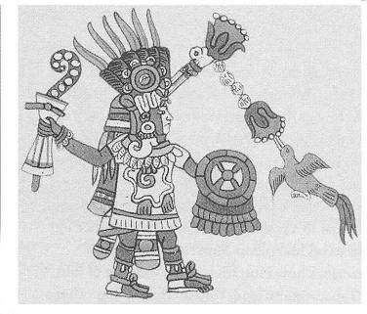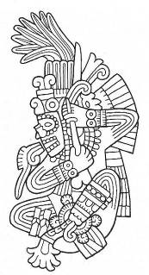 Fig. 29 Fig. 30 Huitzilopochtli if full battle array, wielding the Xiuhcoatl and feeding Huitzilopochtli letting blood. Of a hummingbird, namesake (“huitzilin”) of this and totem of all warriors. interest is his left foot, which is generally considered a mark of Tezcatlipoca. Note Fig. 32. 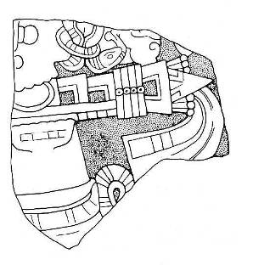 Fig. 31 Coyolxauhqui pierced by Huitzilopochtli’s xiuhcoatl. 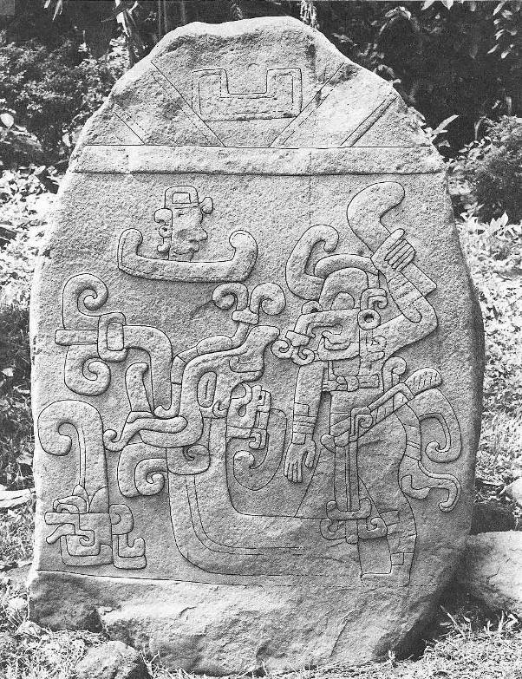 Fig. 32 Fig. 32 Notes: Stela 3, Izapa, Chiapas, Mexico (with tracing), c. 50 AD. A warrior, helmeted with the mask of his god, challenges an erupting earth-serpent, which is, however, contiguous with his left foot. He brandishes an empty atlatl (spear thrower) but holds his throwing arm in a passive position while his avatar observes from his spirit-canoe. Corn sprouts at lower left, counterpart to his discreetly portrayed phallus. 89 such stelae have been catalogued in the Izapa site, many with equally provocative images. This is the earliest known representation of the serpent-footed god motif developed through the Maya representations of Itzamna, K’awil and the God K, and the Teotihuacano-Azteca Tezcatlipoca. It represents the iconographic (and historical?) basis for all the subsequent manikin scepters which are the ubiquitous emblems of rulership displayed by Mayan priests and rulers. Malmstrom (1997) places the origin of the seminal Olmec culture (usually seen as arising in Caribbean-coastal Veracruz) in the Izapan Soconusco of the Pacific coast, and finds evidence of this in calendar, language, and cultural diffusion patterns, although most researchers interpret the Izapan culture to be a bridge between the Olmec and the Maya civilizations. Research by Malmstrom and Jenkins also indicates that Izapa was the place of origin of the ubiquitous 260-day colander. This earliest known representation of the serpent-footed god motif develops through the Maya representations of Itzamna, K’awil and the God K, and the Teotihuacano-Azteca Tezcatlipoca, in which the shaman confronts the serpent, the Earth-monster; his double. This emblem is profound in its symbolism and is one which is carried through all of Mesoamerican lore. Steiner (1916) offers indications towards additional understandings of the pivotal Tezcatlipoca- Quetzalcoatl dynamic: Vitzliputzli as an avatar of Tezcatlipoca. I suggest that this image indicates the Mesoamerican prototype for the full-spectrum encounter with the same personal and universal kundalini forces which, unresolved, wounded the European Amfortas. I also consider this, the earliest and most explicit known representation of this shamanic function, to be historical evidence of a strong “Vitzliputzli” influence emanating from Izapa. Could the avatar have been born and raised in an Essene-type community here, later to journey to Cuicuilco for his epochal encounter? The overall gesture could not be more explicit in representing the Manichean stance with regard to the “problem of evil.” This is, in indigenous terms, none other than the role of the shaman. Note that in the dynamic of the encounter, the “Earth Monster” (as it is described in the scholarly literature, which may be only vaguely and partially correct) faces away from the protagonist, and a flower sprouts from its mouth. Hardly the typical “Good vs. Evil” battle-to-the-death dynamic typically attributed to the “Manichean” ethic. The first human God-agent on Earth in the Mayan Popul Vuh cosmogenesis also was one-footed: Hunrakan. In this respect also, the Izapan initiate partakes of the original creative and world-sustaining function. As does the effectively one-footed Hanged Man of Card 12 in the Western Tarot and the 23rd Path in the Kabbalah. This image (and extensive discussion) from: Norman (1973 & 1976), Lowe, Lee, and Martinez (1982). Also from Stirling (1941), pp. 276-327. 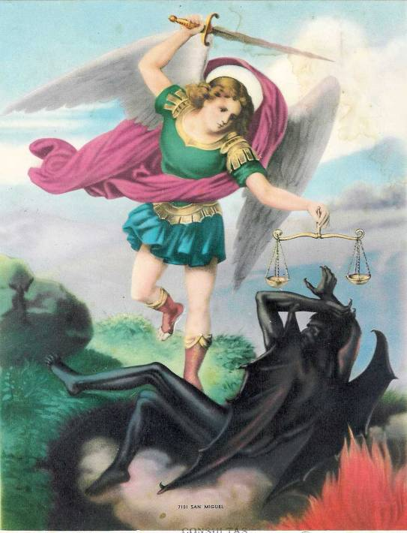 Fig. 33 A familiar scene, from a contemporary Mexican print, but note: the dark figure is not being assaulted nor vanquished, but held in check and in place. Note similarities to Fig. 32, above. Engagment with the dynamic indicates that, in the same fashion, Michael’s sword functions more as an antenna in the mode of an implement of magic than as a literal weapon. I believe this to be an accurate depiction 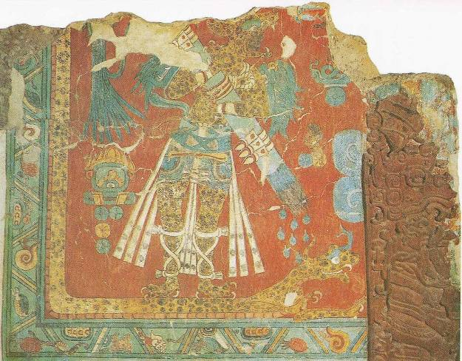 Fig. 34 A mural fragment from c. 900 A.D., Cacaxtla, central Mexico. The jaguar-warrior demonstrates his authority over the dragon but does so by a gesture of healing; water showers down upon it from his weapon and symbol of rulership, a bundle of darts, arrows, or spears. The jaguar is the spirit-animal most intimately associated with Tezcatlipoca. 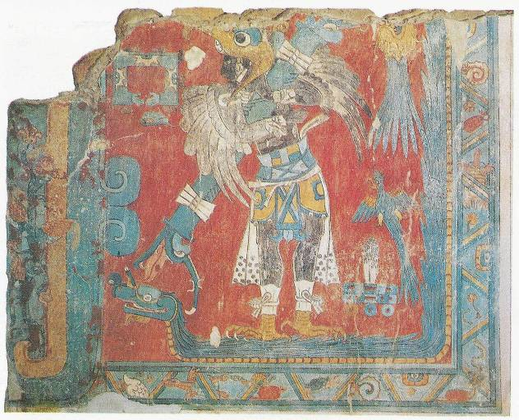 Fig. 35 Another, even more striking depiction, from the same suite of murals in Cacaxtla. The Eagle Warrior holds a ceremonial bar, emblem of magical capacity, which just barely touches the head of the serpent. The mood is one of dynamic balance, not violent conflict. 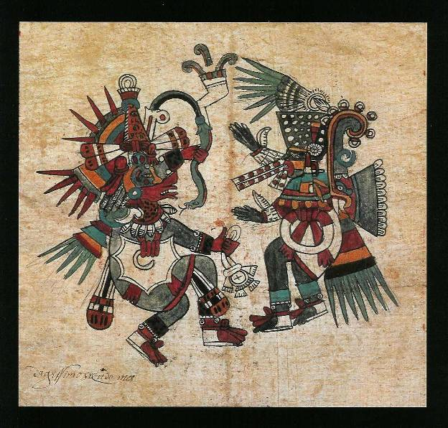 Fig. 36 Quetzalcoatl, “Feathered Serpent” (L), and Tezcatlipoca, “Smoking Mirror” (R) face off. Are they mortal enemies or allied counterparts? Is one good and the other evil or are they like the black-and-white of the Chinese Yin-Yang? However the Mexica of the 15th C. viewed it, their appreciation was complex and subtle, involving mutual metamorphosis. Perhaps comparing them to the two foci of an ellipse would not be too far off. 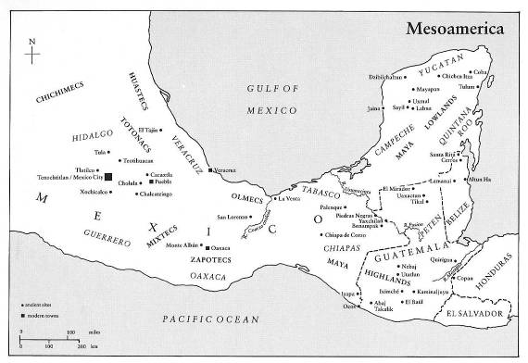 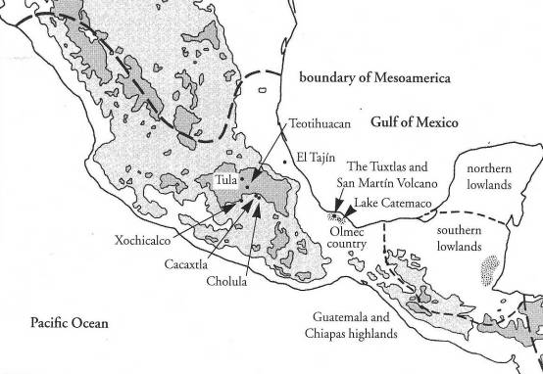 Figs. 37 & 38 – Mesoamerican Maps 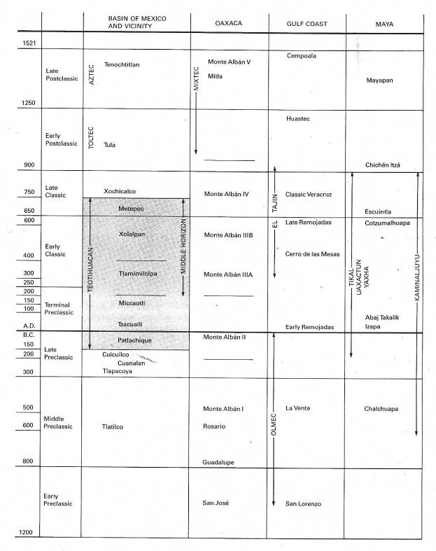 Fig. 39 – Mesoamerican Timeline Fig. 40 – Mesoamerican Cosmos 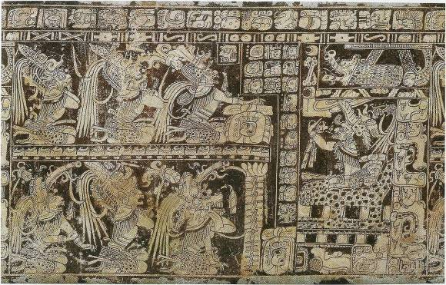 Fig. 41 The Mayan Lords of the UnderWorld; a rollout photograph from a Mayan vessel. 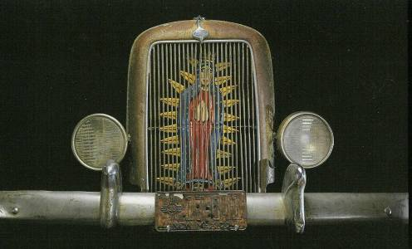 Fig. 42 The Goddess not only lives, she rides again…. Steinerian and Mesoamerican UnderWorlds Subnatural levels in Anthroposophy and Mesoamerica The formulation by Rudolf Steiner of the Nine Layers of Evil within the Earth, from At the Gates of Spiritual Science (alternatively: At the Gate of Theosophy), GA 95, lecture 14 in cycle I, of Sept. 4, 1906, Stuttgart. Rudolf Steiner Press, 1986, pp. 138-140: The occult science of all epochs says the following about the interior of the earth… - The topmost layer, the mineral mass, is related to the interior as an eggshell is to the egg. This topmost layer is called the Mineral Earth. - Under it is a second layer, called the Fluid Earth; it consists of a substance to which there is nothing comparable on Earth. It is not really like any of the fluids we know, for all these have a mineral quality. This layer has specific characteristics: its substance begins to display certain spiritual qualities, which consist in the fact that as soon as it is brought into contact with something living, it strives to expel and destroy this life. The occultist is able to investigate this layer by pure concentration. - The “Air Earth”. This is a substance, which annuls feelings: for instance, if it is brought into contact with any pain, the pain is converted into pleasure, and vice versa. The original form of feeling is, so to speak extinguished, rather as the second layer extinguishes life. - The “Water Earth”, or “Form Earth.” It produces in the material realm the effects that occur spiritually in Devachan. There, we have the negative pictures of physical things. In the “Form Earth” a cube of salt, for example, would be destroyed, but its negative would arise. The form is as it were changed into its opposite; all its qualities would pass out into its surroundings. The actual space occupied by the object is left empty. - The “Fruit Earth.” This substance is full of exuberant energy. Every little part of it grows out at once like a sponge; it gets larger and larger and is held in place only by the upper layers. It is the underlying life which serves the forms of the layers above it. 6. The “Fire Earth.” Its substance is essentially feeling and will. It is sensitive to pain and would cry out if it were trodden on. It consists, as it were, entirely of passions. 7. The “Earth-mirror” or “Earth-reflector.” This layer gets its name from the fact that its substance, if one concentrates on it, changes all the characteristics of the earth into their opposites. If the seer disregards everything lying above it and gazes down directly into this layer, and if then, for example, he places something green before him, the green appears as red; every color appears as its complementary opposite. A polaric reflection arises, a reversal of the original. Sorrow would be changed by this substance into joy. - The “Divisive” layer. If with developed power one concentrates on it, something very remarkable appears. For example, a plant held in the midst of this layer appears to be multiplied, and so with everything else. But the essential thing is that this layer disrupts the moral qualities also. Through the power it radiates to the Earth’s surface, it is responsible for the fact that strife and disharmony exist there. In order to overcome this disruptive force, men must work together in harmony. That is precisely why this layer was laid down in the Earth – so that men should be enabled to develop harmony for themselves. The substance of everything evil is prepared and organized there. Quarrelsome people are so constituted that this layer has a particular influence on them. This has been known to everyone who has written out of a true knowledge of occultism. Dante in his Divine Comedy calls this layer the Cain-layer. It was here that the strife between the brothers Cain and Abel had its source. The substance of this layer is responsible for evil having come into the world. 9. The “earth-core.” This is the substance through whose influence black magic arises in the world. The power of spiritual evil comes from this source. The only elaborating remarks are brief ones relating earthquakes and volcanic activity to the “evil passions” of man and the volatile “passion-layer in the interior of the earth.” The correspondence which Eduard Schure discusses in the introduction to the lecture-cycle is that of the concentric regions of the Earth and the Old Saturn, Old Sun and Old Moon manvantaras which in later lectures are corresponded to the three Mothers. The natural reaction to this is: “That’s dreadful! Why bother?” If it weren’t that it was given by “der Doktor”, it would seem to the results of a bad meal. No mollifying context is supplied; pity on the person who stumbles across this passage as his or her first introduction to Steiner’s work! This is definitely Steiner at his worst and lays the foundation for an attitude as reflected in Querido’s diagram which was have referred to elsewhere (endnote 4 here and American Chapters I, p. 62). The note to it reads: Figure 1-75 A diagram appearing in Rene Querido’s Introduction to Rudolf Steiner’s Spiritual Beings in the Heavenly Bodies and in the Kingdoms of Nature. Insofar as it goes, it is accurate, but the mistaken impression given is that this is the whole map. Granted, Steiner in his title (accurately translated) said only that he would address the Heavenly and Natural realms, but even in that, his treatment of the natural realms is sketchy at best. However, Querido, long-time President of Steiner’s Anthroposophical Society in America, goes so far as to state what even his own diagram does not indicate: “The threefold hierarchical world (each comprising beings of three ranks) interpenetrates the three kingdoms of nature with the human being at the center.” Although it is true that the human being does indeed occupy the Middle realm of the Worlds, the format as indicated is woefully out-of-balance: none of the spiritual worlds lying below the sensible world are indicated. That this flaw is not even noticed nor commented upon indicates the huge blind spot that most European-based spiritualities have for the UnderWorld, Orpheus and the like notwithstanding. All of the preceding images from natively American sources draw heavily upon the Inspirations that emanate from Below. There are pathways native to Europe that go there and we will investigate them in due course.) The diagram: 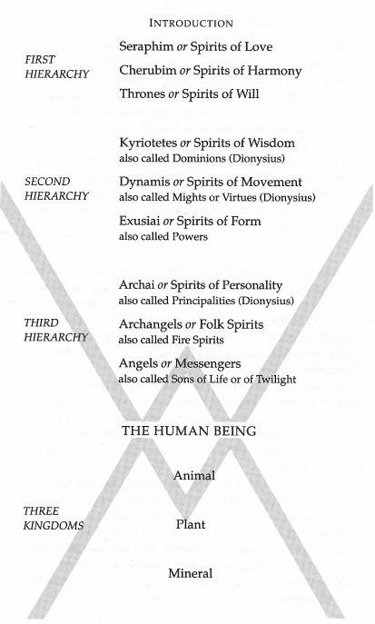 Fig. 43 Although it may be remarked that at the time he made the above formulation, Dr. Steiner was speaking as a representative of the Theosophical Society, and hence may be somewhat excused for using the more florid and less discriminating idiom of that circle, it would then also have to be noted that some of the more illuminating remarks concerning positive aspects of the Earth-Being as cited above were also made at that same time. Judging from the tenor of these remarks, one would have no idea that he also can come up with things like this: “The silver-sparkling blue below, arising from the depths of the Earth and bound up with human weakness and error, is gathered into a picture of the Earth Mother. Whether she is called Demeter or Mary, the picture is of the Earth Mother. So it is that in directing our gaze downwards, we cannot do otherwise than bring together in Imagination all those secrets of the depths which go to make up the material Mother of all existence. While in all that which is concentrated in the flowing form above, we feel and experience the Spirit Father of everything around us. And now we behold the outcome of the working together of the Spirit Father with the Earth Mother, bearing so beautifully within itself the harmony of the earthly silver and the gold of the heights. Between the Father and the Mother we behold the Son.” - The Four Seasons and the Archangels, lecture of Oct. 1923, p. 66. And: “It is a fact that in the occult regions of the earth what is prepared by the forging of Michael’s Sword is carried to a subterranean altar in the process – to an Altar which is invisible and which really exists beneath the earth.” - Youth’s Search in Nature. Most peculiar. In the interests of completeness, we offer the following similar treatment by him, given on a prior occasion: THE INTERIOR OF THE EARTH Physical science as yet only knows of the terrestrial crust, a mineral layer which in fact is only like a thin skin at the surface of the earth. In reality the earth consists of a succession of concentric layers which we shall now describe: 1) The mineral layer contains all the metals which are found in the physical bodies of everything that lives at the surface. This crust is formed like a skin around the living being of the earth. It is only a few miles in depth. 2) The second layer can only be understood if we envisage a substance which is the very opposite of what we know. It is negative life, the opposite of life. All life is extinguished there. Were a plant or an animal plunged into it, it would be destroyed immediately. It would be totally dissolved. This second shell - half liquid - which envelopes the earth is truly a sphere of death. 3) The third layer is a circle of inverted consciousness. All sorrow appears there as joy. And all joy is experienced as sorrow. Its substance, composed of vapors, is related to our feelings in the same negative manner as the second layer is in regard to life. If we now abstract these three layers by means, of our thinking we would then find the earth in the condition in which it was before the separation of the moon. If one is able by means of concentration to attain a conscious astral vision, one would then see the activities in these two layers: the destruction of life in the second and the transformation of feelings in the third. 4) The fourth layer is known as water-earth, soul-earth, or form-earth, it is endowed with a remarkable property. Let us imagine a cube and now picture it reversed inasmuch as its substance is concerned. Where there was substance there is now nothing: the space occupied by the cube would now be empty while its substance, its substantial form, would now be spread around it; hence the term ‘earth of form.’ Here this whirlwind of forms, instead of being a negative emptiness, becomes a positive substance. 5) This layer is known as the earth of growth. It contains the archetypal source of all terrestrial life. Its substance consists of burgeoning, teeming energies. 6) This fire-earth is composed of pure will, of elemental vital forces - of constant movement - shot through by impulses and passions, truly a reservoir of will forces. If one were to exert pressure on this substance it would resist. If now again in thought one were to abstract these last three layers just described, one would arrive at the condition in which our globe was when Sun, Moon and Earth were still interwoven. The following layers are only accessible to a conscious observation which is not only that of dreamless sleep but a conscious condition in deep sleep. 7) This layer is the mirror of the earth. It is similar to a prism which decomposes everything that is reflected in it and brings to expression its complementary aspect; seen through an emerald it would appear red. 8) In this layer everything appears fragmented and reproduced to infinity. If one takes a plant or a crystal and one concentrates on this layer the plant or the crystal would appear multiplied indefinitely. 9) This last layer is composed of a substance endowed with moral action. But this morality is the opposite of the one that is to be elaborated on the earth. Its essence, its inherent force, is one of separation, of discord, and of hate. It is here in the hell of Dante that we find Cain the fratricide. This substance is the opposite of everything which among human beings is good and worthy. The activity of humanity in order to establish brotherhood on the earth diminishes the power of this sphere. It is the power of Love which will transform it inasmuch as it will spiritualize the very body of the Earth. This ninth layer represents the substantial origin of what appears on earth as black magic, that is, a magic founded on egoism. These various layers are connected by means of rays which unite the center of the earth with its surface. Underneath the solid earth there are a large number of subterranean spaces which communicate to the sixth layer, that of fire. This element of the fire-earth is intimately connected with the human will. It is this element which has produced the tremendous eruptions that brought the Lemurian epoch to an end. At that time the forces which nourish the human will went through a trial which unleashed the fire catastrophe that destroyed the Lemurian continent. In the course of evolution this sixth layer receded more and more toward the center and as a result volcanic eruptions became less frequent. And yet they are still produced as a result of the human will which, when it is evil and chaotic, magnetically acts on this layer and disrupts it. Nevertheless, when the human will is devoid of egoism, it is able to appease this fire. Materialistic periods are mostly accompanied and followed by natural cataclysms, earthquakes, etc. Growing powers of evolution are the only alchemy capable of transforming, little by little, the organism and the soul of the earth. The following is an example of the relationship that exists between the human will and telluric cataclysms: in human beings who perish as a result of earthquakes or volcanic eruptions one notices, during their next incarnation, inner qualities which are quite different. They bring from birth great spiritual pre-dispositions because, through their death, they were brought in touch with forces which showed them the true nature of reality and the illusion of material life. One has also noticed a relationship between certain births and seismic and volcanic catastrophes. During such catastrophes materialistic souls incarnate, drawn sympathetically by volcanic phenomena - by the convulsions of the evil soul of the earth. And these births can in their turn bring about new cataclysms because reciprocally the evil souls exert an exciting influence on the terrestrial fire. The evolution of our planet is intimately connected with the evolution of the forces of humanity and civilizations. [Drawing No. 2 not included here] THE INTERIOR OF THE EARTH 1. Mineral crust 2. Negative life 3. Inverted Consciousness 4. Circle of forms 5. Circle of growth 6. Circle of fire 7. Circle of decomposition 8. Circle of fragmentation 9. Ego-centric-egoism - An Esoteric Cosmology, GA 92, lecture 16 of June 12, 1906, Paris: Earthquakes, Volcanoes, and the Will of Man. http://wn.elib.com/Steiner/Lectures/EsoCosmo/19060612p01.html The first six strata are also briefly referred to, without much additional detail, in Steiner’s lecture-cycle: The Deed of Christ and the Opposing Spiritual Powers: Lucifer, Ahriman, Mephistopheles, Asuras, GA 107, lecture 2 on Jan. 1, 1909, Berlin. Additional Steiner references (not reviewed): - The Interior of the Earth and Volcanic Eruptions. April 16, 1906, Berlin (GA 96). - Das Innere der Erde. April 21, 1906, Munich (GA 97). - Christian Initiation, (GA 96): Popularer Okkultismus, lecture 14, July 11, 1906, Leipzig (although the eLib lists no lecture for that date). - Seven Lectures to the Workmen, lecture 2.June 2, 1923, Dornach (GA 350). - The Forming of the Earth and the Moon, Causes of Volcanism. Sept. 18, 1924, Dornach (GA 354). In all this he is at least consistent, although there is a complete lack of linkage or integration between these comments and his other equally sparse references to the Divine Feminine as found within the body of the Earth. Valentine Tomberg does review the subject: The right kind of fighting against human karma is the carrying, by mankind, of forgiveness and remission into the affairs of the world; for if Man will abandon the principle of “an eye for an eye, a tooth for a tooth”, this principle will no longer be used against himself. The resistance to karma which was set up by the Turanian culture, was, how- ever, of quite a different type. In it Man strove to flee from individual karmic responsibility into a “we-consciousness”, and the ”we-humanity” was striving in its turn to escape the universal human karma, by seeking refuge in the Subterranean Spheres. The crushing of individuality in the womb of the "we-consciousness," was the one side of the Turanian endeavour; the other side was the turning of this we-totality towards the principles and forces of the Subterranean Spheres, especially to that Subterranean Sphere called the “Fire- Earth”, which represents the region of Ahriman's power within the terrestrial organism. It would never have occurred to Man to take refuge in the interior of the Earth, if the betrayal of the Vulcan Mysteries - of which Rudolf Steiner speaks in An Outline of Occult Science - had not taken place in the Atlantean Epoch. It was precisely these "betrayed" Vulcan-mysteries - that is, Mysteries given over to Evil and inversely realized by Evil - which constituted, although in a weakened form compared with that of the Atlantean Epoch, the spiritual basis of the Turanian civilisation. The fundamental truth of the Vulcan Mysteries was that the highest goal of terrestrial evolution consisted in the complete conversion of the Interior of the Earth through the agency of Man. This, moreover, is the reason why Rudolf Steiner chose the name "Vulcan" for the seventh and highest state of Earth's evolution. This name is enigmatic so long as we try to find a planet which would indicate the future Vulcan-condition, in the same way as "Jupiter" and "Venus" indicate two conditions of the future. But the enigma disappears if we seek the corresponding heavenly body, not in Heaven, but in the Interior of the Earth, whither, indeed, the Greek mythology has relegated it. The truth of the matter is that there is no planet Vulcan, but that this "planet" is hidden in the Interior of the Earth. Now when the time arrives that the Earth is turned completely inside out (a relevant idea of this inversion is given, from the standpoint of the etheric, in Dr. G. Wachsmuth's work on the Etheric Formative Forces of the terrestrial organism), the objective phenomenon of the Vulcan-planet will make its appearance, encircled by a spiritualised ring of the former terrestrial humanity. Then will mankind, in conjunction with the Father-forces of the universe, be faced with the tremendous task of converting the lowest Evil into the highest Good. The fundamental thought of the betrayed Vulcan Mysteries was, precisely, to misinterpret the spiritual state of things indicated above, in such a way that it would become its opposite. The Earth's Interior was not regarded by them as the object of the highest conquest of future Man, but as the source of his highest conquering forces. And this highest conquest which would be attained, with the help of the Vulcan-forces, consisted in overcoming the "curse" of the Father, that is, in overcoming pain, toil and death. It was hoped, for instance, to put an end to all pain through the forces of the “Air-Earth” (the third subterranean sphere), which kill feeling, and by applying the energy of the "Fruit-Earth's" luxuriant growth, in conjunction with the "technical" forces of the "Fire-Earth," to achieve freedom from all toil. And it was hoped that still deeper strata of the Earth's Interior would give that terrestrial immortality which Rudolf Steiner calls "the Ahrimanic ideal of immortality" - which, actually, would be no immortality at all, but "deathlessness," that is, an escape from the primal karmic necessity of death into a region whither this necessity does not extend. These intentions were active in the foundations of the Turanian civilisation, and determined many of its details: for instance, the kind of communism extending even into family life, which was peculiar to the Turanian civilisation. In this fact was expressed the "we-consciousness" of Turanianism; for instance, its inner bias towards the Interior of the Earth was shown in its hostility to agriculture. For if Man's hand furrows the Earth with the plough and scatters seeds which are brought to growth and fruition by means of the warmth, light and rain of Heaven, he is carrying out a deed in conjunction with heaven, which stands in deepest contrast to the alliance with the Earth's Interior. For this reason the great Zarathustra taught the small Iranian community which had gathered round him, agriculture, as a religious duty of Man. To the Ancient Indian, agriculture was a servitude exacted by nature; to the Turanian, it was something hostile; to the Ancient Persian, whose life was necessarily spent in hard toil among sterile mountains, it was, nevertheless, the earthly expression of fidelity to Ahura-Mazdao. The fact that Zarathustra attributed religious significance to agriculture, points to what was the essential part of Zarathustra's wisdom, and of the Ancient Persian culture-impulse resulting from it. Tomberg, Anthroposophical Studies of the Old Testament, Candeur Manuscripts, 1985 (from the German of 1933), pp. 153 – 155 Elsewhere, Tomberg does develop the theme of the Divine Feminine somewhat more than Steiner, but in a cautious manner which reflects his anthroposophical background. In the remarks quoted above he shows no independent point of view towards the “Inner Earth.” There is a correspondence - of sorts - to these levels as described in Aztec lore: …the Aztecs conceived of their cosmos as containing three superimposed sections: the heavens, the surface of the earth, and the underworld. An ensemble of pictorial and written sources, including the Codex Vaticano Latino 3738, shows us that the vertical ordering of the cosmos consisted of thirteen celestial layers rising above the earth, culminating in the realm of Omeyocan, the "Place of Duality," and nine layers below the earth, ending in Mictlan, the "Place of the Dead." This dense vertical column was joined by the central region, Tlalticpac, the "Earth Surface." The Iynchpin was the city of Tenochtitlan. At the time of the Spanish contact, thirteen deities inhabited the thirteen levels, which were designated the "Sky of the Paradise of the Rain God," the "Sky of the Star-Skirted Goddess," the "Sky of the Sun," the "Sky of the Salt-Fertility God," the "Sky Where Gyrating Occurs," the "Sky That Is Blackish," the "Sky That Is Blue-Green," the "Place That Has Corners of Obsidian Slabs," the "God Who Is White," the "God Who Is Yellow," the "God Who Is Red," and the "Place of Duality." The gods associated with these levels were termed the Lords of the Day and are: Xiuhtecuhtli, Tlaltecuhtli, Chalchiuhtlicue, Tonatiuh, Tlazolteotl, Mictlantecuhtli, Cinteotl, Tlaloc, Quetzalcoatl, Texcatlipoca, Chalmecatecuhtli, Tlahuizcalpantecuhtli, and Citlalincue (not necessarily in that order). The layers below the earth had such names as the "Place for Crossing the Water," the "Place Where the Hills Crash Together," the "Obsidian Mountain," the "Place of the Obsidian Wind," the "Place Where the Banners Are Raised," the "Place Where People Are Pierced with Arrows," the "Place Where People's Hearts Are Devoured," the "Obsidian Place of the Dead," and the "Place Where Smoke Has No Outlet." The gods associated with these levels were termed the Lords of the Night and are: Xiuhtecuhtli, Itztli or Tecpatl, Pilzintecuhtli, Cinteotl, Mictlantecuhtli, Chalchiuhtlicue, Tlazolteotl, Tepeyollotl, and Tlaloc (the typical order in this cycle). This information from Lopez Austin: The Human Body and Ideology, p. 54, as cited in David Carrasco’s: The City of Sacrifice, pp. 33 – 34, from and Mary Miller & Karl Taube, 1997 (from 1993), pp. 53 – 54. Since the earth-surface was considered one of the thirteen cosmic levels, only twelve celestial levels are named. Bruce Scofield has this listing, I include some of his commentary: The Lords of the Night In the codices that contain a tonalamatl are also pictorial diagrams suggesting a host of other arrangements and linkages between the day-signs, the gods, the directions, Day Lords, trees and birds. One important sequence was that of the Lord of the Night, also known as the Nine Figures. These nine gods of the night or underworld are found in both the Maya and Aztec traditions. The glyphs of the nine Maya gods have been identified, but the names of the gods themselves are not known and they have been labeled G-1 through G-9. The names of the Aztec gods in this series are well known and occupy a prominent place in the several codices that contain astrological and cosmological material. In the frontispiece of the Codex Fejervary-Mayer the nine Lords of the Night are shown as part of the cosmic scheme…. In the center of the diagram is the god Xiuhtecuhtli, the Lord of Central Fire. In the region of the East, above the center, are Itzli, the sacrificial knife god, and Pilzintecuhtli, the Sun god. In the North are Tepeyollotl, the jaguar god, and Tlaloc, the rain god. In the West are Chalchihuitlicue, the water goddess, and Tlazolteotl, the filth goddess. In the region of the South are Cinteotl, the maize god, and Mictlantecuhtli, the god of the underworld. The usual order of the nine Lords is as follows with Quiauitecuhtli, a rain god, sometimes substituted for Tlaloc. 1. Xiuhtecuhtli 2. Itzli 3. Pilzintecuhtli 4. Cinteotl 5. Mictlantecuhtli 6. Chalchiuhtlicue 7. Tlazolteotl 8. Tepeyollotl 9. Tlaloc …Throughout the Mesoamerican culture region, the cosmos was conceived as having 13 heavens above and 9 underworlds below. It is not clear whether those layers were stacked vertically (which is what some drawings suggest) or if they were arranged as a pyramid, with the center god standing at the apex or nadir. - Bruce Scofield, Signs of Time, One Reed Publications, 1999, pp. 86 – 87, by kind permission. Also see the note to the Frontispiece image which serves to illustrate this commentary. Now all of this is good information, but the question is: what does it mean? Something that should not be accepted uncritically - without a solid inner understanding of what was referred to by Steiner and the Aztecs (hardly the most evolved representatives of Mesoamerican sensibilities!) - is: do Steiner and the Aztecs refer to the same Nine Levels of the Under World? Regarding Steiner, one may ask: is he referring to nine levels within the Subnatural realm, the entire nine levels of a complete Underworld cosmos, or only to the devolved and degenerate levels of the latter? At any rate, the overall impression one gets from Steiner’s take on this is that it is a very rough and crude sketch. Regarding the Aztec format, one cannot reliably say that one knows anything as a result of a tabulation of names and deity-associations such as I have mentioned. First of all, unless one knows who the deities are, their names signify nothing - that is, to one who is not intimately familiar with Nahuatl culture and spiritual practice. Secondly, even if one is, the next question is: Which Nahuatl culture? There are many - there were many, and the tabulation given here may or may not correspond to anything subscribed to by any one person in pre-Colombian fifteenth century, AD in Mesoamerica. The list given is probably made up of a compendium of fragmentary data from wildly disparate sources. That there was a widespread belief in an UnderWorld, that that cosmos was finely differentiated – probably into nine levels (this is a fairly confident assertion, since the Maya format is similar) and that there were great beings associated with different aspects of it, is all we can take in confidence from this arrangement. A simplistic parallelism of lists simply will not do if one is to be doing serious research into the question. Sifting through relics and second-hand information can only yield so much. To close, we will cite several passages from a modern adept, which will throw a different light upon our subject of what it is like when one goes “down” into the Earth: R. J. Stewart on the UnderWorld, the Goddess, and the Child of Light A few words giving yet another, but contemporary, perspective on what goes on “Below”… THE UNDERWORLD AND THE PLANETARY MIND The Underworld is the mind of the planet. This planetary mind is the totality of all matter, energy and consciousness associated with the planet; it exists upon a planetary time-scale. The planetary cycles are part of a stellar time-scale which encompasses our own relative time, defined by the movements of the solar system. Just as our own consciousness is not solely defined by the physical brain and body, the planet has an individuality and awareness that may not be defined by material form. Meditation teaches us through direct experience that we may redirect our attention inwardly, the balancing opposite of our customary direction. When we do so we find a reality that is not limited to the materialist biological model, for we do not experience reduction of awareness to a cellular state, but a powerful expansion. The meditative disciplines also enable access to realms of being that are closed to us when our attention and will are outwardly directed. The Underworld and Earth Light experiences, accessible through various means including meditation and visualization, teach us the reality within the land and planet. This inner reality is as subjective or objective as any other, for all realities are defined and conditioned by the roles and rules of the participants. Particle physics has recently 'discovered', via the hard road of modern science, that there are no observers, only participants. This simple truth has been taught for millennia in the esoteric traditions, though the models (world-models) within which it is expressed vary from culture to culture and from land to land. The Underworld traditions teach us ways towards conscious participation in the life-patterns of the planet; through the simple but neglected method of passing awareness downwards into the land. Popular meditation techniques, regardless of their origin, are inwardly balancing, for through them our attention is drawn away from outward-reaching habits and focused inwardly. Underworld work gives us the essential balance below, drawing attention away from our other addiction or obsession, that of escaping upwards to a distant light. The obsession with elevation is only a variant of the outward-seeking trap, for both depend upon rejection or dualism. We find this at its most serious in religions and spiritual practices which raise energy/consciousness upward above the head, rejecting (or more arrogantly 'redeeming') all that is below. In externalized materialism, this old spiritual arrogance appears as humanity's self-acclaimed right to exploit nature. Interestingly it is science today that has realized that dualism and lack of responsibility towards the natural world leads directly to our own destruction; the current spiritual revival still uses, to a great extent, the dualistic Christian-materialist model. Light is always above, while superior masters and angels will intervene to save or at least lecture us through channeled communications. In the Underworld tradition the land and all living beings upon and within it are holy, sacred, and spiritually and physically aspects of one being, of which we are an integral part. As the planetary patterns of awareness and our individual and collective human life-patterns are aspects of a holism, we may enter into planetary awareness directly for, of course, we are already there. We need not think of the land and planet as having separate minds in an exclusive sense, as we are conditioned to think of each other, but that our own awareness is of the planet, it is the planetary awareness. If, as is often the case, we are unable to make the conscious dive, to plunge directly into a state of planetary being, we should work through the land, that part of the planetary zone upon which we live and to which we are organically attuned. The Underworld is the mind of the planet and is not limited to the parts that we identify through our self-limited participation. Like our own minds it has many patterns and is protean and (in the true sense of the word) plastic. Although the Underworld Initiation begins at home, as the primal power traditions are always regional and ethnic, it does not stay there. At the present time we are moving out of some of our old racial patterns but not out of the enabling limitation of regions, lands and zones, which are both geomantic and spiritual. Each relative entity, from zones to microscopic life forms, is a part of the planetary mind. The substance of the world, defined by the Four Elements, is also part of the planetary mind. We are of it and yet we reject and abuse both the planet and ourselves. The Underworld initiates plunges willingly and deeply into the planetary mind, seeking to pass into it and be changed by it rather than reject it and rise away from it. THE PARADOX OF EARTH LIGHT There are some significant links between the Underworld and the more widely popularized idea of rising to the light, or 'rising through the planes'. Initially such links seem to be m paradoxical, for the deeper we reach into the Underworld the closer we come to light. In folk tradition, the faery realm is p filled with illumination, but there is no sight of the Sun or Moon. The light is that of the sacred land, the primal world, the light of the stellar universe inherent within the body and substance of the planetary being. In the pagan myths this light was that of the Goddess, and to be at one with her light involved passing through darkness. The best known name for her is Isis, who was both black and white. The Black Isis is simultaneously the depths of the Underworld and the depths of the universe, while the White Isis is the light of the planet and the light of the stars. The Earth Light experiences bridge between the planetary mind (of which we are an integral part) and the stellar consciousness. There is a widespread assumption in esoteric literature that the Goddess of the Earth and Moon, known as Isis and by countless other names, is a lesser power than, say, the God of the Sun. This idea is merely propaganda or patriarchy. Apart from the Underworld tradition which does away with such hierarchies and propaganda, we need only do a little home- work to discover that the Earth, Moon, sun and stars manifested deities of both sexes. In psychic and magical terms, the way in which we approach these entities, regarding them as t male, female or androgyne, makes definable changes within ourselves. Ironically, the patriarchal and prejudiced Victorian scholars of myth and legend identified over a century ago that there were many major examples of solar goddesses and lunar gods in ancient religion, a well-documented body of truth that is virtually ignored in the modern revival of paganism and the New Age movement. Earth Light is a term that developed from the first book, in which the light of the faery realm is revealed. The idea of the Earth as a world of light was once widespread in religion and magic, though orthodox political Christianity fought constantly to suppress such a liberating truth. Today we inherit the suppressive propaganda, both in the form of materialism and in many unchallenged assumptions in our spiritual revival and New Age enthusiasm. Much nonsense is attached to the idea of the Earth and Underworld as negative, dark, even corrupt. We must flee, we are told, the drag of A- matter, or alternatively we must seed the passive Earth with manly light from the higher worlds. This antagonistic sexist propaganda is rehashed in endless ways by people who have never once entered the sacred land in meditation or vision, and found it vibrant and filled with light. The Christian war waged upon our world has subtly evolved into arrogant abuse through science and industry, but it does not stop there. New spirituality seems determined to find only the higher planes, the Masters, and escape from responsibility. We dread confrontation with any power that will act as a catalyst for true inner change, we fear and reject the Earth by our crass assumption that spiritual Masters, angels or a Saviour will appear in some external manner to save us from ourselves. The Underworld tradition teaches that we must confront and pass through our fear and rejection of the Earth as a transformative illuminating matrix. Earth Light, found by moving our energy and awareness into the body and power of the land. This light is our closest light, the divine Being in matter or substance, in living interaction with its individual and collective creations. The land and planet are alive, and our spiritual reality derives from this life just as much as our physical reality. Indeed, the Underworld tradition makes little or no distinction between physical and spiritual…these are merely clumsy words. - from R. J. Stewart: Power Within the Land, pp. 16 – 19 (Bib. II) THE WEAVER GODDESS IN THE UNDERWORLD Our last visualization returns us to the Dark Goddess of the Underworld. In this we pass beyond the faery realm to one of the deep Underworld temples. Serious undertakings in inner transformation, magic, call it what we will, cannot be approached or achieved without experience of two closely related concepts; the Underworld and the Goddess. Although we have used the word concepts the Underworld and the Goddess are not theories but fundamental universal powers. They are presentations or modulations of the unknowable One Being, the ultimate reality and truth beyond expression. There are many ways of expressing the Underworld and the Goddess, but no amount of discussion replaces actual experience. It is pointless to argue over the 'reality' of words and images, for they all derive from a deeper reality, beyond form. Both primal concepts and powers, Goddess and Underworld, have been ignored and suppressed with terrible, possibly irreparable, effect upon both humanity and the planet Earth. Understanding the Goddess leads us to sexual balance and maturity upon all levels of consciousness, including those that transcend gender. Understanding of the UnderWorld brings a conscious relationship between humankind and the land, environment and planet. As the Goddess dwells within the Underworld, we should not separate the two in our imagination. The Goddess and the Underworld represent energies and consciousness essential to our individual, collective and manifest well-being. Moreover, these two concepts and powers have the potential to rebalance our humanity and our collective world, both of which are in immediate undeniable danger of extinction. In very basic terms we may see the nuclear problem, both civil and military, as a result of ignorance and abuse of Underworld powers; Pluto and Uranus. The heavy metals are Underworld entities or stellar entities, but specifically stellar entities within the Earth. We may see the grotesque extremes of materialism and male stereotypical (rather than archetypical) consciousness as a result of suppression of Goddess powers. The Underworld tradition, the Light within the Earth (as opposed to theoretical magic or literary occultism) must work with Goddess power. This much was realized by the revival occultists of the nineteenth and early twentieth centuries, just as it had been understood by the adepts of the Rosicrucian movement, the alchemists, and the Renaissance magicians and metaphysicians. Only one or two generations ago, Goddess workings were unusual in magical groups, though not unknown. Iv1agical arts were still dominated by savage phantoms of male egocentric 'authority' and dogmatic 'hierarchy', phantoms which have by no means been exorcized at the present time. Such male-dominated groups tended and still tend to work with the Goddess only in her Venus or sexual-loving aspect, because this is close to the pernicious stereotype of pseudo-femininity to which they were conditioned from childhood. As we emerge from a period of monosexual religion and culture, such stereotypical imagery is beginning to be replaced by something new, yet essentially ancient and primal and enduring. Social conditions change slowly, and often express transformations which were once limited to exploration by magical groups of earlier generations. Thus, the restoration of sexual equality is now a wide- spread social and political issue in the Western world whereas at the turn of the century, equality was often a highly daring experiment in which men and women worked magic together (as opposed to the exclusively male Masonic Orders from which such groups often derived). More significant than the mere fact that men and women were working equally at magical arts, though this was a major step forward in itself, were Goddess-orientated rituals and visualizations that began to appear, often drawing on material from earlier cultures and religions. The late Dion Fortune, for example, spent an entire life in the task of resolving Atlantean and Egyptian Goddess forces in the context of the twentieth century. The results, with many potent Goddess visions and rituals, are found not in her textbooks on psychology and magic (which seem outdated now) but in her remarkable novels. Further discussions of the explosion of Goddess worship and various aspects of active feminism in revival paganism are not relevant in a book of this sort; nevertheless, one of the most astonishing of the many wonders appearing in the twentieth century is the irresistible return of the Goddess, regardless of her forms of expression. Only a generation ago students heard whispered secrets concerning 'sex magic' in which and something unspeakably mysterious occurred between men and women (and it was not sexual intercourse!). The entire science of polarity magic has now opened out and is becoming increasingly defined and intelligible. Such developments could not occur, in the magical or poetical sense, without the active power of the Goddess restoring our awareness and to a balanced condition. In Western esoteric tradition, as in the East, there is a wide range of what are nowadays called feminine archetypes. They are preserved in legend, myth, folklore and in magical, alchemical and mystical allegory, including the heretical Grail legends. Such archetypes have been banished, often unsuccessfully, from political orthodox religion, though they frequently resurface in the form of female saints who replace pagan goddesses, or as folklore and popular superstition, and revivals of the cult of the Virgin Mary. More important than any of the sources listed is the inner tradition of they making contact with empowered images of goddesses, through meditation, visualization and ritual, It is quite facile and inaccurate to suggest, such that the West has no goddesses and that such images can play no part in new, mystical or magical work; but a clear definition and firm contact with such images is often difficult to establish, due to centuries of orthodox suppression and conditioning, Once the contacts have been made, her however, the Goddess is an undeniable force, and experienced as a powerful presence in many ways. In the Underworld tradition there are two aspects of the Goddess that are especially relevant and potent. We might call them She Who the Dwells Below, the Goddess of the Underworld, the Dark Mother, and She Who Dwells Above, the universal Goddess of the Stars. They are ere extremes of one unity, and are found in practical terms to be very close to one another, when we visualize or meditate upon them; but they are not interchangeable in a facile manner through human arbitration. The Western tradition has a shortened way to enlightenment, which of has much in common with similar methods found in Tibetan Buddhism the or Zen, though there is no suggestion here that they are identical; we do and not need to turn to Eastern variants when we already have well-defined and powerful initiatory techniques of our own. The similarities are due to shared properties of human consciousness; the differences are due to ancestors, environment and psychic patterns, all of which are transcended only by working with and moving through a native tradition to any its very end. The shortened way simply consists of going into the Underworld and ion encountering the Goddess. For many people this is a terrifying experience to be avoided at all costs: such people should not be involved in empowering traditions or initiatory arts of consciousness and energy. If they do become so involved, most soon abandon the effort or become side-tracked into the various self-perpetuating dead ends of occultism or New Age cosiness and mutual congratulation. These may seem like hard words but no growing experience, no transformation, is ever easy. By descending into the Underworld we are paradoxically reaching towards comprehension and experience not only of the Dark Goddess, the Power of Taking and Giving, but also of Her universal stellar aspect. First the catabolic destroying force that we fear, which is the Dark Goddess, then her universal aspect beyond all concepts of self-hood or false limitation. In this phase we comprehend the Goddess as a conscious power permeating all time, space and energy. We find the imagery for this Goddess in various forms in myth and legend, and such imagery is particularly active upon inner levels of visualization and contact. In our present context we can exclude intermediary forms such as culture goddesses, love goddesses, sister goddesses, war goddesses and specific localized female deities: these are strung like beads upon a cord that reaches from the Underworld to the Stars. During the Underworld Initiation, we realize that the linear concept of this cord is an illusion, and that both ends are one, giving us the image of a circle or sphere. This sphere contains the universe in one dimension, and the planet or Underworld in another: the Goddess weaves all dimensions and energies together. In human terms, this power is found both beneath and within, a practical matter of the direction of energy and consciousness through ritual and imaginative constructs such as goddess forms and guided visualizations. T o our ancestors there was an eminently simple method: they went underground into chambers, caves, catacombs, and sought enlightenment. This physical movement is analogous to a visionary transformative experience in which we enter a realm beneath the Earth, yet find that it is full of stars. In both Celtic and Greek mythology, we find the goddess known as The Weaver, and She appears in several important magical or mystical visions. - from R. J. Stewart: Earth Light, pp. 101 – 106. (Bib. II ) WHAT THE BIG MAN TAUGHT The Big Man taught me many things, but the best of them is the story of the Fall, which was never a fall but rather a loving embrace. “In the beginning”, he said, “the world was in many places. Yet it longed to be in one place at one time and yearning drew in its presence into a few places only. In the heart of the stars great ones of light and power felt the world draw in, just like a breath inhaled and held tight. One of the star beings saw her and loved her then, knowing that she must exhale and that she could not, and that her fullness would destroy her in time. So he fell from the furthest star, through the Sun and through the planet Venus, into the earth, who was still holding her breath. Now as the Bright One came into the Earth, many lesser beings were drawn in also like burning flames in his wake, a cloak of light weaving through the stars, and perhaps it was her, daughter of the Great Mother, who drew them all in with her holy breath, for the Mother was of her and in her also, She who draws all things unto herself. And when the saints took up the story, handed own in poems, dreams, and visions of the first breath of the World, they called the Bright One Lucifer, who is the light of Venus in the morning and evening. And they said he was a fallen archangel, out of Heaven. And they said that when he fell many angels fell with him, so many in fact that God and Jesus had to shut the heavenly gates, for fear that they might jot have no hosts to shout holy holy holy any more. And those that fell into the earth were the faery races, sons and daughters of Lucifer, star-cousin to the Sun, reflected to us in Venus. And this reflection of Lucifer through Venus is one of the great Mysteries of Liberty. And now the Earth is breathing out. She has been doing so since before the coming of mankind, for Lucifer burning within her causes her to whale and come into being in many worlds. First she breathed out the smallest of living creatures, so small that they cannot be seen, only their effects can be felt. Then she breathed out the first plants and grasses. Then she breathed out the fishes and the land animals. And all the while the faery races were in and on the Earth, excelling in beauty and light. Then the Sun spoke to the Earth also, responding to her changing breath, which was like the utterance of a sound or word as she exhaled. And the first men and women, partaking of the nature of above and below, sons and daughters of the Earth and Sun appeared, still soft and mutable, on the surface of the Earth. Immediately her Breath blew through them, so that for long ages they absorbed her exhalations and were composed of many animals and fishes, but they also absorbed the angelic sounds, the powers of the Sun, Moon, and Planets, which defined them, and gave them yearning beyond their mutability. So the men and women yearned for the stars beyond the Earth, moulded as they were by the sounds of the angels. And the longed for the Earth, moulded as they were by her divine breath that caused all creatures that ever were and ever will be to be moulded into them. So they became divided within themselves, and through the pride that comes from excess longing, turned away from the wisdom of the Lordly Ones, the faery races, and behaved as if they were only animals. For the words and sounds of the angels were to come into perfection through the faery union with humans, the angels of above and below balanced through men and women, who in themselves held all the living creatures. But when mankind abandoned the faery wisdom, they became imbalanced, for they heard only the word of the Sun, and not that of the stars within the Earth. So the Sun consulted with the other Stars, and a great Being was sent into the World, to unite Lucifer, the faery races, the animals, and the humans. And the Great One was to achieve this unity through the humans, who were still capable of joining with the faery races and the living creatures, to make a whole being that was the final pure breathing out of the world. And this Great One travelled right into the centre of the World, through the Sun, the Planets, and the Moon, linking all together. And in the heart of the world he harmonized with Lucifer, to bring great changes to the world, which are still surfacing today.” Extract from an early 18th century journal - from R. J. Stewart, as included in The Living World of Faery, pp. 175-176 (Bib. II) - all selections copyright R. J. Stewart, and by kind permission. All rights reserved. Earth Light: R. J. Stewart, first published UK, Element Books 1992, US edition published Mercury Publishing USA, 1998. Power Within the Land: R. J. Stewart; first published UK, Element Books 1992, US edition published Mercury Publishing USA, 1998. The Living World of Faery: R. J. Stewart; first published UK, Gothic Image Publications, 1995. Bibliography: Extensive references are included in the bibliography for Section I. Those that pertain directly to the matters at hand in this section are noted below, together with some general background material Inner Impulses in Evolution, GA 171. Rudolf Steiner, 1916, Dornach, Anthroposophic Press, 1984. The English edition contains seven lectures, from Sept. 16, 17, 18, 23, 24, 25, and Oct. 1, 1916. The German edition of GA 171 contains additional lectures from Sept. 30 and Oct. 2, 7, 14, 15, 21, 28, 29, and 30, 1916: this group is entitled Goethe and the Crisis of the Nineteenth Century. An additional lecture from Dec. 10, 1916 is also grouped with GA 171, although it appears as part of The Problem of Faust, GA 273. No mention is made in the English edition of the abridgements of associated material. Christianity as Mystical Fact, GA 8. Rudolf Steiner, Anthroposophic Press, 1997 (Andrew Welburn, trans.), from 1902 book publication. A watershed in Western esotericism, one of Steiner’s major works. His most concise exposition of his conception of the nature and role of Christ, Jesus, and human/planetary evolution. Incarnations of the Aztec Supernatural: The Image of Huitzilopochtli in Mexico and Europe. Elizabeth H. Boone, Transactions of the American Philosophical Society, Vol. 79, Pt. 2, 1989. Full discussion of Huitzilopochtli-related source materials in archeology and post-Conquest literature, together with a large bibliography and reproductions of many curious early illustrations and engravings. General Mesoamerican background: An Illustrated Dictionary of the Gods and Symbols of Ancient Mexico and the Maya: Mary Miller & Karl Taube. Thames and Hudson, 1993. Essential. City of Sacrifice – The Aztec Empire and the Role of Violence in Civilization. David Carrasco, Beacon Press, 1999. “We know that power, whatever its origin – sacred, natural, ethnic, contractual, or democratic – is an expression of violence. David Carrasco now demonstrates a shattering, unsentimental truth: civilizations themselves are born and maintained by violence. A brilliant, provocative, timely, and eternal book.” – Carlos Fuentes, from the back cover. This and the following book form an indispensable pair of resources for understanding the role of sacrifice in the West. The Conquest of America – The Question of the Other. Todorov, Tzvetan, U. of Oklahoma Press, 1999 (Harper & Row, 1984; and the original French edition, 1982.). He has a brilliant and most relevant observation on the different ways in which Mesoamerican and European cultures handled social stresses: Mesoamerican attempted to transform them through sacrifice and hence was a sacrifice-culture; Europe attempted to subdue them through wars of obliteration and hence was a massacre-society. This is totally congruent with my view of the different ways in which the two cultures handled the explosive nature of the Double. The Flayed God: Roberta H. & Peter T. Markman, Harper Collins, 1992. On Quetzalcoatl: pp. 63 – 96, ff. Superb relating and analysis of Mesoamerican pathways. Mexico: Coe, Michael D. Thames and Hudson, fourth edition, 1994. Basic background. The Olmec World – Ritual and Rulership: Coe, Michael D., and Richard A Diehl, David A. Freidel, Peter T. Furst, F. Kent Reilly, III, Linda Schele, Carolyn E. Tate, and Karl A. Taube: The Art Museum, Princeton U. & Harry N. Abrams, Inc., 1995. Splendid essays and color photography by the best in the business. The Olmec is the Ur-civilization in Mesoamerica and this volume reflects the current high state of scholarship in the field. Shamanism and Sacred Magic: Meditations on the Tarot: Anonymous, Chapters 1 – 5 especially. Back in print from Jeremy P. Tarcher/Putnam, 2002 (from 1985). Owning Your Own Shadow: Robert A. Johnson. HarperSanFransisco, 1993 Religions of Mesoamerica – Cosmovision and Ceremonial Centers: David Carrasco. Harper Collins, 1990. The UnderWorld Initiation: R. J. Stewart. Mercury Publishing, 1998 (from Aquarian Press, 1985). This Tree Grows Out of Hell – Mesoamerica and the Search for the Magical Body: Ptolomy Tompkins, Harper SanFrancisco, 1990. Insightful understanding of the core mythos of Mesoamerica. Images References Frontispiece Codex Fejervary-Mayer, from the Mixtec-Puebla area, line drawing of opening page illustration of this tonalamatl, or Book of Days, in Susan Milbrath, Star Gods of the Maya – Astronomy in Art, Folklore, and Calendars. U. of Texas Press, 1999, p. 132, Fig. 4.4i. Xiuhtecuhtli, God of Fire is in the center as the axis mundi, in the top segment at the base of the Tree of the East the sun rises, in the bottom quarter the Earth-Monster waits to receive it in the West. Blood flows in from the semi-quarters from dismembered Tezcatlipoca and is received by Xiuhtecuhtli. The 260 stations of the Calendar Round occupy the border. A good color copy of the unretouched faded original is in Markmann & Markmann, pl. 6. Bruce Scofield has a good discussion breaking down the meaning of its different elements in his Signs of Time – An Introduction to Mesoamerican Astrology, One Reed Publications, 1999, pp. 72, ff, esp. pp. 86 – 89 (see his commentary excerpted on p. 135 of this Chapter). p. 9 Fig. 1 - Bernard Picart, Ceremonies et coutumes des peoples idolatres, representees par des figures dessinees de la main de Bernard Picart, 1728-1729, as reproduced in Boone, Incarnations…, p. 65, Fig. 27. Fig. 2 - Allain Mannesson Mallet, Description de l’Univers, contenant Les Differents Systems du Monde, 1683, as in Boone, p. 82, Fig. 37. pp. 51 - 75 Fig. 3 - Esther Pasztory, Aztec Art. U. of Oklahoma Press, 1998 (from Abrams, 1983), colorplate 49. Fig. 4 - ibid, p. 258. Fig. 5 - . Tagle, p. 38 Fig. 6 - Mary Ellen Miller, The Art of Mesoamerica – From Olmec to Aztec, Thames & Hudson, 1996, pl. 139, p. 168. Fig. 7 - National Geographic, magazine, Dec., 1995. Fig. 8 - Pasztory, Pre-Columbian Art, Cambridge U. Press, 1998, p. 43. Height 9’6”. Fig. 9 - ibid, p. 8. Fig. 10 - Michael Coe, Mexico – From the Olmecs to the Aztecs, 4th ed., 1994, p. 139. Fig. 11 - Richard F. Townsend, The Aztecs. Thames & Hudson, 2000, rev. ed., p. 161. Fig. 12 - Pasztory, Aztec, p. 154. Fig. 13 - Arqueologia Mexicana, #6 Especial, p. 57. Figs. 14 & 15 - Pasztory, Aztec, p. 153. Fig. 16 - Susan Charlot Jay, www.susancharlotjay.com Fig. 17 - H. D. Disselhoff & S. Linne, The Art of Ancient America, Crown Publishers, Inc., 1960, restored Tepentitla altepetl, p. 46. Fig. 18 - Arqueologia Mexicana, Vol. VI, No. 34, p. 26. Fig. 19 - Joseph Campbell, Historical Atlas of World Mythology, Vo. II: The Way of the Seeded Earth, Pt. 1: The Sacrifice, plate 162, p. 77. Fig. 20 - Codex Borgia, Gisele Diaz and Alan Rodgers, ed., Dover Publications, 1953, pl. 53. The resurrection motif; life from death. Human beings were considered to be made of maize by the gods and the yearly cycle of fallow and harvest mirrored the larger cycles of personal and cosmic life. Hell harrowed. Campbell’s large-format book – Historical Atlas of World Mythology, Vol. II: The Way of the Seeded Earth, Pt. 1: The Sacrifice, Harper & Row, 1988, p. 36, has a wonderful unretouched full-page copy of the original codex illustration. Fig. 21 - Albrecht Durer, woodblock print, The Great Crucifixion, c. 1498. From Campbell, p. 53. Fig. 22 - Karl Taube, The Major Gods of Ancient Yucatan, Dumbarton Oaks Research Library and Collection, 1997, p. 132, temple column detail, Chichen Itza. Fig. 23 - Codex Dresden, p. 3a Fig. 24 - the lid to Pacal’s tomb, Palanque, Chiapas, Mexico, c. MAYA, Rizzoli, 1998, p. 301. Fig. 25 - Campbell, ibid, p. 37. The Dream of the Virgin by Christophoro Simone dei Crocefissi, c. 1350 A.D., Italy. In both this and the previous item, the voluntary shedding of blood is the saving grace. Fig. 26 - Roger Cook, The Tree of Life – Symbol of the Centre. Thames and Hudson, 1974, pl. 75. Fig. 27 - MAYA, p. 233. Fig. 28 - Linda Schele & Mary Miller, Blood of Kings – Dynasty and Ritual in Mayan Art, George Braziller, Inc., 1986, p. 172, Copan, Honduras, c. 775 A.D. pp. 115 – 128 Fig. 29 - Kay Almere Read & Jason J. Gonzales, Mesoamerican Mythology, Oxford U. Press, 2000, p. 194, from Codex Magliabechiano, fol. 53r. Fig. 30 - Karl A. Taube, Aztec and Maya Myths, U. of Texas Press, 1993, p. 45 Fig. 31 - Miller & Taube, An Illustrated Dictionary, p. 189 Fig. 32 - Lowe, Gareth W., Lee, Thomas A. and Espinoza, Eduardo Martinez. Izapa: An Introduction to the Ruins and Monuments. New World Archeological Foundation, Paper #31, 1982. Fig. 33 - Santa Fe Flea market, Mexican print. Fig. 34 - Roman Pina Chan, Cacaxtla, Fuentes Historicas y Pinturas, Fondo de Cultura Economica, 1998, lamina 10. Fig. 35 - ibid, lamina 8. Fig. 36 - Pasztory, Aztec, colorplate 33. Fig. 37 - Taube, p. 8 Fig. 38 - Linda Schele and Peter Matthews, The Code of Kings – The Language of Seven Sacred Maya Temples and Tombs, Scribner, 1998, p. 15. Fig. 39 - Rene Millon, Art, Ideology, and the Rise of Teotihuacan, p. 402 Fig. 40 - Taube, p. 38. Fig. 41 - Mary Miller & Simon Martin, The Courtly Art of the Ancient Maya, Thames & Hudson, 2004, p. 82. From the Naranjo region of Guatemala/Belize, c. 775 A.D. Fig. 42 - Nicholas Herrera, Santa Fe artist, sculpture, and cover to La Herencia de Hispana catalogue. Fig. 43 - Rene Querido, from his Introduction to Steiner’s Spiritual Beings in the Heavenly Bodies and in the Kingdoms of Nature, GA 136. Anthroposophic Press, 1992, lectures from 1912, Helsinki, p. 16. Endpiece Fig. 44 - Chan, p. 88. Stephen Clarke can be reached at mozartg@yahoo.com 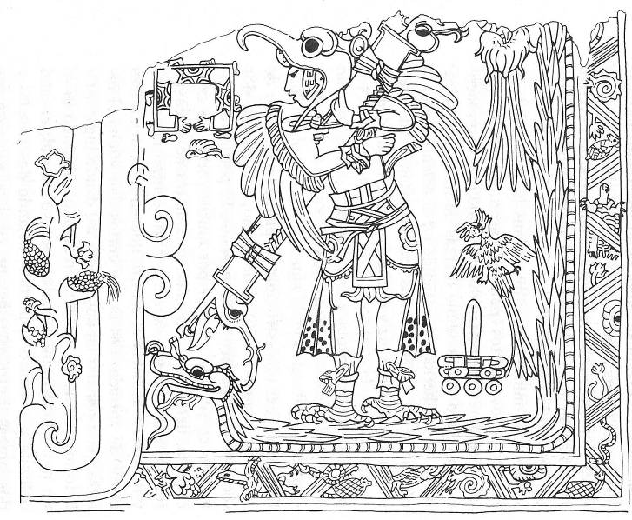 Fig. 44 Print this out for your kids to color….

